**Solutions Architect - Associate**

* The AWS Certified Solutions Architect – Associate exam is intended for individuals with experience in designing distributed applications and systems on the AWS platform.

* Exam concepts you should understand for cracking this exam include:
  + Designing and deploying **scalable**, **highly available** and **fault-tolerant systems** on AWS
  + Lift and shift of an existing on-premises application to AWS
  + Ingress and egress of data to and from AWS
  + Selecting the appropriate AWS service based on data, compute, database, or security requirements
  + Identifying appropriate use of **AWS architectural best practices**
  + **Estimating AWS costs**

**Candidate Overview**

* Eligible candidates for this exam have:
  + One or more years of hands-on experience designing available, cost efficient, fault-tolerant  and scalable distributed systems on AWS
  + Knowledge of at least one high-level programming language
  + Ability to identify and define requirements for an AWS-based application
  + Experience with deploying hybrid systems with on-premise and AWS components
  + Capability to provide best practices for building secure and reliable applications on the AWS platform

* [AWS Curriculum](https://drive.google.com/open?id=1sdDEflMCHneNRmci3HGIa_IQE7ZeVWHo)
* [AWS LINK](https://aws.amazon.com/certification/certified-solutions-architect-associate/)
* [EXAM GUIDE](https://drive.google.com/open?id=1BFksc1eOqBRvDR0_JHQ9fYeMyvUvi7O4)

**When you want to be an AWS CSA - Associate, start thinking like an Architect**

**Architect**

* Architect - A person who designs and guides a Plan or Project .
  + In AWS, An architect will try to understand and analyze the AWS Services(Building Blocks) and how to put together these services to build a solution.

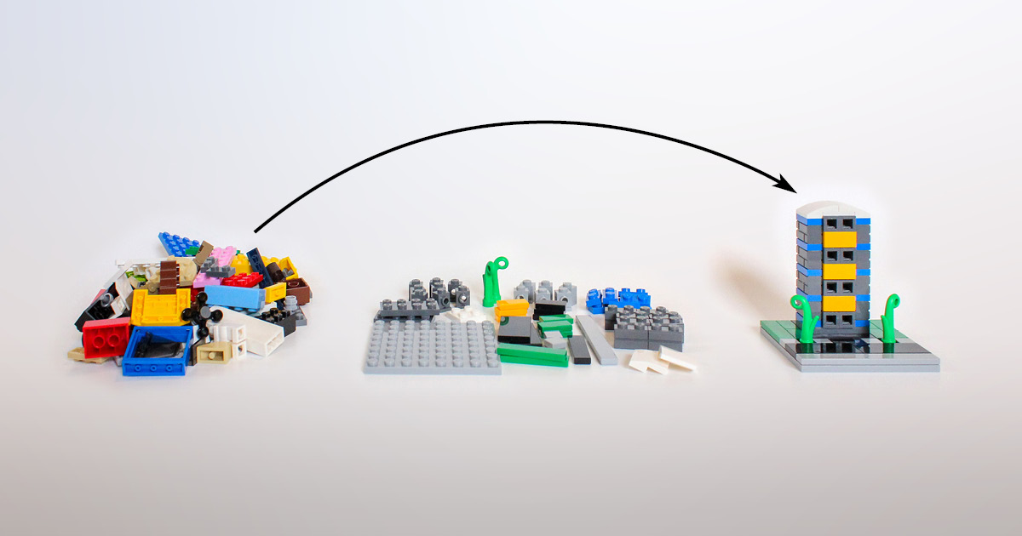

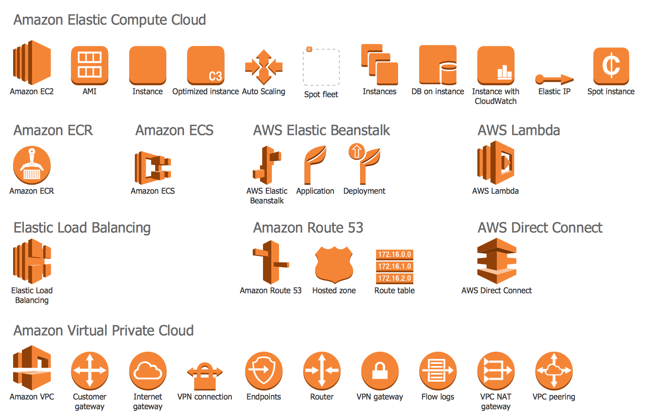

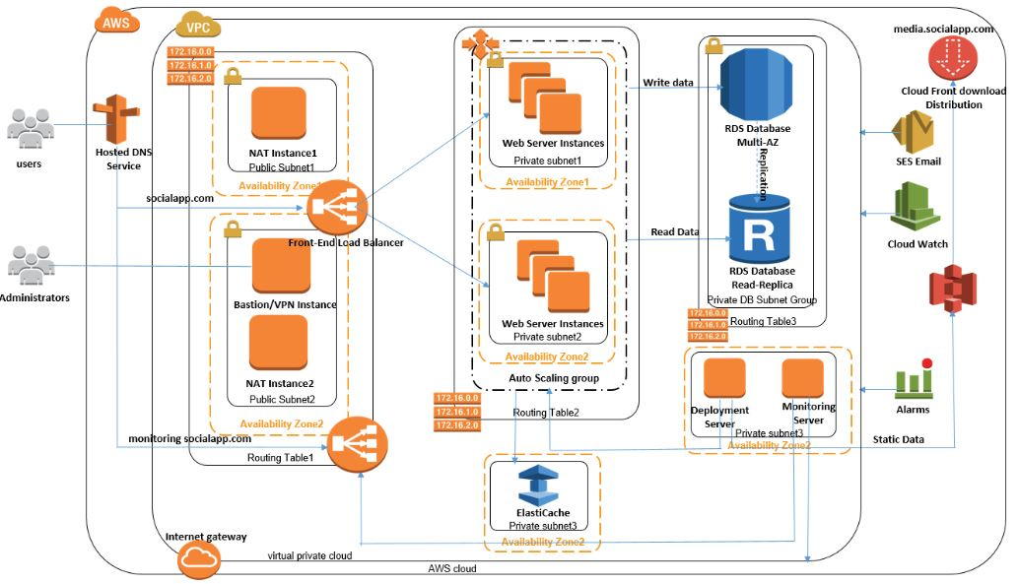

**AWS References**

* [AWS Certifications](https://aws.amazon.com/certification/)

* [AWS Services](https://aws.amazon.com/products/)

* [AWS Documentation](https://aws.amazon.com/documentation/)

* [AWS FAQs](https://aws.amazon.com/faqs/)

**From Physical Data Center to Cloud**

* A Data Center is a facility that houses computing facilities like servers, routers, switches and firewalls, as well as supporting components like backup equipment, fire suppression facilities and air conditioning.

* A Data center may be complex (dedicated building) or simple (an area or room that houses only a few servers).

* We may have one or more Data centres, depending on how large the customer base is.

**Components Of Data center**

* A data center infrastructure may include:
  + **Racks** : Data center hardware is typically mounted into racks that maximize the use of space in the facility.
  + **Network Connectivity** : Data centers often have multiple fiber connections to the internet provided by multiple carriers.
  + **Power** : Each machine in a data center may be dual-power provided with the data center having multiple grid connections.
  + **Energy Production Systems** : A system of backup power such as a generator with fuel storage. It is common for data centers to have a solar panel system on the roof or nearby.
  + **Environment Control** : Systems for cooling hardware and providing heating, ventilation, air conditioning, humidification and dehumidification for the facility.
  + **Physical Security** : Typically monitored with cameras and may have on-site security guards.

**Cons Of Physical Data Center**

* For many organizations, the job of running a Data center is an Expensive and Complicated burden
  + Cost of Building
  + Cost of Administration
  + Cost of Power Generators
  + Cost of Cooling
  + Cost of Cabling
  + Physically securing the place



**Virtualization**

Virtualization is the creation of a virtual,  rather than actual version of something, such as an operating system, a server, a storage device or network resources.

You probably know a little about Virtualization if you have ever divided your hard drive into different partitions. A partition is the logical division of a hard disk drive to create, in effect, two separate hard drives.

When people talk about Virtualization, they’re usually referring to **Server Virtualization**, which means partitioning one physical server into several virtual servers, or machines.

**Pre-Virtualization World** - **Why do we need Server Virtualization ??**

In a world before virtualization, servers would traditionally run **one** **application** on      **one** **server** with **one** **operating system**. In the old system, the number of servers would continue to mount since every new application required its own server and operating system.

As a result, expensive hardware resources were being purchased, but not used. Each server would only use about **12%** of its resources. **Almost 88% of server resources were completely unutilized**.

Virtualization is possible because of a software layer called a **HYPERVISOR**.

Virtualization allows multiple operating systems to run concurrently on a single host computer.

**Hypervisor**

What is a hypervisor and how does it differ from bare metal?

A **Hypervisor/Virtual Machine Monitor** (**VMM**) is an low-level program/software that can create and run Virtual Machines (VM's) within a bare-metal server.

Let’s have a look at the representation below to better understand the difference between the two.

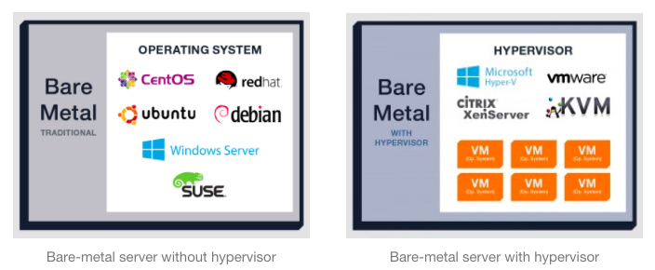

The first image above represents a traditional bare-metal server. The operating system (CentOS, Debian, Ubuntu, Windows Server, etc.) is installed directly on the server, and applications are running natively in the operating system, **A single OS owns all hardware resources**.

The first step of the virtualization process is installing the hypervisor onto a server.

In the second image above, a bare-metal server installed with a hypervisor provides the user with a management suite to create virtual machines on the server.

After the hypervisor is up and running, multiple “software containers” known as virtual machines (VMs) are built on top of the hypervisor. All of the VMs are isolated from each other.

Once the VMs have been built on top of the hypervisor:

* Applications and operating systems can be added to each VM.
* Every app and operating system placed on the server lives in a separate VM, which means if an app or operating system goes down on one VM, none of the other apps or operating systems on the other VMs are affected.

**So how do the VMs interact with the hardware resources?**

This is where the hypervisor comes in: the hypervisor is able to distribute the underlying resources based on what each VM needs. Resources (like memory, storage, processors, and networking) are pooled together so that every VM can get exactly what it needs for its ideal performance.

You can think of the hypervisor as the traffic cop that controls processor,memory, networking and storage management.

If one VM needs more memory than other apps, the hypervisor can allocate more memory for that VM. If another needs more storage, the hypervisor can allocate more storage. And so on.

Virtualization lets you run more applications on fewer physical servers. Rather than one application running on one server with one operating system, multiple VMs run multiple applications and operating systems on one physical server.

Just in case this is still muddled or confusing, here’s how I would explain virtualization.

Virtualization is like a school bus. Before the school bus was invented, every parent used their own car to drive their kid to school, using extra gas and resources—putting all of the kids into one vehicle wasn’t an option.

One day, the school bus was introduced, exposing the inefficiency of every parent driving their kid to school separately. By using the school bus, parents could use less gas and fewer vehicles, all while transporting more kids.

**Benefits of Virtualization**

* Power Savings
* Cooling Savings
* Hardware Savings
* Network savings, no need of extra network cables
* Space Savings, lower number of physical servers
* Resource Sharing, can create multiple machines on single server, which saves Money by reducing cost.
* Deploy multiple Applications & OS's
* Full utilization of Hardware resources
* Isolation, VM's are isolated from each other as if they are physically separated
* VM's can be migrated between different hosts

With Virtualization solution you can reduce IT costs while increasing the efficiency, utilization and flexibility of their existing computer hardware i.e, simplified management of Data center.

**Two types of Hypervisors**

**Type 1 Type 2**

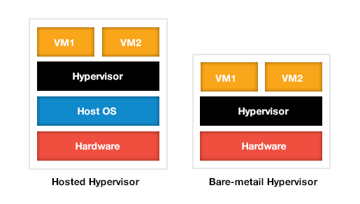

**Type-1, native or Bare-metal hypervisors**

These hypervisors run directly on the host's hardware. Examples: Xenserver, Oracle VM Server, Microsoft Hyper-V, VMware ESX/ESXi etc

**Type-2 or hosted hypervisors**

These hypervisors run on a host operating system (OS) just as other computer programs do. Examples: VMware Workstation, VirtualBox etc

Experts predict that shipping hypervisors on bare metal will impact how organizations purchase servers in the future. Instead of selecting an OS, they will simply have to order a server with an embedded hypervisor and run whatever OS they want.

**Cloud Computing**

* Cloud computing is the on-demand delivery of compute power, database storage, applications, and other IT resources through a cloud services platform via the internet with pay-as-you-go pricing.

* With cloud computing, you don’t need to make large upfront investments in hardware and spend a lot of time on the heavy lifting of managing that hardware. Instead, you can provision exactly the right type and size of computing resources you need to operate your IT department. You can access as many resources as you need, almost instantly, and only pay for what you use.

* Testing of your new ideas for the applications becomes much easier.

**Cloud Computing Offerings**

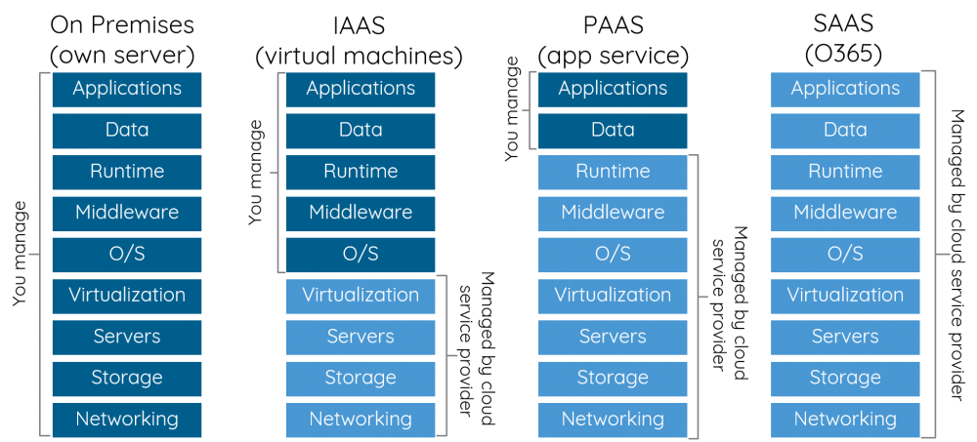

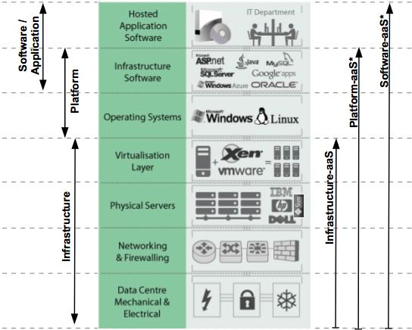

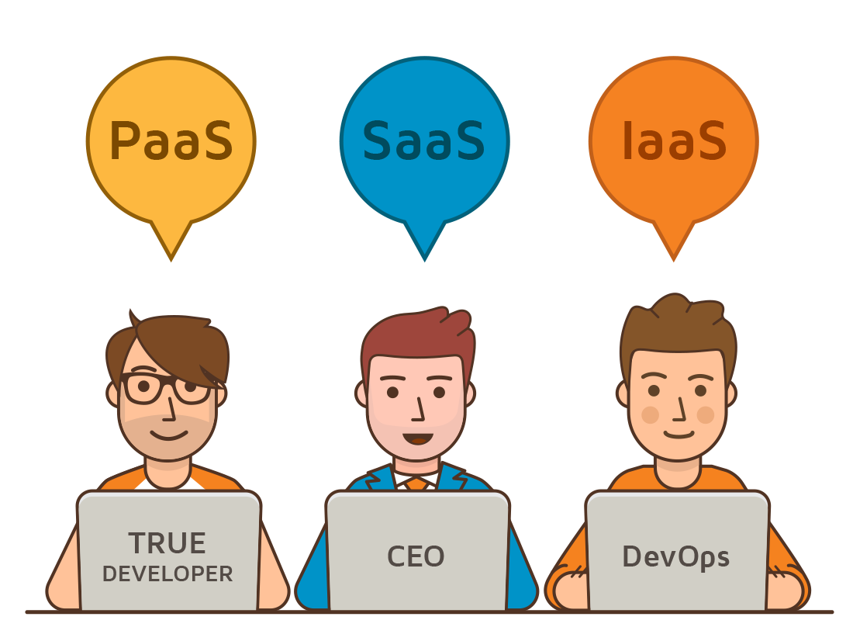

**Cloud Deployment Models**

* **Public Cloud**
  + Public clouds are the most common way of deploying cloud computing.
  + In a public cloud, you share the same hardware, storage and network devices with other organisations or multiple “tenants.”

* **Private Cloud**
  + A private cloud consists of computing resources used exclusively by one business or organisation or simple single tenant.
  + The private cloud can be physically located at your organisation’s on-site datacenter.
  + Private clouds are often used by government agencies, financial institutions

* **Hybrid Cloud**
  + Often called “the best of both worlds,” hybrid clouds combine on-premises infrastructure, or private clouds, with public clouds so organisations can reap the advantages of both.

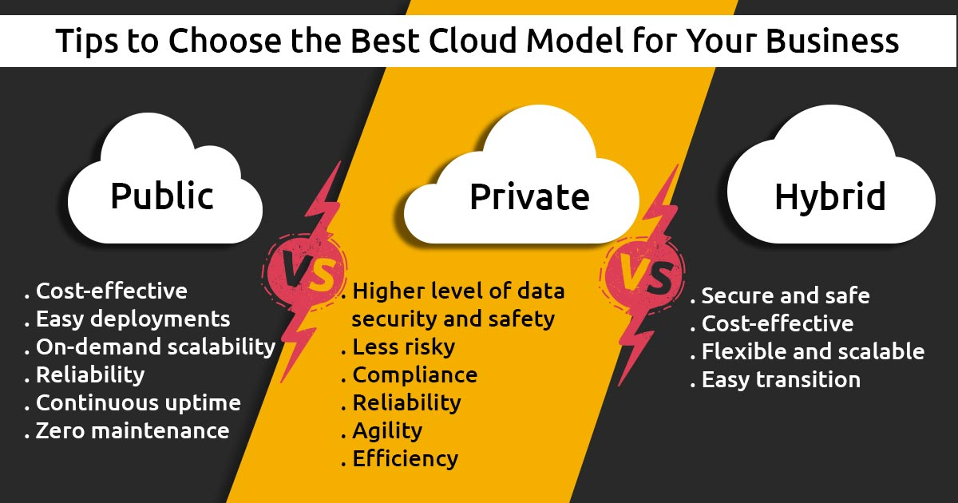

**Cloud Computing Advantages**

* **Trade capital expense for variable expense**
  + Instead of having to invest heavily in data centers and servers, before you know how you’re going to use them, you can only pay when you consume computing resources, and only pay for how much you consume.
* **Stop guessing capacity**
  + Eliminate guessing on your infrastructure capacity needs. When you make a capacity decision prior to deploying an application, you often either end up sitting on expensive idle resources or dealing with limited capacity. With cloud computing, these problems go away.
* **Increase speed and agility**
  + In a cloud computing environment, new IT resources are only ever a click away, which means you reduce the time it takes to make those resources available to your developers from weeks to just minutes. This results in a dramatic increase in agility for the organization, since the cost and time it takes to experiment and develop is significantly lower.

* **Go global in minutes**
  + Easily deploy your application in multiple regions around the world with just a few clicks.

**Why Become AWS Certified ??**

* AWS Certified are becoming more in demand by Day by Day

* Salary survey shows AWS -CSA Associate salary averages 120K +

* AWS is growing massively and is leading public cloud space, which creates higher demand for CSA

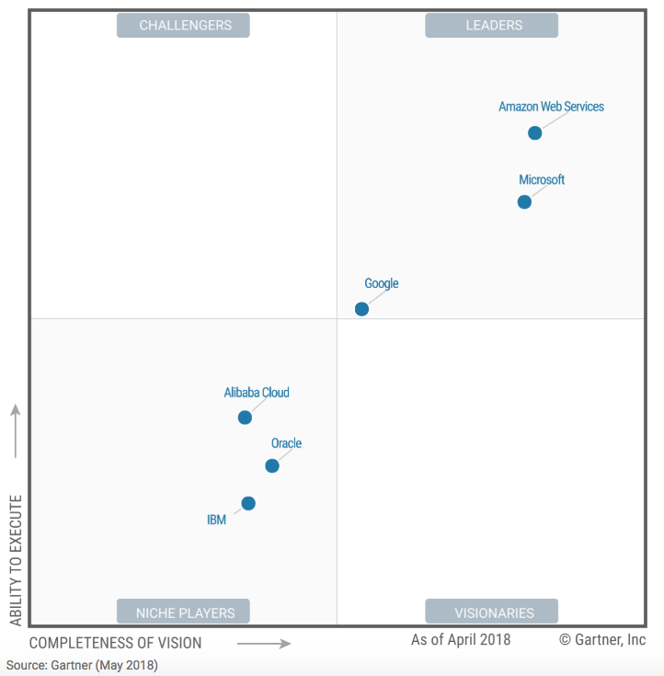

Account Setup

**Setting up AWS Account**

* The AWS Free Tier enables you to gain free, hands-on experience with the AWS platform, products, and services.

* These free tier offers are only available to new AWS customers, and are available for 12 months following your AWS sign-up date.

* [FREE TIER FEATURES](https://aws.amazon.com/free/) and you can register an account in same page

* [Visit](https://aws.amazon.com/free/)

* Click the button to “Create an AWS Account”

* On the next page, provide your Email Address, Password, and AWS Account Name (you can change this name in your account settings after sign up).

* Click “Continue” to proceed

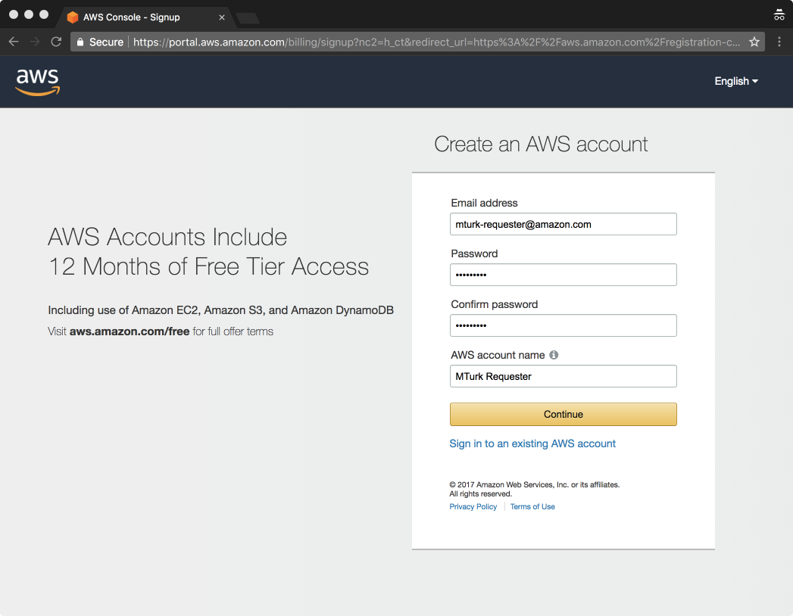

* Next, you’ll provide your contact information. If you’re registering as an individual, select “Personal” and if you’re using any business, select “Company”

* Complete the remaining fields with your information. Then click “Create Account and Continue” to proceed.

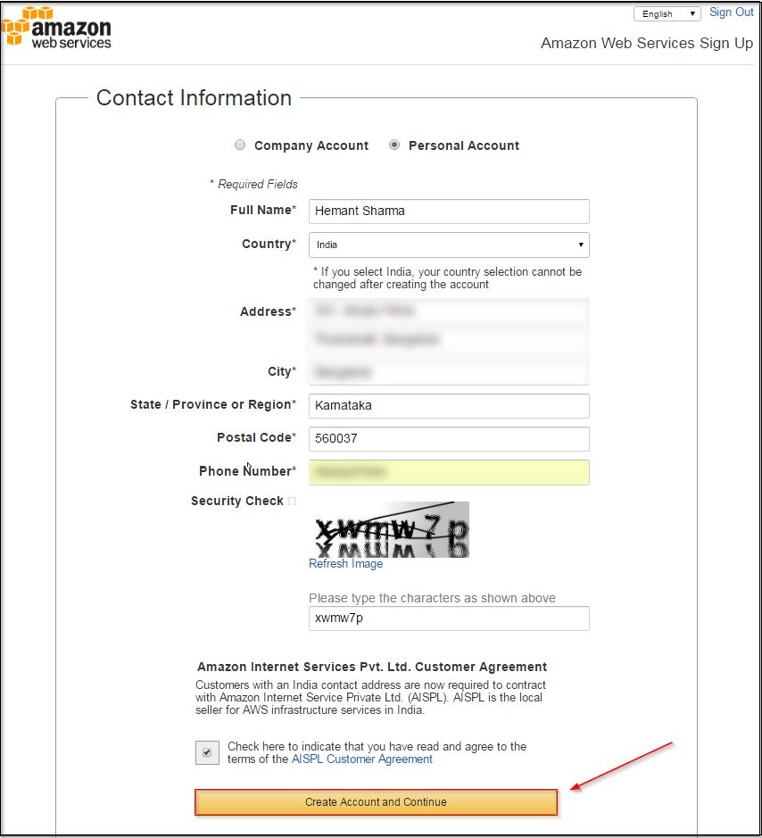

* Next, you’ll be asked to provide a credit card for your AWS Account.

* Once you’ve completed this information, click the “Secure Submit” button to proceed.

* Next, you’ll be asked to complete a brief phone verification step. Here, you are asked to provide a phone number where you can be reached, and to click the “Call Me Now” button to receive an automated phone call.

* Once you receive the call, you’ll input the number shown on your screen using your dial-pad

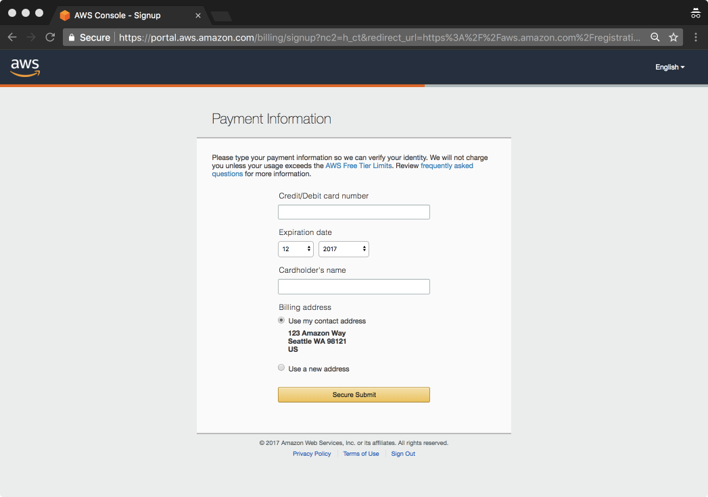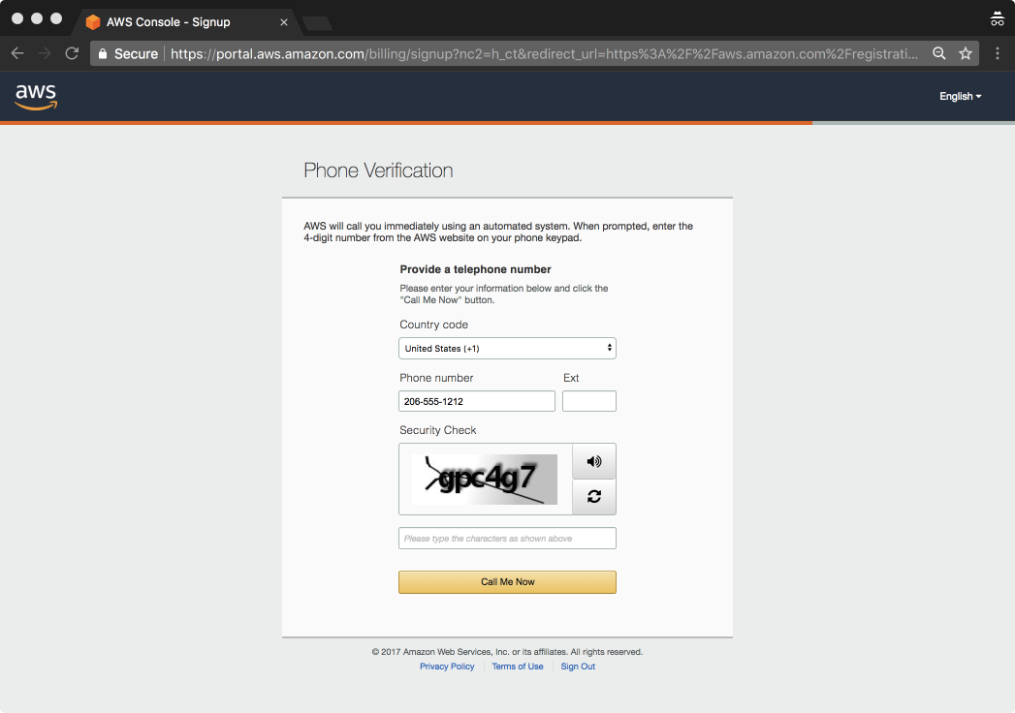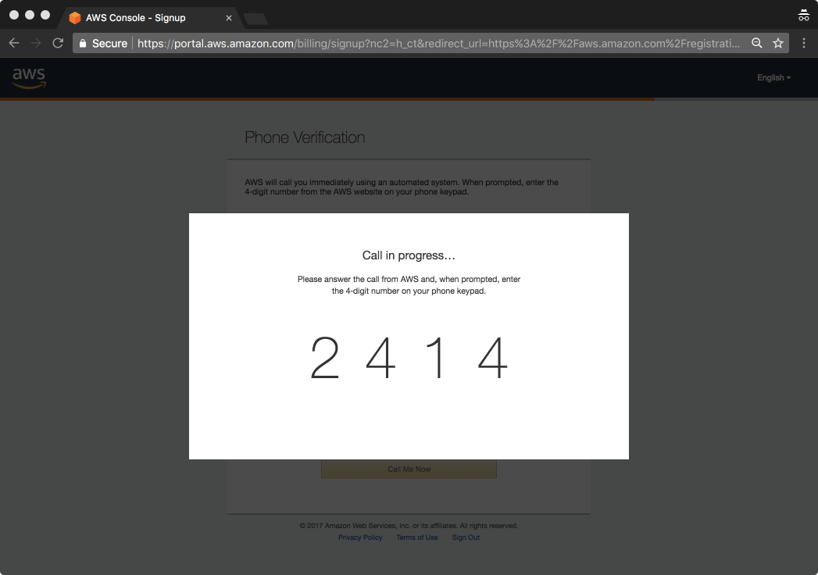

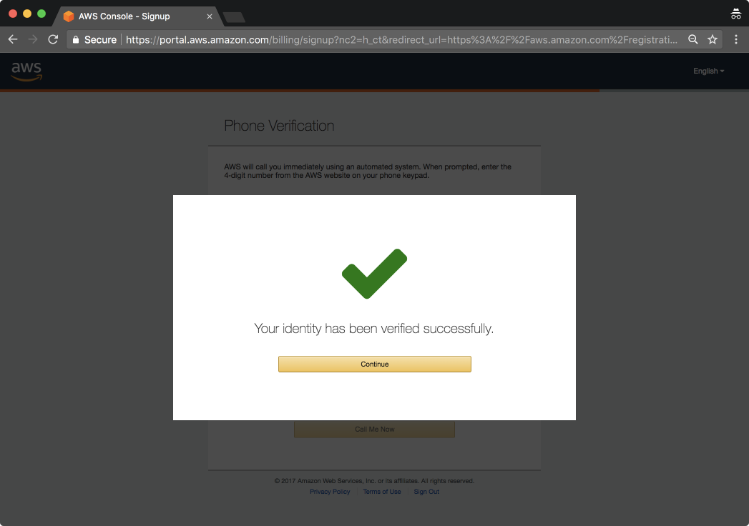

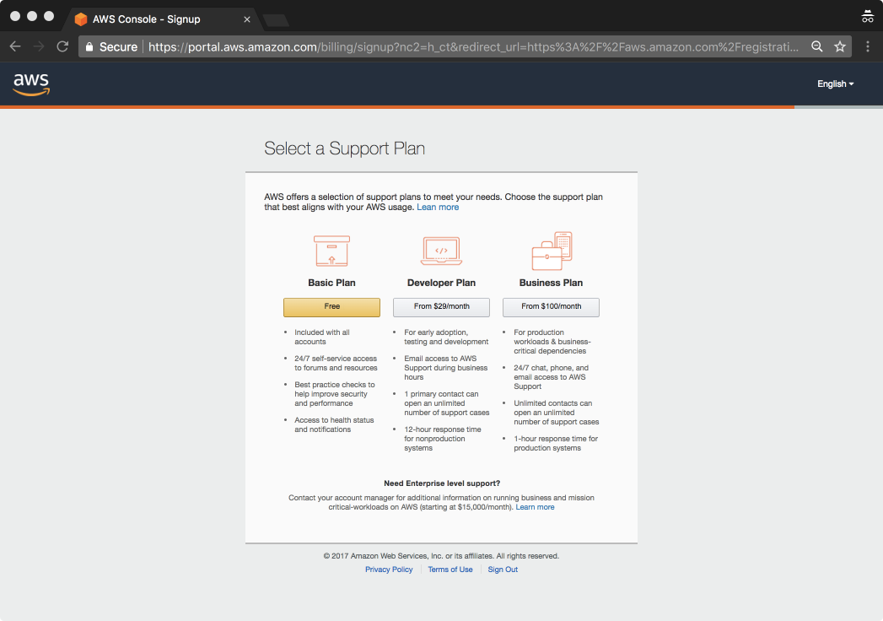

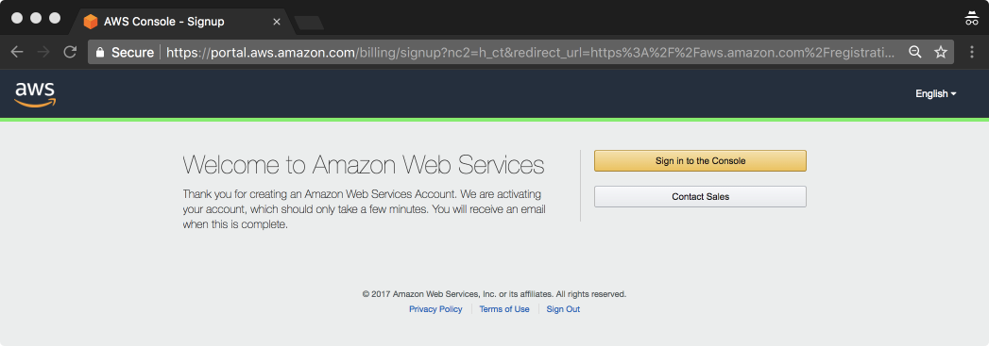

**Account & Services Layer**

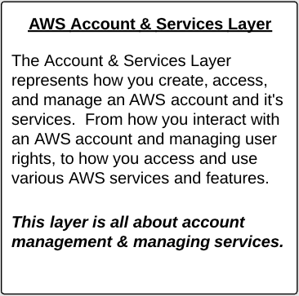

**Root User**

* The user created when you first create your AWS account is called the "root" user.
* It's credentials are the email address and password used when signing up for AWS account.
* By default, the root user has FULL administrative rights and access to every part of the account.

* **Best practices for Root user**
* You should not use the root user for  daily works  and AWS administration. You should create a second user that has a admin rights and sign in as that user for daily work.
* You should always protect your user account with MFA.

**AWS Users**

* This represents an AWS users that you may create (in IAM), who will have varying degrees of access to the "production" AWS account
* We also have different set of users, Developer users they have access to dev account.
* We have two separate AWS user accounts, where dev account is used by developers and production account id used by prod users.
* This is how organizations keep their accounts two seperate accounts one for production and one for development.

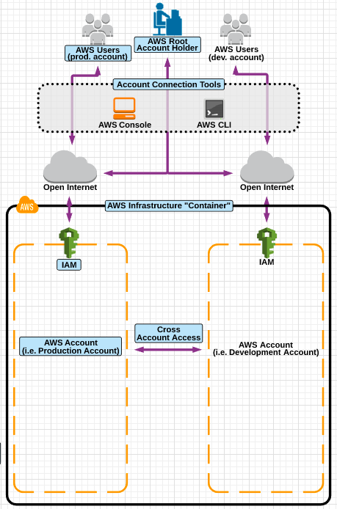

**Access Ways**

* The lines coming down from AWS users represent the two main ways of connecting to AWS.

* AWS Console  - GUI Based

* AWS CLI  - CLI tool

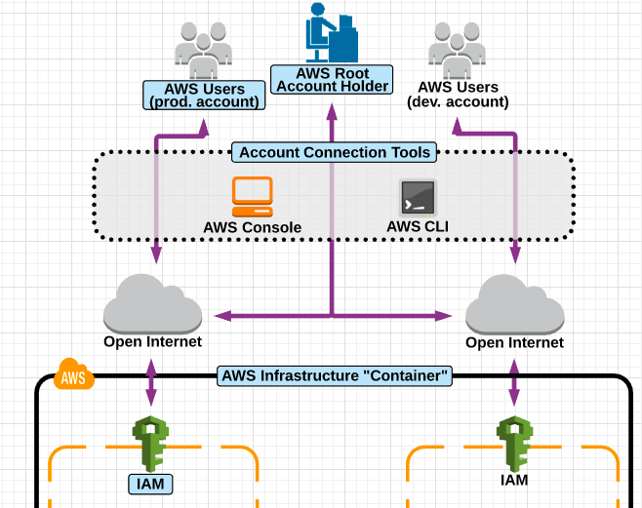

**AWS Management Console**

* The AWS Management Console (generally referred to as the "console") is the primary means for which we will access and interact with AWS.

* Access and manage Amazon Web Services through a simple and intuitive web-based user interface.

* All actions done in the console are API Calls.

* Features
  + Administer your AWS account
  + Finding Services
    - *Recently visited services* section, or expand the *All services*
    - list of all services, either grouped, or arranged alphabetically
* Pin Service Shortcuts

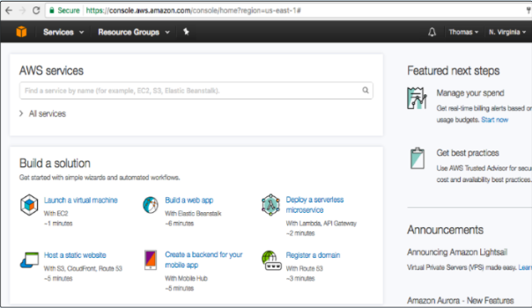

**AWS CLI**

* The AWS Command Line Interface is (generally referred to as the "CLI") is a text based interface for accessing and administering AWS resources.

* Using aws cli you can control multiple AWS services from the command line and automate them through scripts.

* All commands executed using the CLI are API Calls - and require API key configuration.

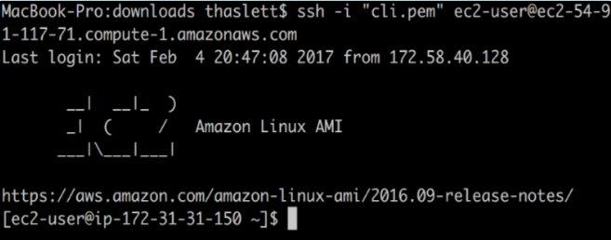

* Windows
  + Download and run the [64-bit](https://s3.amazonaws.com/aws-cli/AWSCLI64PY3.msi) or [32-bit](https://s3.amazonaws.com/aws-cli/AWSCLI32PY3.msi) Windows installer.

* Mac and Linux
  + Requires [Python](http://www.python.org/download/) 2.6.5 or higher. Install using [pip](http://www.pip-installer.org/en/latest/).
  + pip install awscli

**Usage**

* CLI reference -  [**https://docs.aws.amazon.com/cli/latest/reference/**](https://docs.aws.amazon.com/cli/latest/reference/)

* **S3** - [**https://docs.aws.amazon.com/cli/latest/reference/s3/index.html**](https://docs.aws.amazon.com/cli/latest/reference/s3/index.html)
  + [cp](https://docs.aws.amazon.com/cli/latest/reference/s3/cp.html)
  + [ls](https://docs.aws.amazon.com/cli/latest/reference/s3/ls.html)
  + [mb](https://docs.aws.amazon.com/cli/latest/reference/s3/mb.html)
  + [rm](https://docs.aws.amazon.com/cli/latest/reference/s3/rm.html)
* Follow the approach to configure
  + aws configure { will prompt for **access & secret keys** }
  + Then you can run the cli commands

# aws s3 mb s3://mybucket --region us-west-1

# aws s3 cp test.txt s3://mybucket/test2.txt

# aws s3 ls

**Physical & Networking Layer**

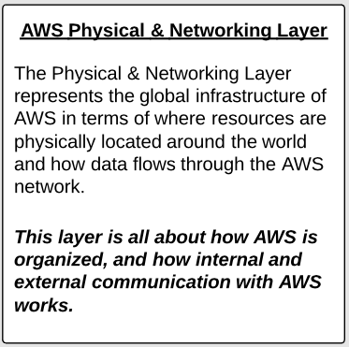

**Physical Infrastructure**

* AWS, in terms of its global infrastructure is broken up at the highest level between
  + AWS Regions
  + AWS Availability Zones
  + AWS Edge Locations

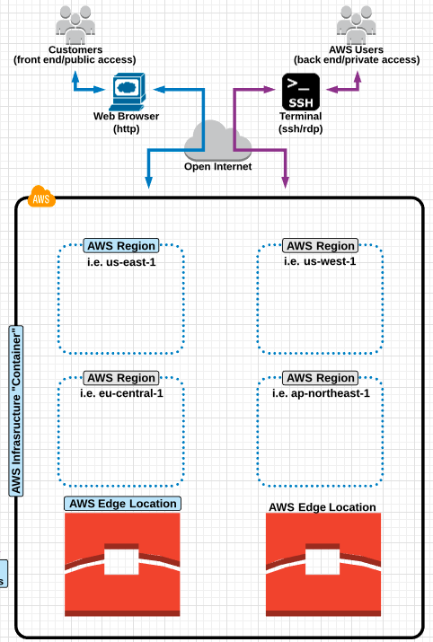

**Regions**

* A group of AWS resources located in a specific geographical location.
* Availability of regions allow the architects to design applications to confirm to specific laws and regulations for specific parts of the world. When viewing region in the console you will only view resources in one region at a time.
* Regions are designed to service AWS customers (or your users) that are located closest to a region.
* Some AWS services work "globally" while some work within a specific region only
* When we provision an EC2 instance or S3 Bucket, then you would select the region and that is where these are provisioned or stored in that region.
* Regions are comprised of multiple Availability Zones.

**Edge Locations**

* An Edge Location is an AWS datacenter which does not contain AWS Services.
* Instead, it is used to deliver content to parts of the world.

* An example would be CloudFront which is a CDN:
  + Cached items such as a PDF file can be cached on the edge location which reduces the amount of "space/time/latency" required for a request from the other part of the world.

**Availability Zone**

* The Availability zone is where the actual data centres are located.
* So within a Region there can be multiple Availability zones which are physically separated but are connected through low latency and high speed internet connections.
* Availability zones work together in a region to make up a collection of your AWS resources.
* Properly designed applications will utilize multiple availability zones for fault tolerance and failover.
* [VISIT AWS Global Infra](https://aws.amazon.com/about-aws/global-infrastructure/)



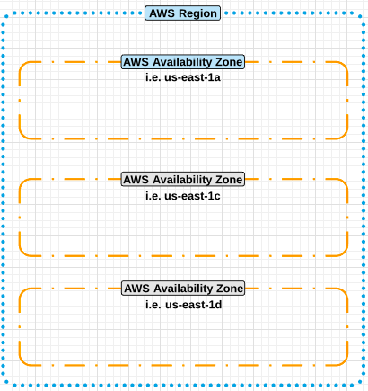

**High Availability**

* Refers to systems that are durable and likely to operate continuously without failure for a long time. For a solutions architect this means making sure your application (hosted in AWS) is always available when a user/customer tries to access it.

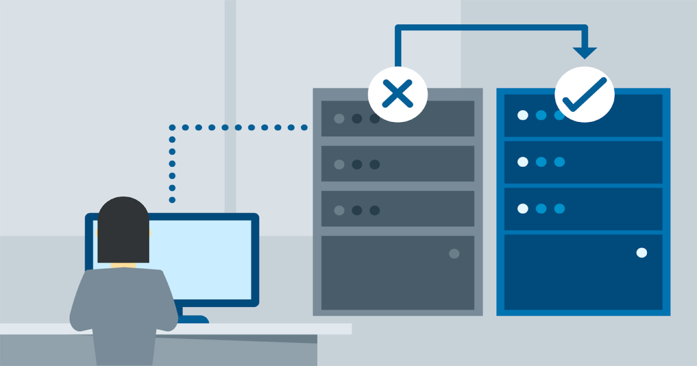

**Fault Tolerance**

* Is the property that enables a system to continue operating properly in the event of the failure of one or more of its components. A fault tolerant application (in Aws) would be where one of its web servers can fail, and still serve traffic to visitors (and ever repair itself).

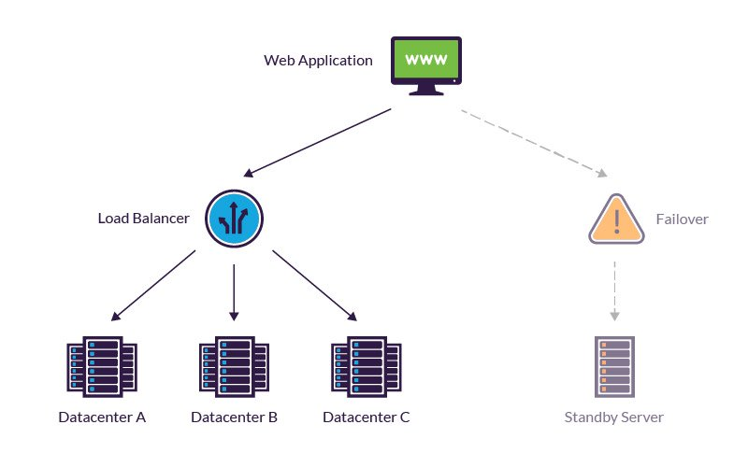

**Scalability**

* The ability of a system to easily increase in size and capacity in a cost effective way (usually based on usage and demand).

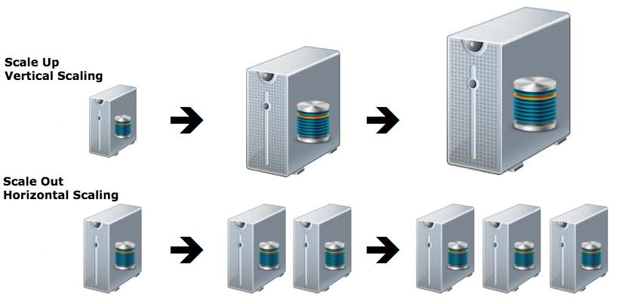

**Elasticity**

The ability of a system to increase and decrease in size (usually based on usage demand), in architecting applications, this usually refers to the ability of an application to increase and decrease server capacity on demand.

**Cost Efficient**

Choosing the correct options to make a system as inexpensive as possible.

**Secure**

Following proper security guidelines and practices to secure a system.

**AWS Best Practices**

A set of guidelines outlined by AWS that should be followed when provisioning and using their services.

IAM

**Identity & Access Management**

* AWS - IAM helps you securely control access to AWS resources. You use IAM to control who is authenticated (signed in) and authorized (has permissions) to use resources.

* IAM (Identity & Access management) is where you manage your AWS users, groups, roles  and their access to AWS accounts and services:

* IAM provides access and access permissions to AWS resources (such as EC2, S3 etc)

* IAM is global to all AWS regions, creating a user account will apply to all the regions.

* The common use of IAM is to manage:
* **Users**
* **Groups**
* **Roles**
* **Policies**
* **Api Keys**
* Specify a password policy as well as manage MFA requirements on a per user basis

* By default, any new IAM new user you create in an AWS account is created with NO access to any AWS services. This is a non-explicit deny rule set on all new IAM users.

* For all the users (besides the root user), permissions must be given, that grant access to AWS services

**Security Checks**

* When a new AWS root account is created, it is a "best practice" to complete the tasks listed in IAM under "Security Status" - which includes:
  + Delete your root access keys
  + Activate MFA on your root account
  + Create individual IAM users
  + Users groups to assign permissions
  + Apply an IAM password policy

* Best practice is to login and do daily work as an IAM user - NOT as the root user.

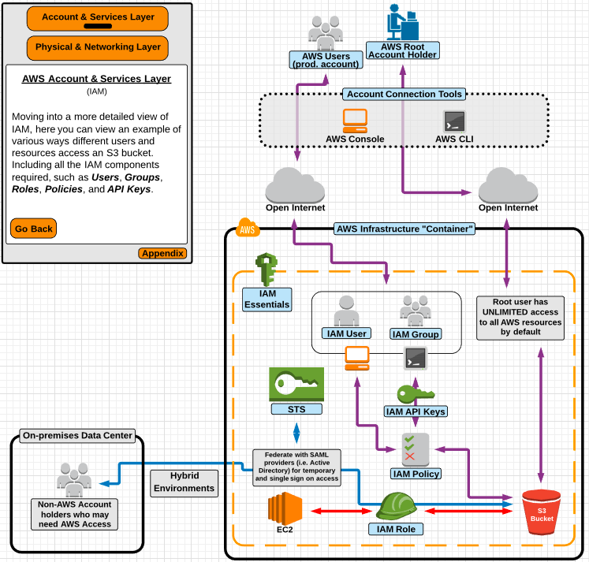

* In AWS Console →  All Services → Security, Identity & Compliance → IAM (Click it)

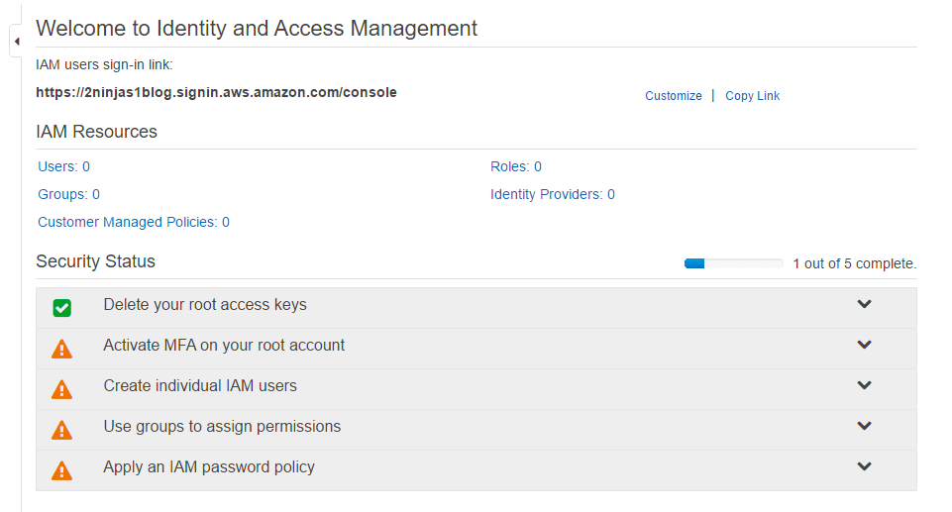

**Activate MFA**

* MFA (Multi Factor Authentication) is an additional layer of security on your root account that is provided by 3rd party.

* It takes form of continually changing, random six digit code that you need to input in addition to password, when logging into your root account.

* How to get MFA ?

* **Virtual MFA Device**
  1. Smartphone or Tablet
  2. Use Google Authenticator from IOS or Android

* **Hardware Key Fob**
  1. Small physical device with display that can be attached to keychain
  2. Oder it directly from AWS

* Click → Select Virtual MFA device → Next → Download Google Authenticator in phone → Next → Scan QR code → Activate MFA →

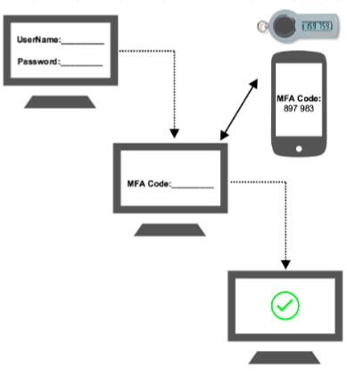

**Create IAM Users**

* AWS strongly recommend that you do not use the root user for your everyday tasks, even the administrative ones.

* Instead, adhere to the [best practice of using the root user only to create your first IAM user](http://docs.aws.amazon.com/IAM/latest/UserGuide/best-practices.html#create-iam-users).

* So let's create a user called admin and will use this user as our daily driver.
  + Create Individual IAM users → Manage Users → Add User( name: admin) → Check ✅  both Programmatic access and Management console access → Custom Password → Next → Review → Says User has no permissions → Create User
  + I'll not set the permissions right away, will set the permissions later on

**Groups**

* Will go in detail about Groups later, but let's finish this setup first, so lets create a group called administrators.

* Click Manage Groups → Create new Group → administrators → Attach policy → I'll not attach any policy now, just go to → Next → Create group

**IAM Password Policy**

* A Password Policy dictates the format and expiration rules that must be followed when a user creates or modifies their passwords.

* Rules Include
  + Length, Case requirement, Number requirement, Password Expiration, Password Reuse etc

* Click Manage password policy → Give the policy you want

* Now moving back to Dashboard we can see all the Checks are in Green

**Login with IAM User(admin)**

* Now how do i login as an IAM User ??

* On top you got a link, IAM users sign-in link copy and paste in other browser or a private window.

* Login with the admin user

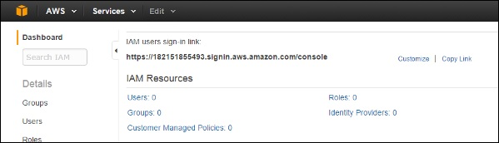

**IAM Users**

* An IAM user is an entity that you create in AWS.
* A primary use for IAM users is to give people the ability to sign in to the AWS and perform
  + **interactive tasks** and
  + **making programmatic requests** to AWS services using the CLI
* A user in AWS consists of a username and password to sign into the AWS Management Console and access keys that can be used with CLI.

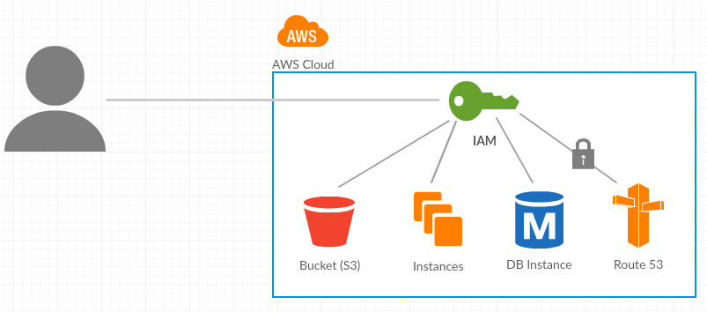

* When first created by default, an IAM user has a **non-explicit deny** for all the AWS services

* **Non-explicit deny** means, NOT having access to use any AWS service.

* Users can have group and regular user policies apply to them - meaning **a user can have multiple IAM policies applied** to them at any given time.

* By default, an explicit deny always overrides an explicit allow from attached IAM policies.
  + **Explicit deny always overrides explicit allow** : means let say we have a user and we granted S3 access with allow policy and later we gave with deny policy, then even though the user has allow policy he will be denied access of S3.

* MFA can be configured on as per user basis for login and resources access

* Even though i logged in as admin user i can only see the console, but i cannot access any resource in AWS, Click on EC2 and S3, access is denied.

**IAM Groups**

* An IAM Group, is a collection of IAM users.

* Groups let you specify permissions for multiple users, which can make it easier to manage the permissions for those users.

* For example, you could have a group called Admins and give that group the types of permissions that administrators typically need.

* If a person changes jobs in your organization, instead of editing that user's permissions, you can remove him or her from the old groups and add him or her to the appropriate new groups.

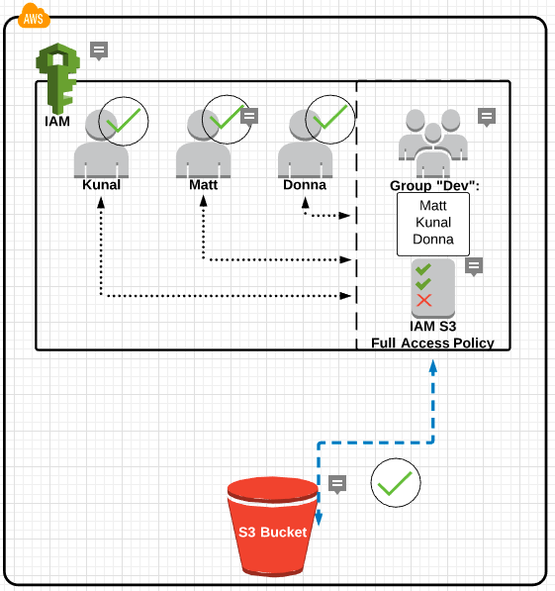

Now groups is great way of simplify the process of granting or restricting access.

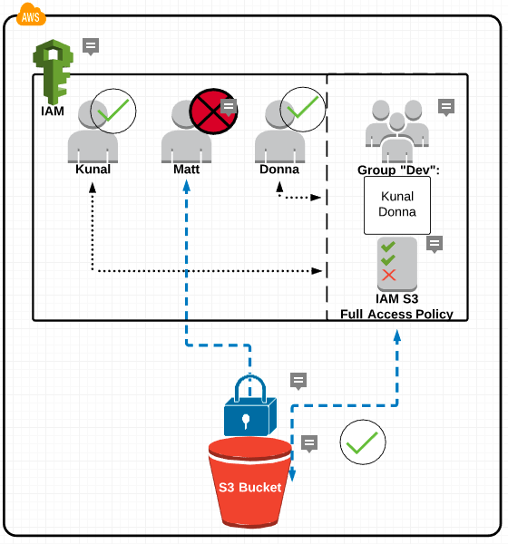

**IAM Policies**

* A policy is an entity in AWS, when attached to an resource, defines their permissions.
* Permissions in the policies determine whether the request is allowed or denied to resource
* Policies are stored in AWS as JSON documents, so basically a policy is a document that formally states one or more permissions.
* It is not necessary for you to understand the JSON syntax. You can easily create custom IAM permission policy using the Visual Editor
* Policies can be attached to a principal (or identity), such as an IAM user, role, or group
* More than one policy can be attached to a principal (or identity), at the same time.
* Policies cannot be directly attached to AWS resources ( such as EC2 instance).
* Policies are of two types:
  + **AWS Managed**
  + **Customer Managed**

**Intro to JSON Policies**

* The policy document includes the following elements:
  + **Effect** – whether the policy allows or denies access
  + **Action** – the list of actions that are allowed or denied by the policy
  + **Resource** – the list of resources on which the actions can occur
  + **Condition** (Optional) – the circumstances under which the policy grants permission

Here's an example of a simple policy

{  
  "Version": "2012-10-17",  
  "Statement": {  
    "Effect": "Allow",  
    "Action": "s3:ListBucket",  
    "Resource": "arn:aws:s3:::example_bucket"  
  }  
}

Lab - IAM

* Login with root account user and create a couple of buckets in S3
* Create a user with name **developer** and select the type with **AWS Management Console access**
* Now login with **developer** user, and try to access S3, but developer has no permissions as of now, so will be getting permission denied error.
* Switch to root account, then apply a Policy (AWS Managed) to developer, to **only List & Read the buckets** in S3 but not to write.
* Switch to developer user, now we should be able to get the list of buckets in S3.
* Also create a user **admin** and attach the Full Administrator (AWS Managed Policy), policy to admin user.
* Now login to **admin** user,  and create a user **sysadmin** and attach Full Administrator (AWS Managed Policy), policy to **sysadmin** user.
* Create a Customer Managed Policy to deny access to S3 service with the name **DenyS3Access**
* Now attach a **DenyS3Access** policy to the user **sysadmin,** so that access is denied to S3 Service.
  + You can observe here, even though user **sysadmin** has Full Administrator policy, by applying the deny policy, preference is given to deny rather then allow.

**IAM API Access Keys**



* We can see that IAM users can use console login and access the S3 bucket via a policy.

* Similarly let say we got users who are using CLI to access S3 in this scenario we need API Keys to access S3.

* API Access Keys are required to make Programmatic calls to AWS from the:
  + AWS Command Line Interface (CLI)
  + Windows PowerShell
  + AWS SDKs

* API credentials are used by developers, working from an on-premise network, for CLI access.

* **Important API Access Key Facts**:
  + Access keys are only available ONE time, when a new users is created OR when you reissue a new set of keys
  + AWS will Not regenerate the same set of access keys
  + In the AWS console you can only see the Access Key ID - never the Secret Key ID
  + If you require new API credentials,  you must deactivate current set and generate new one.

LAB IAM API Keys

* For this lab we need Java Runtime Environment Setup

* Maven Build Tool is also required for application to work

* [Project Links](https://github.com/ravi2krishna/aws-s3-java-api-keys)

* Once Project is Build, run the following command
  1. java -jar target/AWS-S3-API-Keys-1.0-SNAPSHOT.jar

**AWS CLI**

* The AWS Command Line Interface is (generally referred to as the "CLI") is a text based interface for accessing and administering AWS resources.

* Using aws cli you can control multiple AWS services from the command line and automate them through scripts.

* All commands executed using the CLI are API Calls - and require API key configuration.

**AWS - CLI Setup**

* [Windows](https://docs.aws.amazon.com/cli/latest/userguide/awscli-install-windows.html)
  + Download and run the [64-bit](https://s3.amazonaws.com/aws-cli/AWSCLI64PY3.msi) or [32-bit](https://s3.amazonaws.com/aws-cli/AWSCLI32PY3.msi) Windows installer.

* [Mac and Linux](https://docs.aws.amazon.com/cli/latest/userguide/awscli-install-linux.html)
  + Requires [Python](http://www.python.org/download/) 2.6.5 or higher. Install using [pip](http://www.pip-installer.org/en/latest/).
  + pip install awscli

* [CLI Commands Reference](https://docs.aws.amazon.com/cli/latest/reference/)

* Configure Workstation
  + aws configure { will prompt for access & secret keys }
    1. aws s3 ls
    2. aws s3 mb s3://mybucket --region us-west-1
    3. aws s3 cp test.txt s3://mybucket/test2.txt

Assignment LAB

* Create an IAM user admin
  + What is the default rule set for this user ??
  + Now Assign Full Administrator policy to the admin user
* Create an IAM user ec2-admin
  + Login with the user and try to access EC2 service
* Now create a policy(ALLOW) with name ProjXEC2ReadAccess, to grant EC2 Read access to ec2-admin user
* Now create a policy with name ProjXEC2FullAccess, to grant EC2 Write access to ec2-admin user
* Now create a policy(DENY) with name ProjXEC2DenyWrite, to deny EC2 write access to ec2-admin user
  + If a user has both allow and deny rules applied, DENY is given more preference
  + Ex : + x - = -
* Create users u1, u2, u3, u4, u5 and u6 with console and CLI access
* Add u1 & u2 under Dev group
* Add u3 & u4 under Admin group
* Add u5 & u6 under HR group
* Attach direct policy to groups
  + Dev - Full Database access, But deny S3 access to u2
  + Admin - Full admin access, But deny IAM for u4
  + HR - Allow IAM full access & S3, but deny IAM write and S3 write to u6

* Create a user admin with administrator privileges, enable MFA for both root & admin
* Create a customized login link and set a password policy for admin user with following requirements :
  + minimum 14 characters
  + at least uppercase letter
  + at least one lowercase letter
  + at least one number
  + at least one non alphanumeric character i.e ! @ # $
* Enable password expiration 60 days

**IAM Roles**

* An IAM role is similar to a user, in that it is an AWS identity with permission policies that determine what the identity can and cannot do in AWS.
* However, instead of being uniquely associated with one person, a role is intended to be assumable by anyone who needs it.
* User and roles use policies for authorization. Keep in mind that user and role can't do anything until you allow certain actions with a policy.
* Also, a role does not have standard long-term credentials (password or access keys)

* In the context of this course, "entities" that can assume a role includes AWS resources (such as an EC2 instance)
* Roles must be used because policies cannot be directly attached to AWS services such as EC2 instances.
* If you are using an EC2 instance and it need to access an S3 buckets, You "can" but should never pass or store credentials in or to an EC2 instance - so roles are used instead
* Other services can assume a "role" for temporary access to AWS accounts and resources
  + I AM User - Long lived credentials
  + I AM Role - Short lived credentials

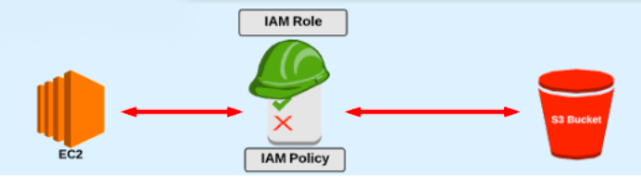

**IAM Facts**

* Can have a password ?
  + User → Yes &  Role → No
* Can have an access key ?
  + User → Yes &  Role → No
* Can belong to a group ?
  + User → Yes &  Role → No
* Can be associated with AWS Services (for example EC2 instances) ?
  + User → No &  Role → Yes



**IAM STS**

* From the main diagram you can check that, if you want to access S3 via EC2 then that EC2 needs to have a role attached to it.
* Now Role actually gets it's temporary credentials from STS.
* STS allows you to create a temporary security credentials that grant trusted users access to your AWS resources

* These temporary credentials are of short-term use

* After the credentials expire, AWS no longer recognizes them or allows any kind of access

* Temporary security credentials are not stored with the user but are generated dynamically and provided to the user when requested

**STS Benefits**

* No disturbing or embedding long-term AWS security credentials in an application

* Grant access to AWS resources without having to create an IAM identity for them

* Since the credentials are temporary, you don't have to rotate or revoke them

**IAM Best Practices**

* Lock Away Your AWS Account Root User Access Keys

* Create Individual IAM Users

* Use Groups to Assign Permissions to IAM Users

* Use AWS Defined Policies to Assign Permissions Whenever Possible

* Grant Least Privilege
  1. When you create IAM policies, follow the standard security advice of granting least privilege that is, granting only the permissions required to perform a task. Start with a minimum set of permissions and grant additional permissions as necessary.

* Configure a Strong Password Policy for Your Users

* Enable MFA for Privileged Users

* Use Roles for Applications that Run on Amazon EC2 Instances

* Rotate Credentials Regularly

* Remove Unnecessary Credentials

LAB Python code Roles

# Create a file app.py in notepad and copy the below code

import subprocess

subprocess.call(["aws", "s3", "mb", "s3://aws-lab-videos-your-name","--region","us-east-1"])

subprocess.call(["aws", "s3", "cp", "video.mp4","s3://aws-lab-videos-your-name/video.mp4"])

VPC - Virtual Private Cloud

* Amazon Virtual Private Cloud (Amazon VPC) lets you provision a logically isolated section of the AWS Cloud where you can launch AWS resources in a VIRTUAL NETWORK that you define.

* This virtual network closely resembles a traditional network  that you'd operate in your own datacenter, with the benefits of using the scalable infrastructure of AWS.

* AWS clients has full control over resources and launch virtual compute instances inside that VPC, it is similar to having your own data center inside AWS. The resources are completely isolated from other VPC's on AWS

* VPC is the Backbone of infrastructure of any systems that we decide to build on AWS. Amazon VPC is the networking layer for Amazon EC2.

**VPC Features & Benefits**

* You have complete control over your virtual networking environment
  + selection of your own IP address range
  + creation of subnets
  + configuration of route tables
  + configuration of network gateways.

* A variety of connectivity options exist for your Amazon VPC. You can connect your VPC to the Internet, to your data center, or other VPCs, based on the AWS resources that you want to expose publicly and those that you want to keep private.

* Layered security
* Instance level - Security Groups (firewall on instance level)
* Subnet level - Network ACLs (firewall on the subnet level)

**VPC Connectivity Options**

* Connect directly to the Internet (public subnets) – You can launch instances such as web servers into a publicly accessible subnet where they can send and receive traffic from the Internet.

* Connect to the Internet using (private subnets) – Private subnets can be used for instances such as database servers that you do not want to be directly addressable from the Internet.

* Connect securely to your corporate datacenter – All traffic to and from instances in your VPC can be routed to your corporate datacenter over an VPN connection.

* Connect privately to other VPCs - Peer VPCs together to share resources across multiple virtual networks owned by your or other AWS accounts.

* **NOTE** : First thing you need to understand is, VPC within a region spans across Multiple Availability zones because of that it spans across multiple data centres.

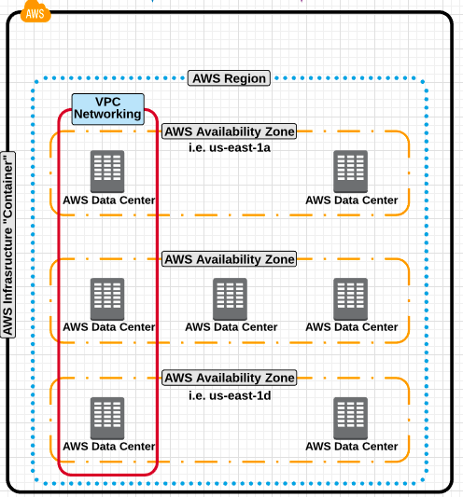

* We got Customers and AWS Users
* Customers are going to access a fully functional web application, generally through http protocol using a web browser.
* AWS Users are going to access our EC2 instances or RDS servers using protocols like ssh or rdp to do maintenance and administration

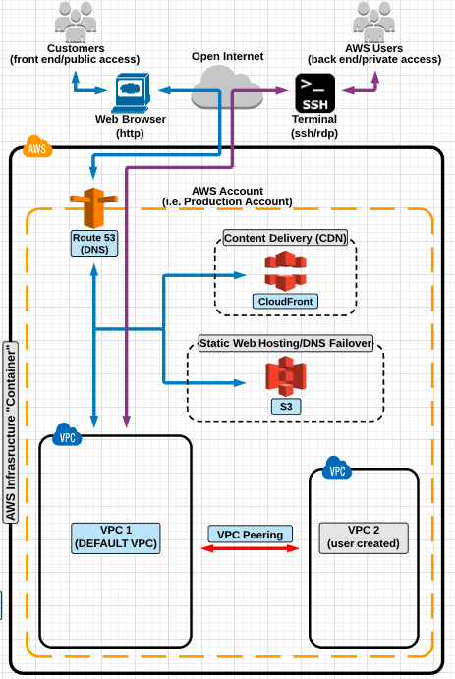

**Default VPC**

* Your AWS resources are automatically provisioned in a ready-to-use default VPC that was created for you.

* The default VPC is meant to allow the user easy access to VPC without having to configure it from scratch.

* Default VPC has CIDR, Security Group, NACL and Route Table settings

* Has Internet Gateway created and attached by default

* Each instance launched in the default VPC (by default) has a private and public IP address (defined on the subnet settings).

**Custom VPC**

* A VPC, an AWS Account owner creates with custom settings

* AWS user creating the custom VPC can decide CIDR

* Has its own default Security Group, NACL's and  Route Tables

* Doesn't have Internet Gateway by default, if needed user needs to create

**VPC Network Routing Basics**

* Now to understand Routing we need to first look into VPC Components
  + Internet Gateway
  + Route Tables
  + Subnets
  + NACL's
  + Security Groups

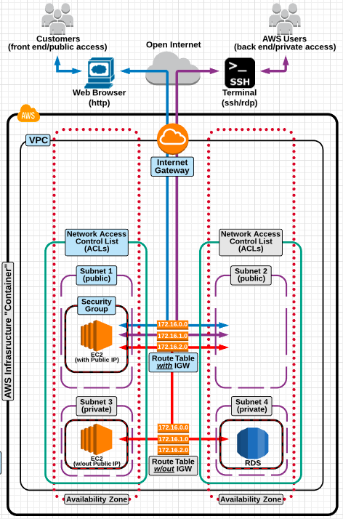

**Internet Gateway [ IGW ]**

* Internet Gateway (IGW) is a VPC component that allows communication between instances in your VPC and the internet.

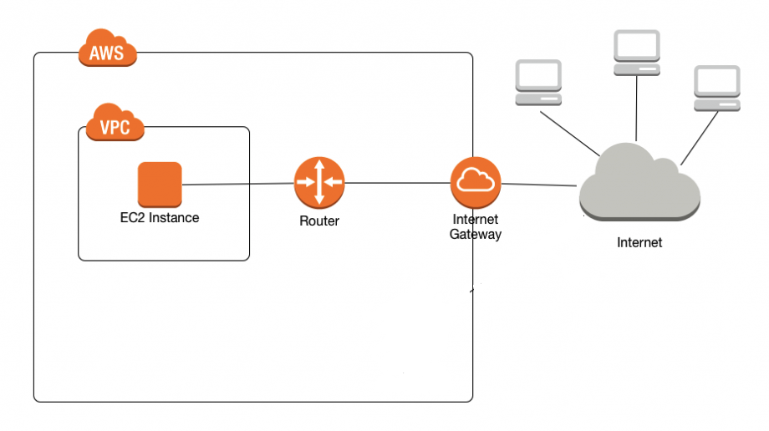

* **IGW is highly available service.**

* **As it's an AWS managed service, IGW imposes no availability risks or bandwidth constraints on your network traffic.**

* **NOTE: Your "default" VPC already has a IGW attached.**

**Internet Gateway Rules**

* Internet Gateway rules and details you need to know:
  + Only 1 IGW can be attached to a VPC at a time.
  + An IGW cannot be detached from a VPC while there are active AWS resources in the VPC (such as an EC2 instance or RDS Database).
  + An IGW must be attached to a VPC if the resources inside the VPC need to connect to resources via the open internet.

* "**To enable access to or from the internet to an instance in a VPC subnet, you must attach an Internet gateway to your VPC, ensure that your subnet route table points to the Internet gateway and ensure that instances in your subnet have a public IP address or Elastic IP address, and ensure that your network access control and security group rules allow the relevant traffic to and from your instance**" -- AWS

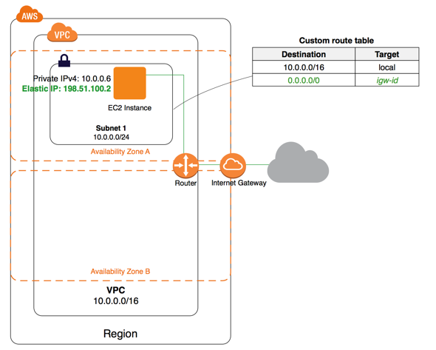

In the above diagram, Subnet 1 in the VPC is associated with a custom route table that points all internet-bound traffic to an Internet gateway. The instance has an Elastic IP address, which enables communication with the internet.

**Router**



* It's the central VPC routing function
* It connects different Availability Zones and Subnets together
* It connects VPC to IGW
* Each Subnet will have a Route Table and router uses it to forward the traffic within the VPC
* Route tables will have entries to destinations

**Route Tables**

* A route table contains a set of rules called routes, that are used to determine where network traffic is directed.

* Your VPC has an implicit router.

* Your VPC automatically comes with a main route table

* You can create additional custom route tables for your VPC.

* Each subnet must be associated with a route table, which controls the routing for the subnet. If you don't explicitly associate a subnet with a particular route table, the subnet is implicitly associated with the main route table.

* You cannot delete the main route table, but you can replace the main route table with a custom table that you've created

* A route table's rules are comprised of two main components:
* Destination: The CIDR block range of the target (where the data is routed to).
* Target: A name identifier of where the data is being routed to.

* By default, all subnets traffic is allowed to each other, available subnet within your VPC which is called the local route.

* You cannot modify or delete the local route.

* Unlike an IGW, you can have multiple route tables in a VPC

* You cannot delete a route table if it has "dependencies" (associated subnets)

* Best practice is to leave the default route table and create a new route table when new routes are needed for specific subnets.

* NOTE: The "default" VPC already has a "main" route table.

**Main Route Table**

* When you create a VPC, it automatically has a main route table. On the Route Tables page you can view the main route table for a VPC by looking for Yes in the Main column.

* The main route table controls the routing for all subnets that are not explicitly associated with any other route table. You can add, remove and modify routes in the main route table.

* You can explicitly associate a subnet with the main route table, even if it's already implicitly associated.

**Custom Route Table**

* Your VPC can have route tables other than the default table.

* One way to protect your VPC is to leave the main route table in its original default state (with only the local route), and explicitly associate each new subnet you create with one of the custom route tables you've created

* Custom route tables ensures that you explicitly control how each subnet routes outbound traffic.

* You might want to make changes to the main route table, but to avoid any disruption to your traffic, you can first test the route changes using a custom route table. After you're satisfied with the testing, you then replace the main route table with the new custom table.

**Subnets**

* When you create a VPC, it spans across all of the Availability Zones in the region. After creating a VPC, you can add one or more subnets in each Availability zone. Each subnet must reside entirely within one availability zone and cannot span zones

* Subnets MUST be associated with a route table.

* A PUBLIC subnet HAS a route to the internet.
* It is associated with a route table that has an IGW attached.

* A PRIVATE subnet does NOT have a route to the Internet.
  + It is associated with a route table that does NOT have an IGW attached.
* NOTE: The "default" VPC already has subnets created and associated with a route table.

**NACL**

* A Network access control list (NACL) is an optional layer of security for your VPC that acts as a firewall for controlling traffic in and out of one or more subnets.

* ACL's operate at the subnet level.

* They support allow and deny rules for traffic traveling into or out of a subnet.

* They are Stateless, so return traffic must be allowed through an outbound rule.

* They process rules in number order when deciding whether to allow traffic.

* Rules are evaluated in order,  starting with the lowest rule number - for Example: if traffic is denied at a lower rule number and allowed at a higher rule number, the allow rule will be ignored and the traffic will be denied.

* Best practice to increment numbers by 10 so if you have to place in a rule in a certain order it does not create an issue.

* NOTE - Your "default" VPC already has a NACL and it is associated with the default subnets.

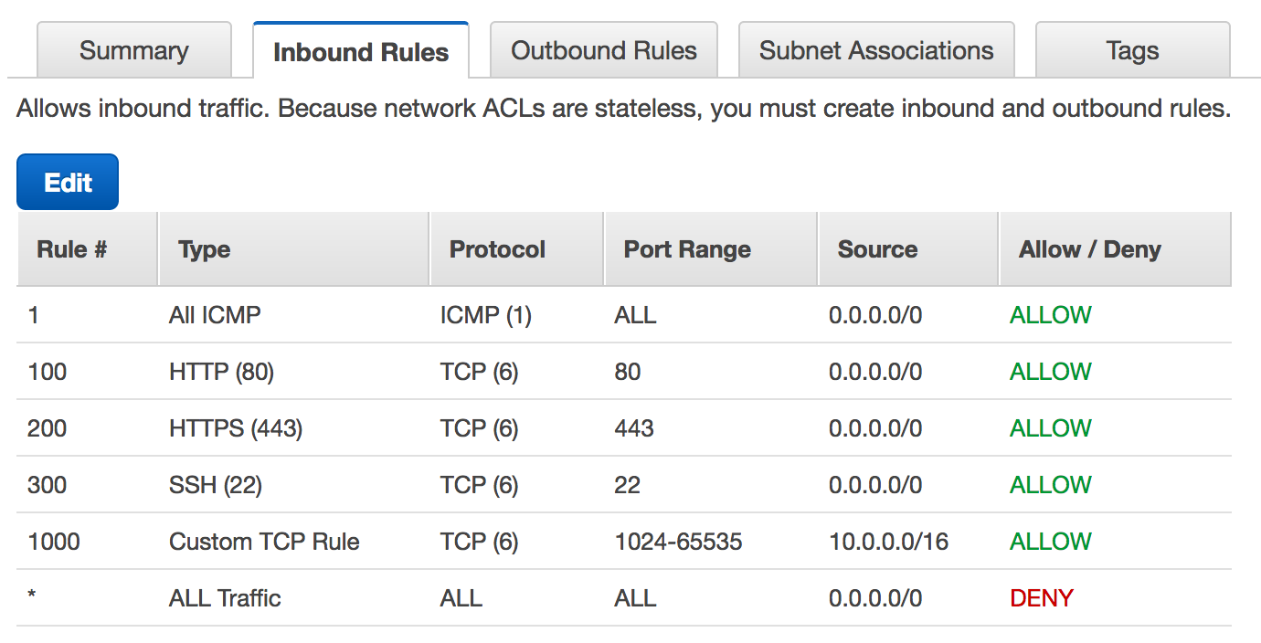

**Default NACL**

* The default network ACL is configured to allow all traffic to flow in and out of the subnets to which it is associated.

* Each network ACL also includes a rule whose rule number is an asterisk. This rule ensures that if a packet doesn't match any of the other numbered rules, it's denied. You can't modify or remove this rule.

* The following is an example default network ACL for a VPC

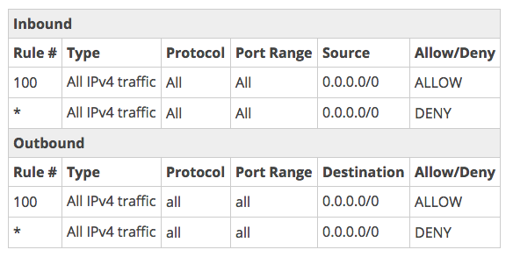

**NACL Rules**

* Rules are evaluated from lowest to highest based on "rule #".

* The first rule found that applies to the traffic type is immediately applied, regardless of any rules that come after it

* An NACL allows or denies traffic from entering a subnet. Once inside the subnet, other AWS resources (i.e EC2 instances) may have an additional layer of security (security groups).

**Security Groups**

* A security group acts as a virtual firewall for your instance to control inbound and outbound traffic.
* Security groups are very similar to NACLs in that they allow/deny traffic, Security groups act at the instance level, whereas NACLs work at subnet level.
* You can specify allow rules, but not deny rules.
* Security groups are stateful — so return traffic requests are allowed regardless of rules.
* Your VPC automatically comes with a default security group. Each EC2 instance that you launch in your VPC is automatically associated with the default security group if you don't specify a different security group when you launch the instance. You can't delete default Security Group.

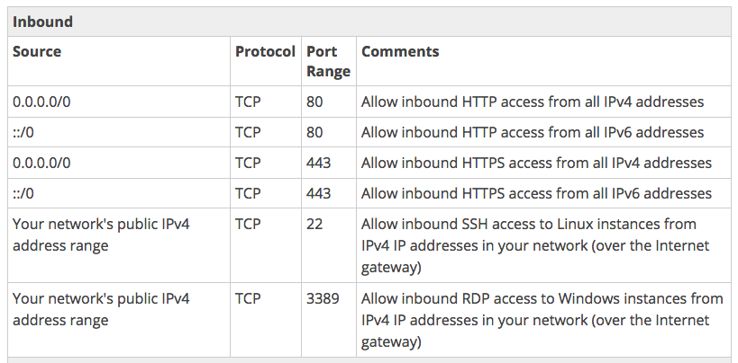

* You can't delete default Security Group.
* Security groups are VPC resources, hence different EC2 instances, in different Availability Zones, belonging to same VPC, can have same Security Groups applied to them.
* Changes to Security Groups take effect immediately
* Default SG, will have inbound rules allowing instances assigned the same SG to talk to one another and also all outbound traffic is allowed
* Custom (non-default) SG will have no inbound rules, basically all inbound traffic is denied by default and all outbound traffic is allowed by default

**NACL VS Security Groups**

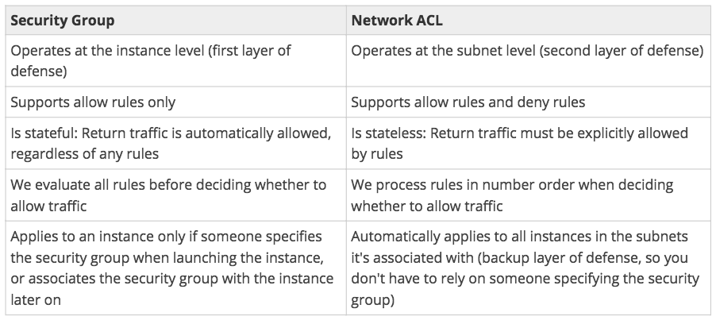

The following diagram illustrates the layers of security provided by security groups and network ACLs. For example, traffic from an Internet gateway is routed to the appropriate subnet using the routes in the routing table. The rules of the network ACL associated with the subnet control which traffic is allowed to the subnet. The rules of the security group associated with an instance control which traffic is allowed to the instance.

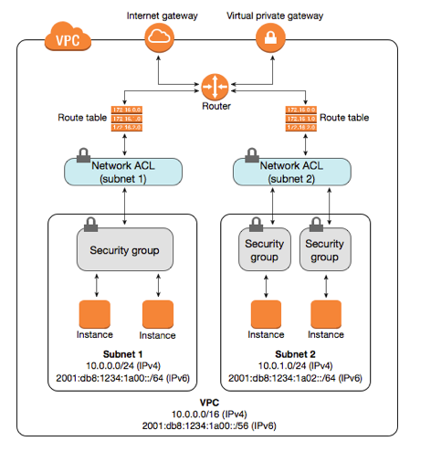

**NAT Instance**

* Nat instance is there to enable the private subnet instances to get to the internet
* Nat instance is configured in public subnet.
* Nat instance need to be assigned a Security group
* No traffic initiated from internet can access the private subnet
* Only admin SSH traffic can be allowed to the NAT instance

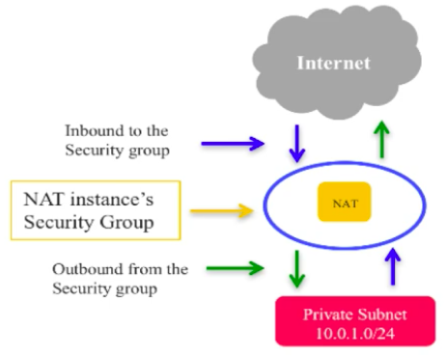

**NAT Gateway**

* Nat Gateway is there to enable the private subnet instances to get to the internet

* In Nat instance we launch the instance, we choose AMI and we are responsible for security.

* NAT Gateway on other hand, is a managed service provided by AWS, so we don't need to worry about what kind of instance, AMI and security.

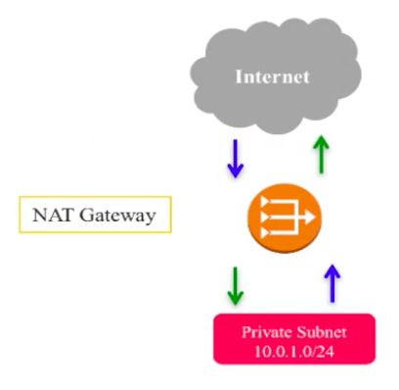

**VPC & Subnetting**

* When you create a VPC, you must specify an CIDR block for the VPC.
* The allowed block size is between a /16 netmask (65,536 IP addresses) and /28 netmask (16 IP addresses).
* AWS recommends to create a CIDR with 10.0.0.0/16 for future purpose
* The CIDR blocks of the subnets cannot overlap.
* <https://docs.aws.amazon.com/vpc/latest/userguide/VPC_Subnets.html>

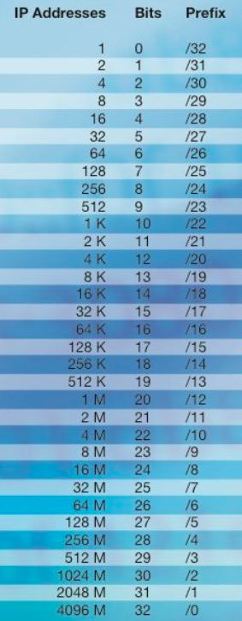

**LAB - VPC - Wizard**

* VPC wizard will simply help you do a lot of VPC creation functions

* Most of the components like route tables, NACL's, Security groups will be created and adjusted based on your configuration

* VPC created with VPC wizard will have
  + An IGW created and attached to VPC
  + By default, a Public subnet(IGW) associated with a custom route tables

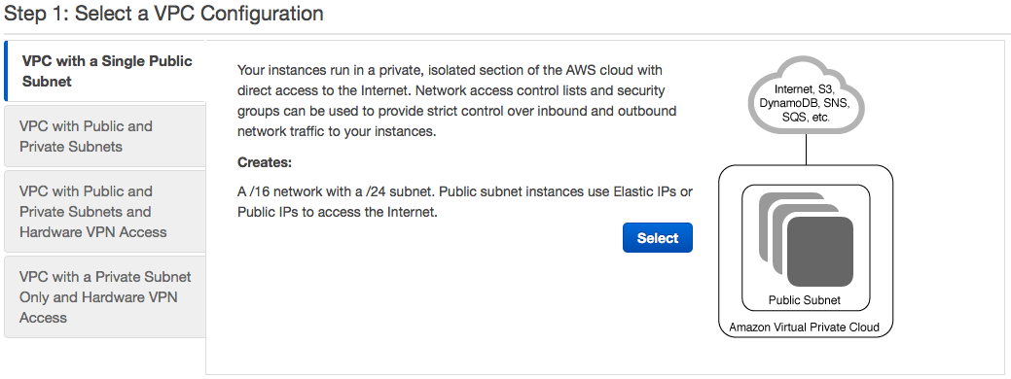

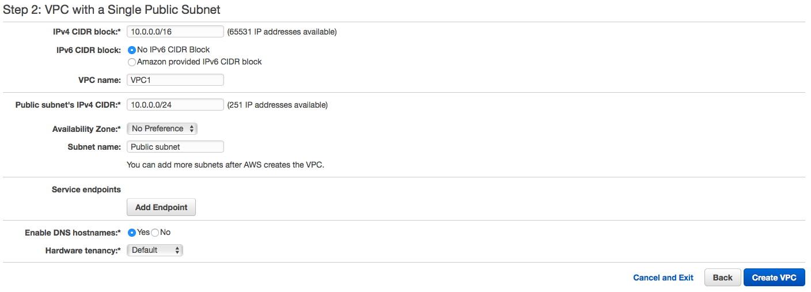

**Reserved IP’s**

* The first four IP addresses and the last IP address in each subnet CIDR block are not available for you to use, and cannot be assigned to an instance.

* For example, in a subnet with CIDR block 10.0.0.0/24, the following five IP addresses are reserved:
  + 10.0.0.0: Network address.
  + 10.0.0.1: Reserved by AWS for the VPC router.
  + 10.0.0.2: Reserved by AWS. The IP address of the [Amazon DNS Server](https://docs.aws.amazon.com/vpc/latest/userguide/VPC_DHCP_Options.html#AmazonDNS).
  + 10.0.0.3: Reserved by AWS for future use.
  + 10.0.0.255: Network broadcast address.

**LAB - Custom -VPC**

* In this lab, we are going to learn to build a VPC from scratch. We will not use the VPC wizard and will instead build each component of a VPC with a public and private subnet by hand.

* In this lab, we will be creating a virtual private cloud (VPC) containing an
  + Internet Gateway
  + Two route tables (One public and One private)
  + Two subnets (One public and One private) across two Availability Zones

* [Subnet Calculator](https://www.site24x7.com/tools/ipv4-subnetcalculator.html)

**Steps**

* VPC Dashboard → Left Side Pane Click on Your VPC's → Create VPC → Name (DL-VPC) → IPV4 CIDR (10.0.0.0/16) → Yes Create.
  + Actions that took place
    - No Subnets Were Created
    - No IGW is created
    - A main route table has been created Default NACL created with all inbound & outbound traffic allowed
    - Default SG created with all outbound traffic allowed and inbound to only that particular security group
* Now Lets Create
  + IGW
  + Route Tables
  + Subnets
* VPC Dashboard → Left Side Pane Click on Internet Gateways → Create Internet Gateway → Name (DL-IGW) → Attach DL-IGW to DL-VPC
* VPC Dashboard → Left Side Pane Click on Route Tables → Create Route Table → Name (DL-RT-PUB) → Ensure this RT is attached to DL-VPC
* VPC Dashboard → Left Side Pane Click on Route Tables → Create Route Table → Name (DL-RT-PVT) → Ensure this RT is attached to DL-VPC
* Select DL-RT-PUB → Click Routes → Edit → Add another Rule → Set Destination to 0.0.0.0/0 & Target to DL-IGW → Save

* VPC Dashboard → Left Side Pane Click on Subnets → Create Subnet → Name (DL-SN-1-PUB) → Choose DL-VPC → Set AZ to us-east-1a → Set IPV4 CIDR to 10.0.1.0/24 → Yes Create.

* VPC Dashboard → Left Side Pane Click on Subnets → Create Subnet → Name (DL-SN-2-PVT) → Choose DL-VPC → Set AZ to us-east-1b → Set IPV4 CIDR to 10.0.2.0/24 → Yes Create.

* We now need to associate our subnets with correct route tables.
  + Now return to Route Tables → Select DL-RT-PUB → Click Subnet Association → Edit → Select Public Subnet (DL-SN-1-PUB)→ Save
  + Now return to Route Tables → Select DL-RT-PVT → Click Subnet Association → Edit → Select Private Subnet (DL-SN-2-PVT)→ Save
* Create Custom Security Group to allow SSH access
  + VPC Dashboard → Security → Select Security Groups → Create SG(DL-SG-SSH) → Select DL-VPC → Create
  + Select DL-SG-SSH → Click Inbound Rules → Add Rules 22 and keep source to 0.0.0.0/0 → Save
* With our VPC setup and security layers created to ensure protection for any future EC2 instances, this lab is now complete.

**Assignment LAB - Custom -VPC**

* In this lab, we are going to learn to build a VPC from scratch. We will not use the VPC wizard and will instead build each component of a VPC with a public and private subnets by hand.

* In this lab, we will be creating a virtual private cloud (VPC) containing an
  + Internet Gateway
  + Two route tables (One public and One private)
  + Four subnets (Two public and Two private) across two Availability Zones
  + Public subnet 1 - Public subnet 2 - Private subnet 1 - Private subnet 2
  + Make sure High Availability network is setup
  + Enable DNS Hostnames
  + Make sure Public Subnets would get public IP assigned automatically

**Steps**

* Launch Amazon Linux 2 Instance in Public subnet 1 name it as - web server 1
* Launch Amazon Linux 2 Instance in Public subnet 2 name it as - web server 2
* Launch Amazon Linux 2 Instance in Private subnet 1 name it as - db server 1
* Launch Amazon Linux 2 Instance in Private subnet 2 name it as - db server 2
* Launch Amazon Linux 2 Instance in Private subnet 2 name it as - app server
* Launch Amazon Linux 2 Instance in Public subnet 1 name it as - db admin
* Allow SSH : 22 access to all the web servers from everywhere
* Allow SSH : 22 access to all the db servers from db admin only
* Allow HTTP : 80 to all the web servers access from everywhere
* Allow MySQL : 3306 to only web server 2 on db server 2
* Allow MySQL : 3306 to only app server on db server 1
* In future i might add new app servers, so create a Security Group that will allow database access to all app servers on port 3306 - for FUTURE
* Imagine there are 20 web servers in Public subnet 1, all the 20 web servers were having access to app server on port 8080, there was an attack on app server, now block all the traffic coming from 20 web servers to app server only on ports 8080 and 80

* To install nc use command

yum -y install nc

* nc -zv ip port
* nc -zv 18.216.11.27 22
* Use nc command to check whether port 22 is opened and connected on web server 2
* Use nc command to check whether port 22 is opened and connected on web server 1
* Use nc command to check whether port 3306 is opened and connected on web server 1
* Allow port 3306 on web server 1 and now check with nc command to see connection is opened and connected
* Allow port 8081 from on app server from only Public subnet 1 and now check with nc command to see connection is opened and connected

EC2 - Elastic Cloud Compute

* Amazon Elastic Compute Cloud (Amazon EC2) provides scalable computing capacity in the Amazon Web Services (AWS) cloud.

* Using Amazon EC2 eliminates your need to invest in hardware upfront, so you can develop and deploy applications faster.

* You can use Amazon EC2 to launch as many or as few virtual servers as you need, configure security and networking, and manage storage. Amazon EC2 enables you to scale up or down to handle changes in requirements or spikes in popularity, reducing your need to forecast traffic.
* I want you to picture EC2 like a computer, and the components that make it up like OS, CPU, HDD, NW, Firewall, RAM etc.

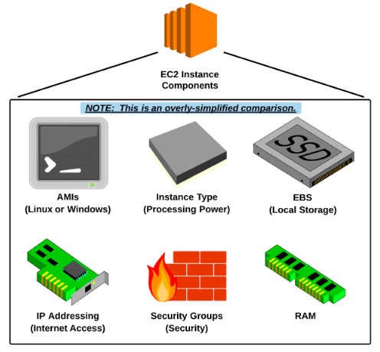

**EC2 - Features**

* Virtual computing environments, known as instances

* Preconfigured templates for your instances, known as Amazon Machine Images (AMIs), that package the bits you need for your server (including the OS and additional software)

* Various configurations of CPU, Memory, Storage and Networking capacity for your instances, known as Instance Types

* Secure login information for your instances using Key Pairs (AWS stores the public key and you store the private key in a secure place)

* Storage volumes for temporary data that's deleted when you stop or terminate your instance, known as Instance Store Volumes

* The instance store is ideal for temporary storage, because the data stored in instance store volumes is not persistent through instance stops, terminations or hardware failures.

* Persistent storage volumes for your data using Amazon Elastic Block Store, known as Amazon EBS volumes

* A firewall that enables you to specify the protocols, ports, and source IP ranges that can reach your instances using security groups

* Static IPv4 addresses for dynamic cloud computing, known as Elastic IP addresses
* Metadata, known as tags, that you can create and assign to your Amazon EC2 resources
* Virtual networks you can create that are logically isolated from the rest of the AWS cloud known as Virtual Private Clouds (VPCs)

**EC2 - Configuration**

* EC2 instances are designed to mimic traditional on-premise servers, but with the ability to be commissioned and decommissioned on-demand for easy scalability and elasticity.

* EC2 instances are primarily comprised of the follow components:
* Amazon Machine Image (AMI): The operating system (and other softwares).
* Instance Type: The hardware (computer power, ram, network bandwidth, etc).
* Network interface: (public, private, or elastic IP addresses).
* Storage: The instances "hard drive" (including two options).
* Elastic Block Store (EBS) - which is "network persistent storage".
* Instance Store - which is "ephemeral storage".

**EC2 Facts**

* A Security group must be assigned to an instance during the creation process.

* Each instance must be placed into an existing VPC, availability zone and subnet.

* Automated (bootstrapping) custom launch commands can be passed into the instance during launch via "user - data" scripts.

* "Tags" can be used to help name and organize provisioned instances.

* Key-pairs are used to manage login authentication.

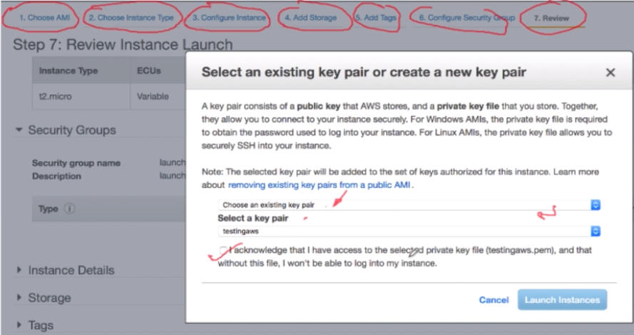

**AMI - Amazon Machine Images**

* Simplified Definition
* A preconfigured package (template) required to launch EC2 instances which includes:
* Operating system
* Software packages
* Other required settings (root storage type & virtualization type)

* AWS Definition
* An Amazon Machine Image (AMI) provides the information required to launch an instance, which is a virtual server in the cloud. You must specify a source AMI when you launch an instance. You can launch multiple instances from a single AMI when you need multiple instances with the same configuration.

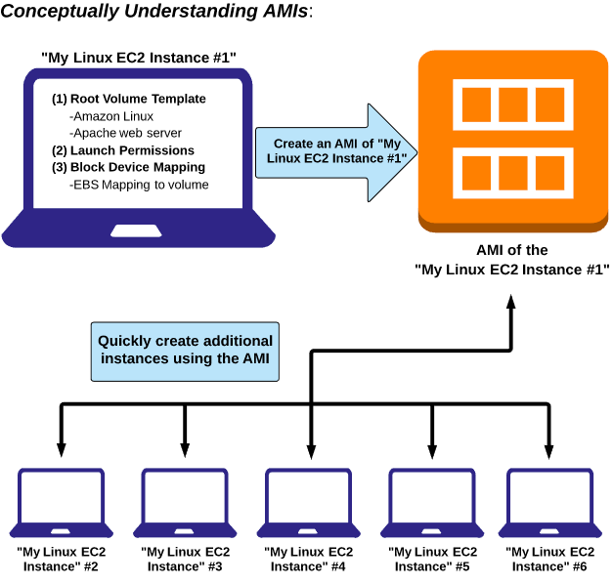

**AMI - Types**

* AMIs come in three main categories:
* **Community AMIs:**
* Free to use
* Generally with these AMIs you are just selecting the OS you want

* **AWS Marketplace AMIs:**
* Pay to use
* Generally comes packaged with additional, licensed software

* **My AMIs:**
* AMIs that you create yourself.

**Instance Types**

* When you launch an instance, the instance type that you specify determines the hardware of the host computer used for your instance.

* Each instance type offers different compute, memory, and storage capabilities and are grouped in instance families based on these capabilities.

* Instances types describe the "hardware" components that an EC2 instance will run on:
* Compute power (processor/vCPU)
* Memory (ram)
* Storage Option (hard drive)
* Network Performance (bandwidth)

* As an architect, it's important to use the proper instance type to handle your application's workload.

* There is a collection of preconfigured instance types that are grouped into families and types that you can choose from:

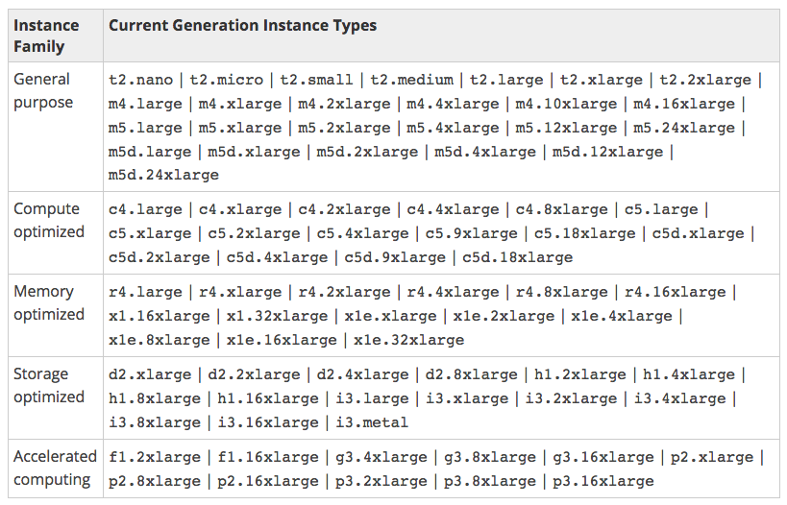

* **General Purpose Instances** - General purpose instances provide a balance of compute, memory, and networking resources, and can be used for a variety of workloads.
  + Websites and web applications, Small and medium databases, Development, build, test, and staging environments

* **Compute Optimized Instances** - Compute optimized instances are ideal for compute-bound applications that benefit from high-performance processors. They are well suited for the following applications:
  + High-performance web servers, High-performance computing (HPC), Media transcoding, Scientific modeling

* **Memory Optimized Instances** - Memory optimized instances are designed to deliver fast performance for workloads that process large data sets in memory.
  + High-performance, relational (MySQL) and NoSQL (MongoDB, Cassandra) databases.
  + In-memory databases using optimized data storage formats and analytics for business intelligence (for example, SAP HANA).

* **Storage Optimized Instances** - Storage optimized instances are designed for workloads that require high, sequential read and write access to very large data sets on local storage. They are optimized to deliver tens of thousands of low-latency, random I/O operations per second (IOPS) to applications.
  + Massive parallel processing (MPP) data warehouse
  + MapReduce and Hadoop distributed computing
  + Applications that require high-throughput access to large quantities of data
  + Log or data processing applications

* **Accelerated Computing Instances** - If you require high processing capability, you'll benefit from using accelerated computing instances, which provide access to hardware-based compute accelerators such as Graphics Processing Units (GPUs)

**EC2 - Purchase Options**

* Amazon EC2 is free to try

* There are four ways to pay for Amazon EC2 instances:
  + **On-Demand**
  + **Reserved Instances**
  + **Spot Instances**
  + **Dedicated Hosts**

* **On-Demand** purchasing allows you to choose any instance type you like and provision/terminate it any time (on-demand)
* Is the **most expensive** purchasing option.
* Is the **most flexible** purchasing option.
* You are only charged when the instance is **running**.
* You can provision/terminate an on-demand instance at anytime.

* **Reserved purchasing** allows you to purchase an instance for a **set time period** of **one (1) or three (3) years**.
* Reserved Instances provide you with a **significant price discount (up to 75%)** compared to On-Demand instance pricing.
* For applications that have steady state or **predictable usage**, Reserved Instances can provide significant savings compared to using On-Demand instances.
* Once you buy a reserved instance, you own it for the selected time period and are **responsible for the entire price** - regardless of how often you use it.

* **Spot pricing** is a way for you to "**bid**" on an instance type, only pay for and use that instance when the spot price is equal to or below your "bid" price.
* Amazon EC2 Spot instances allow you to request spare Amazon EC2 computing capacity for up to **90% off the On-Demand price**.
* This option allows Amazon to sell the **unused instances** at a substantial discount.
* **Spot prices fluctuate** based on supply and demand in the spot marketplace.
* When you have an active bid, an instance is **provisioned for you when the spot price is equal to or less than you bid price**.
* Use spot EC2 instance for "**non production applications**"

* **Dedicated Host** : An Amazon EC2 Dedicated Host is a physical server with EC2 instance capacity fully dedicated to your use.

* Dedicated Hosts can help you address compliance requirements and reduce costs by allowing you to use your existing server-bound software licenses.

* Dedicated Hosts allow you to use your existing software licenses, including Windows Server, Microsoft SQL Server, and so on.

* Price is High

**EC2 - IP Address**

* **Private IP Address**
  + All EC2 instances are automatically created with a PRIVATE IP address.
  + The private IP address is used for internal (inside the VPC) communication between instances.

* **Public IP Address**
* When creating an EC2 instance, you have the option to enable (or auto-assign) a public IP address.
* A public IP address is required if you want the EC2 instance to have direct communication with resources across the open internet, i.e if you want to directly SSH into the instance or have it directly serve web traffic.
* **Auto-assigning** is based on the setting for the **selected subnet** that you are provisioning the instance in.

* **Elastic IP Address (EIP)**
  + An Elastic IP address is a public IPv4 address, which is reachable from the internet.
  + You can mask the failure of an instance or software by rapidly remapping the address to another instance in your account (i.e detaching the EIP from one instance and attaching it to another).
  + Attaching an EIP to an instance will replace it's default public IP address for as long as it is attached.
  + A disassociated Elastic IP address remains allocated to your account until you explicitly release it.
  + To ensure efficient use of Elastic IP addresses, AWS imposes a small hourly charge if an Elastic IP address is not associated with a running instance
  + An Elastic IP address is for use in a specific region only.

**Instance Metadata**

* This is the data that you can use to configure or manage the instance
  + Examples are IP Address, DNS Hostnames, AMI-ID, Instance-ID etc

* Meta data can be only viewed from within the instance itself i.e you have to login in to the instance.

* Meta data is **not protected** by **encryption**, anyone that has access to the instance can view this data
  + curl<http://169.254.169.254/latest/meta-data/>     (displays AMI, instance type, etc)
  + curl [http://169.254.169.254/latest/meta-data/host-name/](http://169.254.169.254/latest/meta-data/host-name)     (displays hostname)

**Bootstrapping & User Data**

* **Bootstrapping**
  + Refers to a self-starting process i.e run set of commands without external input.
  + With EC2, we can bootstrap the instance (during the creation process) with custom commands (such as installing software packages, running updates and configuring other various settings).
* **User Data**
* Is data supplied by the user at instance launch in the form of a script to be executed during instance boot
* User data is limited to **16KB**
* User data is not protected by encryption, do not include passwords or sensitive data in your user data scripts
* You can change user data by stopping the instance first, then actions → Instance settings → View/Change user data

**User Data**

* **User-Data**
* A step/section during the EC2 instance creation process where you can include your own custom commands via a script (i.e a bash script)
* Here ia an example of a bash script that will automate the process of updating the yum package installer, install Apache Web Server and start the Apache service.

***#!/bin/bash***

***yum update -y***

***yum install httpd -y***

***service httpd start***

**View Metadata & Userdata**

* Viewing User-Data & Instance MetaData

* When logged into an EC2 instance, you can view the instance user-data used during creation or metadata by executing one of the following commands:
  + curl<http://169.254.169.254/latest/user-data/>      (displays bootstrapping commands)
  + curl<http://169.254.169.254/latest/meta-data/>     (displays AMI, instance type, etc)

**EC2 Storage**

* EC2 instances support two types for block level storage
  + Elastic Block Store - EBS (Persistent - Network attached drives)
  + Instance Store ( Ephemeral/temporary store)

* EC2 instances can be launched by choosing between AMIs backed by EC2 instance store and AMIs backed by EBS. However, **AWS recommends use of EBS backed AMIs**, because they launch faster and use persistent storage

**EBS - Elastic Block Store**

* Amazon Elastic Block Store ( Amazon EBS ) provides block level storage volumes for use with EC2 instances.

* EBS volumes are **highly available and reliable storage volumes** that can be attached to any running instance that is in the same Availability Zone. EBS volumes that are attached to an EC2 instance are exposed as storage volumes that persist independently from the life of the instance. With Amazon EBS, you pay only for what you use.

* Amazon EBS is recommended when data must be quickly accessible and requires long-term persistence. EBS volumes are particularly well-suited for use as the primary storage for file systems & databases.

**Root vs Additional Volumes**

* Every EC2 instance must have a root volume

* By default, EBS "root" volumes are set to be deleted when the instance is terminated. However, you can choose to have EBS volumes persist after termination.

* You can add additional EBS volumes to instance if needed

* Any additional volume can be attached or detached from instance at any time and is not deleted by default when instance is terminated

* An EBS volume can attach to a single EC2 Instance only at a time

* Both EBS Volume and EC2 instance MUST be in the same AZ

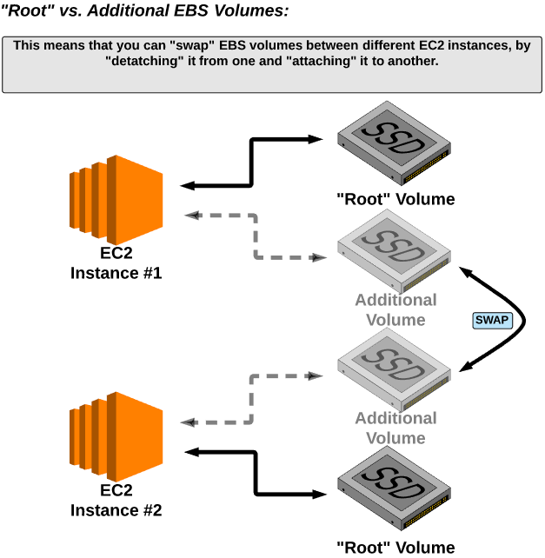

* EBS volumes are persistent, meaning that they can live beyond the life of the EC2 instance they are attached to.

* EBS volumes are network attached storage, meaning they can be attached/detached to or from various EC2 instances.

* However, they can only be attached to ONE EC2 instance at a time.

* EBS volumes have the benefit of being backed up into a snapshot - which can later be restored into a new EBS volume.

**EBS - Performance**

* EBS volumes measure input/output operations in IOPS:
* IOPS are input/output operations per second
* AWS measures IOPS in 256KB chunks (or smaller)
* For example, A 512KB operation would count as 2 IOPS

* The type of EBS volume you specify greatly influences the I/O performance (IOPS) your device

* It is important as architects to understand if your application requires more (or less) I/O when selecting an EBS volume type

**EBS - Types**

* **General Purpose SSD**
* Use for dev/test environments and smaller DB instances.
* Performance :  Max IOPS/Volume - 10,000
* Volume size of 1GiB to 16TiB

* **Provisioned IOPS SSD**
  + Used for mission critical applications that require high IOPS performance i.e Large database workloads.
  + Performance :  Max IOPS/Volume - 32,000
  + Volume size of 4GiB to 16TiB

* **Magnetic (Standard)**
* Magnetic volumes are backed by magnetic drives and are suited for workloads where data is accessed infrequently, and scenarios where low-cost storage for small volume sizes is important.
* Magnetic volumes can range in size from 1 GiB to 1 TiB.
* Magnetic volumes are Previous Generation Volumes.
* These volumes deliver approximately 100 IOPS on average

* **Throughput Optimized HDD**
* Low cost HDD volume designed for frequently accessed workloads
* Cannot be a boot volume, used for Data warehouses & Log processing
* Performance :  Max IOPS/Volume - 500
* Volume size of 500 GiB - 16 TiB

* **Cold HDD**
  + Lowest cost HDD volume designed for less frequently accessed workloads
  + Cannot be a boot volume, Scenarios where the lowest storage cost is important
  + Performance :  Max IOPS/Volume - 250
  + Volume size of 500 GiB - 16 TiB

* [**Comparison**](https://drive.google.com/open?id=15F5t-CKy13HQ1Gq8ChNlK9_Z3-aXq5eY)

**Instance Store**

* Instance store volumes are virtual devices whose underlying hardware is physically attached to the host computer that is running the instance.

* Instance store volumes are considered ephemeral data i.e temporary storage, meaning the data on the volumes only exists for the duration of the life of the instance.

* The EC2 instance attached with instance store can't be stopped, they can only be rebooted or terminated, and termination will erase the data.

|  |  |
| --- | --- |
| **Instance Store** | **Elastic Block Store** |
| Local to Instance | Network Attached Storage |
| Non-persistent storage | Persistent Storage |
| No Snapshot Support | Point in time Snapshot support |

**EC2 - Key Pairs**

* EC2 key pairs are two cryptographically secure keys that are used by AWS to authenticate a client when logging into and EC2 instance.

* To log in to your instance, you must create a key pair which consists of a **public key** and a **private key**, specify the name of the key pair when you launch the instance, and provide the private key when you connect to the instance.

* AWS stores the public key on the instance, and you are responsible for storing the private key.

**Login to EC2**

* To log into an EC2 instance, you must create and authenticate with a key pair

* Linux instances have no password, and you use a key pair to login (using SSH).
* With windows instances, you use a key pair to obtain the administrator password and then login using RDP (remote desktop protocol).
* During the creation process of an EC2 instance, you are required to either create a new key pair OR use an existing key pair - which will be tied to the instance.
* The private key is available for download and stored on your local device, however it is only available once (in the form of a .pem file).

**Snapshots**

**Snapshots**

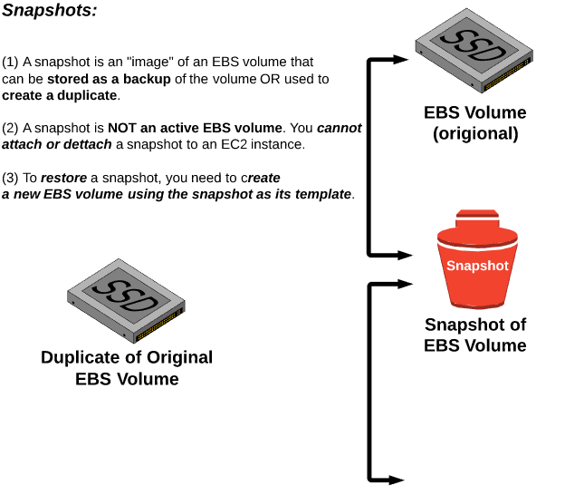

**EBS - Snapshot Properties**

* Snapshots are incremental in nature.

* A snapshot only stores the changes since the most recent snapshot, thus reducing costs (by only having to pay for storage for the "incremental changes" between snapshots).

* Frequent snapshots of your data increases **data durability** - so highly recommended.

* When a snapshot is being taken against the EBS volume, it can degrade performance, so snapshots should occur during non-peak load hours

* To take a consistent Snapshot of your **non-root** (**not the boot**) **EBS** Volume:
  + Pause file writes till you snapshot is complete
  + If you can't pause file writes, you need to unmount (detach) the volume from instance, take the snapshot, then re mount the volume to ensure a consistent and complete snapshot

* To create a snapshot for a **root** (**boot**) **EBS** Volume, you should stop the instance first then take the snapshot.
  + Be careful if you have instance store volumes on EC2 Instance , their data will be lost once you stop the instance.

**EC2 - Placement Groups**

* A placement group is a cluster of instances within the same availability zone.

* Used for applications that require an extremely low latency networks between them.

* AWS attempts to place all the instances as close as physically possible in the data center to reduce latency.

* Instances within a placement group have a low-latency, 10 Gbps network connection between them.

**Troubleshooting Placement Groups**

* If an instance in a placement group is stopped, once it is started again it will continue to be a member of the placement group.

* It is suggested to launch all the required instances within a placement group in a single request, and that the same instance type is used for all instances within the placement group.

* It is possible, if more instances are added at a later time to the placement group OR if a placement group instance is stopped and started again, to receive an "insufficient capacity error". Resolve the capacity error by stopping all instances in the member group and attempting to start them again.

**Facts of placement groups**

* Instances not originally launched/created in the placement group cannot be moved into the placement group.

* Placement groups cannot be merged together.

* A placement group cannot span multiple availability zones.

* Placement group names must be unique within your own AWS account.

* Instances must have 10 gigabit network speeds in order to take advantage of placement groups (proper instance type).

**Elastic File System**

* EFS is a storage option for EC2 that allows for a scalable storage option.

* EFS storage capacity is elastic.
* The storage capacity will increase and decrease as you add or remove files.

* EFS is fully managed (no maintenance required).

* Supports the Network File system version 4.0 and 4.1 (NFSv4) protocols when mounting.

* Best performance when using an EC2 AMI with Linux kernel 4.0 or newer & **EFS is not supported on Windows instances**.

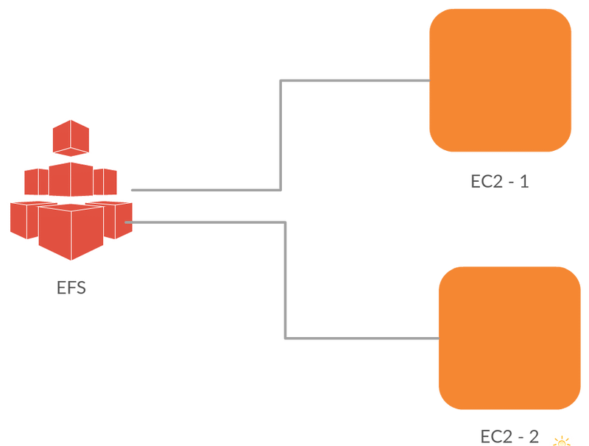

**Benefits Of EFS**

* The EFS file system can be accessed by one (or more) EC2 instances at the same time
* Shared file access across all your EC2 instances.
* Application that span multiple EC2 instances can access the same data.

* EFS file system can be mounted to on-premise servers ( when connected to your VPC via AWS Direct Connect).
* This allows you to migrate data from on-premise servers to EFS and/or use it as a backup solution.

* EFS can scale to petabytes in size, while maintaining low-latency and high levels of throughput.

* You pay only for the amount of storage you are using.

**Lambda Essentials**

* Lambda is a "**serverless**" computing platform.

* Serverless means that you can run code without provisioning or managing servers.
* So if you want to run the code, you don't have to sign up an EC2 instance and install software, you can just create a "**lambda function**", drop your code in it, and execute it .

* Lambda executes your code only when needed and scales automatically, from a few requests per day to thousands per second.

* You pay only for the compute time you consume - there is no charge when your code is not running.

* By default, it is highly available, fault-tolerant, scalable, elastic and cost efficient.

* Lambda integrates with many other AWS services. Current supported languages include
* Node.js
* Java
* C#
* Python
* Go

**NOTE**: For CSA, you don't need to know how to use lambda, but you need to know what it is.

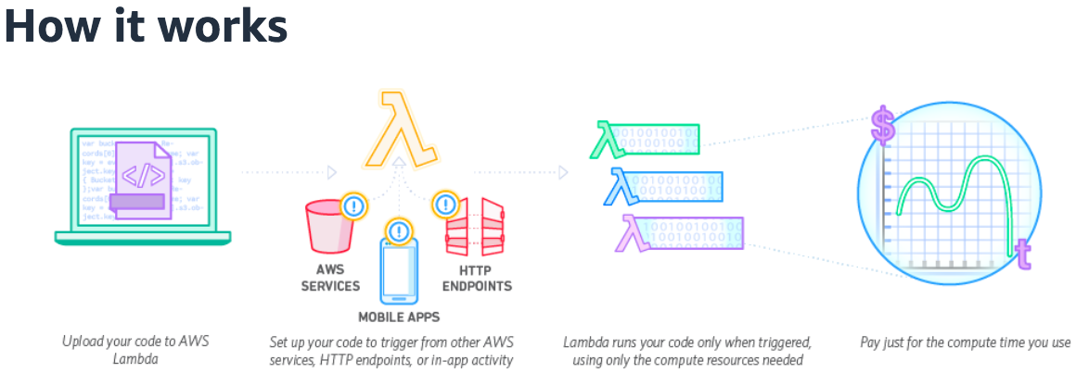

**EC2 - Labs**

**LAB - On premise Server Setup**

> Hypervisor

-> Server Components

> CPU

> RAM

> Storage

> Network

-> Install an Hypervisor i.e Virtual Box

> Setup VirtualBox

> Google Download VirtualBox

> Download the exe and just go with typical .exe installation

-> Steps to setup instance on on-premise

> Download the OS image file { Centos 7 } { Done }

> Choose CPU & RAM { Done }

> Network & IP allocation { Done }

> Storage { Done }

> Tags { Done }

> Security Groups

> Private key to authenticate { usernames & password }

**LAB Assignment**

> Create two instances in public subnet as pub1 and pub2

> Create one instance in private subnet as pvt1

> Create instance in Virtual Box

> Allow all the instances of public subnet to connect to pvt1 instance i.e SSH

> Use Virtualbox instance to login to any EC2 Instance, so basically VirtualBox instance is the centralized authority to login to public instances, coz anyway there is no option to connect to private instances from outside network

**LAB - Windows Instance**

> Launch Windows instance with AMI :: Microsoft Windows Server 2016 Base in public subnet

> Use RDP to connect to win instance

> Launch a private instance with Amazon Linux 2

> Use windows instance to connect to Amazon Linux 2

**LAB - Windows Instance - Attach Additional Volume**

> Launch Windows instance with AMI :: Microsoft Windows Server 2016 Base in public subnet

> Use RDP to connect to win instance

> Now create a 25 GB Additional volume and attach the volume to current running win instance as "D" Drive

> Create few files in D drive { Hello.txt, file.txt and sample.txt }

> Detach the additional volume { Now you shouldn't be seeing the drive "D" and text files }

> Now attach the additional volume back to verify the files

> On Win Server -> Click Start Menu -> CLick Server Manager -> File & Storage Services -> Under Volumes -> select Disks -> Rt click the volume and bring Online -> Right click -> New VOlume -> next and go through the setup at the end Assign the Drive letter

> Now in My Computer you can see D drive

**LAB - Linux Instance - Attach Additional Volume**

> Launch Linux instance with AMI :: Amazon Linux 2 in public subnet

> Use SSH to connect to win instance

> Now create a 15 GB Additional volume and attach the volume to current running linux instance

Steps to attach the Volumes to Linux Instance

> To check available disks using the following commands

# lsblk

# sudo fdisk -l

# df -h

> Format the volume to ext4 filesystem

     # sudo mkfs -t ext4 /dev/xvdf

    > Create a directory of your choice to mount our new ext4 volume. I am using the name myvol

     # sudo mkdir /myvol

     # sudo mount /dev/xvdf /myvol

    > Confirm with the df -h command

     # df -h

    > Create few files in /myvol

LAB - Provisioning Linux Instance

* This Lab provides a hands-on to creating an EC2 instance, which includes
  + choosing an AMI
  + Instance type
  + Determining instance details such as VPCs, subnets, and Availability zones
  + Creating security groups(22) and key pairs
  + Logging into Instance

* Before you begin
* Complete the steps in earlier lab(VPC) and prepare Your VPC

* EC2 Dashboard → Click on **Launch Instance**
  + **Choose AMI** (Amazon Linux AMI)
  + **Choose Instance Type** → **t2.micro** → **Next**: Configure Instance Details
  + **Configure Instance Details** → No of Instances  → Network: Choose **DL-VPC** → Subnet: Choose Public Subnet → Auto-assign Public IP: Enable → Next: Add Storage
  + **Add Storage** → 8GB → Next: Add Tags
  + **Add Tags** → Name : WebServer → Next: Configure Security Group
  + **Configure Security Group** → Select our existing Security Group **DL-SG-SSH** → Review & Launch
  + **Review** → Launch → Create Key Pair → Launch Instance

**Instance States**

* EC2 Dashboard → **Select Instance**
  + **Actions → Instance State**
    - Try **Stop** { Public DNS goes away & Private DNS stays }
      * Start again
    - Try **Reboot** { Public DNS stays }
    - Try **Terminate**

* **NOTE : For Elastic IP the behavior is different**

**Assignment - LAB**

* Launch two EC2 Instances in a custom VPC, ibmvpc. Each in different VPC.
  + VPC CIDR is 10.0.0.0/16
* The first EC2 instance, web-server, will be launched in us-east-1a AZ, and will be in subnet 10.0.0.0/24. Will be allocated a new custom Security Group, WebSG and subnet will be allocated a new custom NACL, WebNACL.
* The second EC2 instance, db-server, will be launched in us-east-1a AZ, and will be in subnet 10.0.1.0/24. Will be allocated a new custom Security Group, DBSG and subnet will be allocated a new custom NACL, DBNACL.
* You need to allow ICMP ping between the two EC2 instances, ensure you do all required routing, security configurations to ensure the ICMP ping is successful.
* Now ssh into DB Server from Web Server.

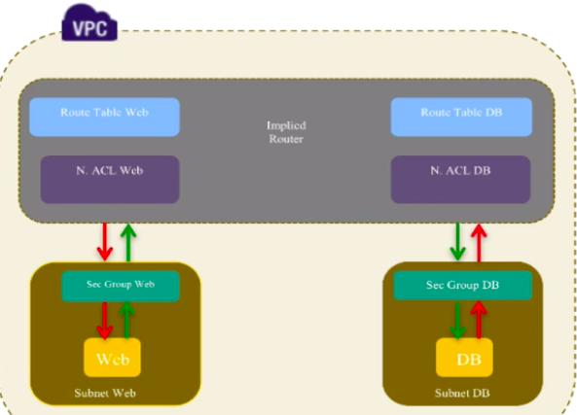

**LAB - Windows Instance**

* This Lab provides a hands-on to creating an EC2 instance, which includes
  + choosing an AMI (**Microsoft Windows Server 2012 R2 Base**)
  + Instance type
  + Determining instance details such as VPCs, subnets, and Availability zones
  + Creating security groups(3389) and key pairs
  + Logging into Instance

* Before you begin
* Complete the steps in earlier lab(VPC) and prepare Your VPC

**Steps**

* EC2 Dashboard → Click on **Launch Instance**
  + **Choose AMI** (**Microsoft Windows Server 2012 R2 Base**)
  + **Choose Instance Type** → **t2.micro** → **Next**: Configure Instance Details
  + **Configure Instance Details** → No of Instances  → Network: Choose **DL-VPC** → Subnet: Choose Public Subnet → Auto-assign Public IP: Enable → Next: Add Storage
  + **Add Storage** → 30GB → Next: Add Tags
  + **Add Tags** → Name : WinServer → Next: Configure Security Group
  + **Configure Security Group** → Create a new security group **DL-SG-RDP (Port 3389)** → Review & Launch
  + **Review** → Launch → Create Key Pair → Launch Instance
  + Connect → Download RDP file → To get password, load pem file

**Assignment Lab**

* This Lab provides a hands-on to security groups
* Build a VPC with following requirement
  + VPC CIDR - 10.0.0.0/16
  + Three Subnetworks
    - DEV1 - 10.0.1.0/24 { Public Subnet }
    - DEV2 - 10.0.2.0/24 { Private Subnet }
    - FIN1 - 10.0.3.0/24 { Private Subnet }
  + Launch two instances in Dev Subnets - Dev1 & Dev2
  + Launch an instance in FIN Subnet - FIN1
  + Case 1
    - Both the instances Dev1 & Dev2  should be able to connect to FIN1
  + Case 2
    - Only Dev2 should be able to connect to FIN1

**Assignment Lab**

* Build a VPC with following requirement
  + VPC CIDR - 10.0.0.0/16
  + Two Subnetworks
    - DEV1 - 10.0.1.0/24 { Public Subnet }
    - FIN1 - 10.0.3.0/24 { Private Subnet }
  + Launch windows instance in Dev1 Subnet
  + Launch linux instance in FIN1 Subnet
  + Connect(SSH) from windows to linux i.e DEV1 to FIN1

**LAB - Attach Additional Volumes - Windows**

* This Lab provides a hands-on to attaching additional volumes to an EC2 instance, which includes
  + Creating a new volume
  + Attaching the volume to instance

* Before you begin
* Make sure you have a instance setup and running

**Steps**

* EC2 Dashboard → Click on **Volumes**
  + **Create Volume** → **Choose Volume Type** → **General Purpose SSD(GP2)**
  + **Storage** **Size** → 20GB → Next: Add Tags
  + **AZ**: Choose based on the instance
  + **Snapshot ID** → LeaveEmpty  → **Create Volume**
  + **Select Volume Created** → Actions → Attach Volume → Choose Instance → Attach
  + Login to win server → Click Server Manager → Servers → Volumes → Disks → Choose Offline Disk → Right click → Bring Online → Yes → Select & Right Click → New Volume → Next → Next → Next → Create
  + To Detach volume → EC2 Dashboard → Volumes → Select & Right Click → Detach Volume

**LAB - Attach Additional Volumes - Linux**

* This Lab provides a hands-on to attaching additional volumes to an EC2 instance, which includes
  + Creating a new volume
  + Attaching the volume to instance

* Before you begin
* Make sure you have a instance setup and running

**Steps**

* To check available disks using the following commands
  + # lsblk
  + # sudo fdisk -l
  + # df -h
* EC2 Dashboard → Click on **Volumes**
  + **Create Volume** → **Choose Volume Type** → **General Purpose SSD(GP2)**
  + **Storage** **Size** → 20GB → Next: Add Tags
  + **AZ**: Choose based on the instance
  + **Snapshot ID** → LeaveEmpty  → **Create Volume**
  + **Select Volume Created** → Actions → Attach Volume → Choose Instance → Attach

* Now let's mount the volume
  + **Format the volume to ext4 filesystem**
    - **# sudo mkfs -t ext4 /dev/xvdf**

* **Create a directory of your choice to mount our new ext4 volume. I am using the name myvol**
  + **# sudo mkdir /myvol**
  + **# sudo mount /dev/xvdf /myvol**

* **Confirm with the df -h command**
* **# df -h**

LAB - Snapshots

* This Lab provides a hands-on to create a Snapshot from an existing volume to an EC2 instance, which includes
  + Creating a snapshot from a volume
  + Use the snapshot to create additional volumes
  + Attach the volumes to the EC2 Instance
  + Log into Instance to check the attached volumes

* Before you begin
* Make sure you have a instance setup and running with apache server with [food website](https://github.com/ravi2krishna/food)

**Steps**

* EC2 Dashboard → Launch Instance With Apache Installed { name - web }
* Now create a Snapshot for the web instance
* EC2 Dashboard → Click on **Volumes { web }**
  + **Select Volume { web }** → **Actions** → **Create Snapshot**
  + **EC2 Dashboard → Snapshots → We have a new snapshot**
  + EC2 Dashboard → Click on **Volumes { web }**

* **To Create the volume from Snapshot**
* Select the Instance → Copy Root device { **/dev/xvda** } **→** Check **AZ**
* Now terminate the **web** instance and launch new instance **restore-web** and access the **IP of restore-web**, no page is displayed

* Now create a volume from Snapshot → Snapshots → Actions → Create Volume, now in volumes section we can see the available volume and name it as web-volume
* Now stop the instance **restore-web** and **detach** it's volume
* Now attach the new volume created from snapshot to **restore-web** and Device attachment { **/dev/xvda** }
* If you check the IP of server apache is up and running

**Assignment Lab**

* Download wordpress tar file into additional volume i.e myvolume

* Now i need the same wordpress site in another instance which should serve from a new additional volume which should be a backup.

LAB - EC2 Backup Solutions with AMI's

* This Lab provides a hands-on to Taking Snapshots.

* In this lab, you will
  + Prepare the VPC
  + Create a new EC2 instance
  + Make some changes to the EC2 instance { setup apache server }
  + We then create an AMI based upon this image
  + Launch a new instance using this AMI

**Steps**

* EC2 Dashboard → **Launch Instance** → Setup apache Server
  + sudo yum -y install httpd
  + sudo systemctl **start** httpd && sudo systemctl **enable** httpd
  + sudo vi /var/www/html/index.html
  + **Creating AMI from instance**
    - Select Above Instance → Actions → Image → Create Image → No Reboot → Create Image { now image is created in Images Section and you can view it in AMI's }
  + **Create Instance(backup) from AMI**
    - Images → AMI → Select AMI → Launch → Repeat { Here already app is installed}

* **NOTE**: When we created an AMI from instance, by default you will get the Snapshot created for that instance and the snapshot is attached to the AMI, to delete the snapshot you need to Deregister the AMI then delete the snapshot.

LAB - Copy AMI to other regions

* This Lab provides a hands-on to Taking AMI's & Snapshots.
* Transfer AMI to other regions for HA

* In this lab, you will
  + Prepare the VPC
  + Create a new EC2 instance - Oregon Region
  + Make some changes to the EC2 instance { setup apache server }
  + We then create an AMI based upon this image
  + Launch a new instance using this AMI in another regions - Ohio

LAB - EFS

* This Lab provides a hands-on to EFS

* In this lab, you will
  + Prepare the VPC
  + Create a two EC2 instance
  + Make some changes to the EC2 instance
  + Create File system in created VPC

* From the below image we can see there are two EC2 instances, and in between them is **EFS**, where two instances are sharing the data.



**Steps**

* Services → **Storage → EFS** → Create File System → Select VPC → Launch it in Public Subnets → Next → Name(EFSTest) → Keep Default → Next → Create

* **Creating EC2 Instances**
* Launch Instance → Choose Amazon Linux AMI → T2 micro → Select LabVPC → Select Public subnet, as this is where the **EFS** is present → Auto Assign IP → Enable → Everything else keep default → Launch
* Launch Instance → Choose Amazon Linux AMI → T2 micro → Select LabVPC → Select Public subnet, as this is where the EFS is there → Auto Assign IP → Enable → Everything else keep default → Launch

* **Mounting EFS**
  + Goto EFS → Click EC2 mount instructions

LAB - Accessing Instances User Data & Metadata

* In this lab, you will learn how to discover the **userdata** and **metadata** of an instance.

* The user data contains any custom commands used to bootstrap the instance, while the metadata contains information such as the AMI, instance type, and more.

* Launch Instance → Choose VPC → Subnet → Auto Assign IP(Enable) → Advanced → User Data → SG Allow 22 → Review & Launch

#!/bin/bash

yum install -y git

yum install -y httpd

service httpd start

git clone<https://github.com/ravi2krishna/food.git> /var/www/html

* Login to the Instance:
  + User-data:
    - curl<http://169.254.169.254/latest/user-data/>
* Metadata:
  + curl<http://169.254.169.254/latest/meta-data/>
  + curl<http://169.254.169.254/latest/meta-data/instance-id>

High Availability & Fault Tolerance

Earlier VPC Setup



* Now this is how the VPC with **High availability** and **Fault tolerance** looks

* Now the difference b/w both the diagrams is, now we have introduced something called ELB and Auto Scaling Group.

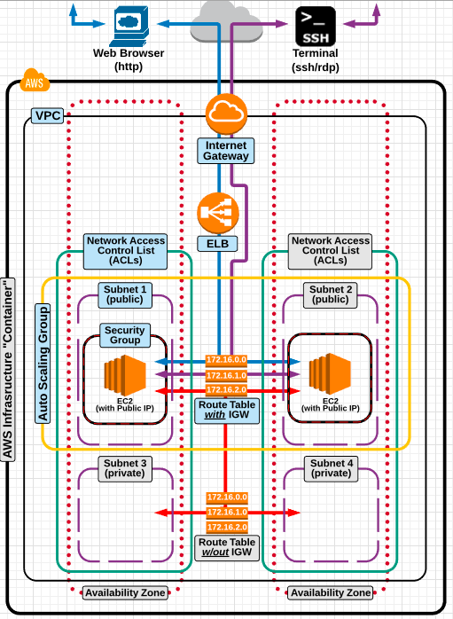

**Elastic Load Balancer**

* Load balancing (as a concept) is a common method used for distributing incoming traffic among servers.

* An Elastic Load Balancer is an EC2 service that automates the process of distributing incoming traffic (evenly) to all the instances that are associated with the ELB.

* An elastic load balancer can load balance traffic to multiple EC2 instances located across multiple availability zones.

* An ELB has its own DNS record set that allows for direct access from the open internet access.

* **Elastic load balancing should be paired with auto scaling to enhance high availability and fault tolerance.**

* ELB's will automatically stop serving traffic to an instance that becomes unhealthy (via health checks).

* An ELB improves the distribution of workloads across multiple servers ensuring that no one server is overworked, which could degrade performance.

**Types Of ELB’s**

* Earlier we had only two types of Load balancers, but now it supports three types of load balancers:
  + Classic Load Balancers
  + Application Load Balancers
  + Network Load Balancers [ NEW ]

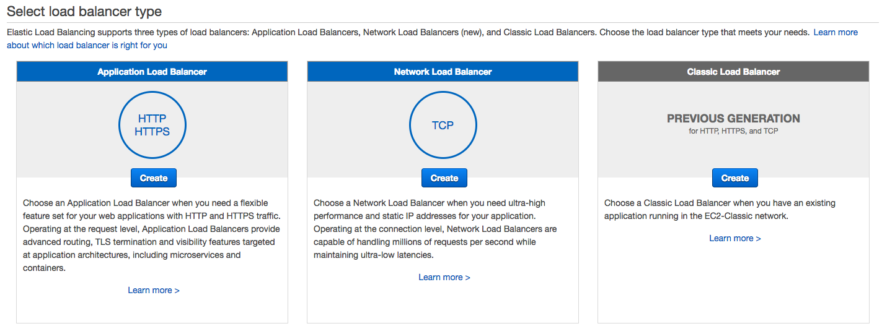

**Classic Load Balancer**

* A "classic" elastic load balancer is designed for simple balancing of traffic to multiple EC2 instances.

* There are no granular routings "rules" - all instances get routed to evenly, and no special request routing can be made based on specific content request from the user.

* Classic load balancing is best used when all instances (that are being served traffic) contain the same data.

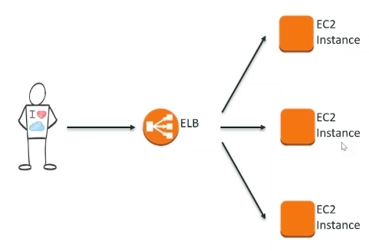

**Application Load Balancer**

* An "application" elastic load balancer is designed for **complex** balancing of traffic to multiple EC2 instances using **Content-based "rules"**.

* Application Load Balancer provides advanced request routing targeted at the delivery of modern application architectures.

* Application Load Balancer routes traffic to targets within Amazon Virtual Private Cloud (Amazon VPC) based on the content of the request.

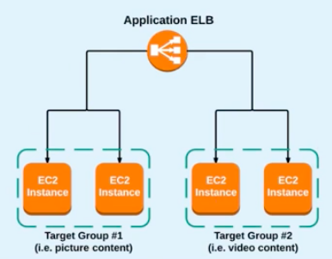

**Network Load Balancer**

* Network Load Balancer is best suited for load balancing of TCP traffic where extreme performance is required.

* Network Load Balancer is capable of handling millions of requests per second while maintaining ultra-low latencies.

* Network Load Balancer is optimized to handle sudden and volatile traffic patterns while using a single static IP address.



LAB - Classic Load Balancer

* This Lab provides a hands-on to Classic Load Balancers. You'll create a load balancer that receives public HTTP traffic and sends it to your EC2 instances.

* Before you begin
* Complete the steps in Prepare Your VPC and EC2 Instances
* Launch the EC2 instances(2) that you plan to register with your load balancer. Ensure that the security groups for these instances allow HTTP access on port 80.
* Install a web server, such as Apache on each instance, and verify that the browser displays the food website hosted on the instances.

**Steps**

* EC2 Dashboard → Click on **Load Balancers**
  + **Define Load Balancer** : Choose **Classic Load Balancer** → LB Name : **my-lb** → Create LB Inside : **Choose VPC** → Listener Config 80 → Available Subnets : Add Public Subnet Where EC2 launched
  + **Assign Security Group** → Next Assign Sec Group (80) → Next → Configure Health Check → Add EC2 Instances → Select two instances → Next - Add tags → Review & Create → Create
  + **Configure Security Settings**
  + **Configure Health Check** → port, ping path
  + **Add EC2 Instances** → Add Two Instances that are running
  + **Add Tags**
  + **Review**

LAB - Network Load Balancer

* This Lab provides a hands-on to Network Load Balancers. You'll create a load balancer that receives public HTTP traffic and sends it to your EC2 instances.

* Before you begin
* Complete the steps in Prepare Your VPC and EC2 Instances
* Launch the EC2 instances(2) that you plan to register with your load balancer. Ensure that the security groups for these instances allow HTTP access on port 80.
* Install a web server, such as Apache on each instance, and verify that the browser displays the food website hosted on the instances.

**Steps**

* EC2 Dashboard → Click on **Load Balancers**
  + **Define Load Balancer** : Choose **Network Load Balancer** → LB Name : **nw-lb** → Scheme Select **Internet Facing** → **Choose VPC** & Select One AZ with public subnet → Configure Routing → Target Group (testGroup) → Protocol : TCP → Port : 80 → Target type : Instance ( you can choose ip as well if you have dedicated ip setup) → Next Register Targets → Choose the Instances and Add to Register → Next Review → Create

LAB - Application Load Balancer

* This Lab provides a hands-on to Application Load Balancers. You'll create a load balancer that receives public HTTP traffic and sends it to your EC2 instances based on the content.

* Before you begin
* Complete the steps in Prepare Your VPC and EC2 Instances.
* Launch 4 EC2 instances where 2 instances (pic 1 & pic 2) are in same zone(1a) with picture content and othe 2 instances (video 1 & video 2) in different zone(1b) with video content

**Steps**

* Instance - pic 1 - instance - /var/www/html/picture.html {Content coming from Picture 1}
* Instance - pic 2 - instance - /var/www/html/picture.html {Content coming from Picture 2}
* Instance - vid 1 - instance - /var/www/html/video.html {Content coming from Video 1}
* Instance - vid 2 - instance - /var/www/html/video.html {Content coming from Video 2}
* On all four instances create a file called health.html
* Now let's create target groups then will create Load balancer and will associate target groups
* Create Target Group → Target Group Name (**Pictures**) → Health : health.html
* Create Target Group → Target Group Name (**Videos**) → Health : health.html
* Now i need to register ec2 instances to their specific target groups
* Select the Pictures Target → Select Targets tab → Edit → Select Pictures instances Click Add to registered → Save
* Select the Videos Target → Select Targets tab → Edit → Select Video instances Click Add to registered → Save

* Now click create load balancer → Select Application Load balancer → Name : AppLB → Internet Facing → ipv4 → Listeners port 80 → Select proper VPC where instances are launched → Select AZ's/Subnets where instances are launched → Configure Security Settings to allow port 80 → Configure Routing → Select Existing target group → Choose Pictures → Register Targets → Review → Create → It's provisioning → Give it some time it will be active
* Copy the DNS name of load balancer and check in browser, now it's going to the Pictures target coz by default i set it to Pictures
* Now let's see how i can route the traffic based on request type
* Now select Pictures target group → Description → I can see it's associated to AppLB
* Now select Videos target group → Description → It's not associated to AppLB,  why is that ?? while creating an AppLB i should associate it to at least one target group
* Now videos target group or any additional target group will not be associated with elastic load balancer until i create content rules that point traffic to video group

* Now let's go back to the Elastic Load balancer select it → Listeners tab → the default action is forward to pictures → Now will create rules that is going to take traffic based on path and it will tell the App ELB where to route traffic.
* Click View/Edit rules → This is the default rule you cannot change it, but you can add new rules, Upper tab besides Rules click add(+) → Insert Rule → Add condition select path is → type: *picture* → forward to Pictures Target group → Save
* Click Insert Rule → Add condition select path is → type: *video* → forward to Videos Target Group → Save
* Go back and in browser give the DNS name of load balancer with path picture.html
  + [http://applb-757660712.us-east-1.elb.amazonaws.com/picture.html](http://applb-757660712.us-east-1.elb.amazonaws.com/video.html)

* Go back and in browser give the DNS name of load balancer with path video.html
  + <http://applb-757660712.us-east-1.elb.amazonaws.com/video.html>

**Auto Scaling**



* Now this was how the VPC with High availability and Fault tolerance looks

* Now the difference b/w both the diagrams is, now we have introduced something called ELB and Auto Scaling Group.

* Every server has limitation of resources, say this server has 8GB and 2 CPU's now it can serve services for 100 clients

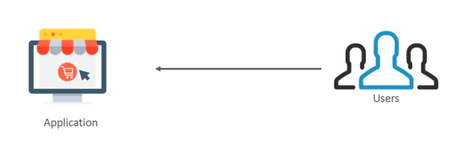

* But if more then 100 clients come then this server cannot handle those extra requests and becomes slow or unstable.
* Now imagine your server got huge traffic may be due to promotional offers.

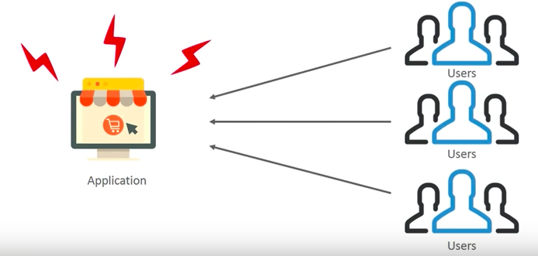

* Now the server is overburden, so you will deploy more servers and distribute the traffic evenly between them, now this thing is a manual task and manual things are **BIG NO** in IT world, So AWS has provided a service **Auto Scaling** to do this kind of activities **automatically**.

* What Auto Scaling does is, it analyzes the load coming in and deploys the new servers to meet that demand, say around 300 people are coming in then, it will spin up new servers and set the application for us automatically.

* Now we need to have the exact configuration of server 1 to be replicated across server 2 and server 3 as well.

* So what happens is in Auto Scaling Service is, you will attach your **AMI**, and using that AMI it deploys more servers.

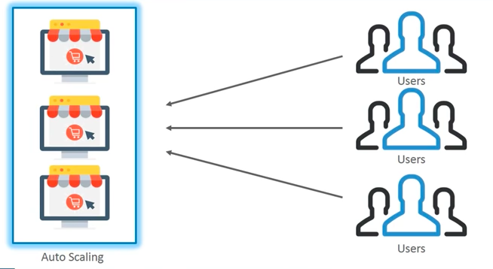

* Auto Scaling is service (and method) provided by AWS that automates the process of increasing or decreasing the instances on-demand for your application.

* Auto Scaling will increase or decrease the amount of instances based on chosen **Cloudwatch** metrics.

* For example: if your application's demand increases unexpectedly, auto scaling can automatically scale up (add instance) to meet the demand and terminate instances when the demand decreases. This is known as **ELASTICITY** in AWS environment

Auto Scaling has two main components:

* **Launch Configuration**:
* The EC2 "template" used when the auto scaling group needs to provision an additional instance (i.e AMI, instance type, user-data, storage, security groups, etc)
* **Auto Scaling Group**:
* All the rules and settings that govern if/when an EC2 instance is automatically provisioned or terminated.
* Number of MIN & MAX allowed instances.
* VPC &AZs to launch instances into
* Scaling policies (cloudwatch metrics thresholds that trigger scaling)
* SNS notifications (to keep you informed when scaling occurs)

LAB - Auto Scaling

**SNS LAB**

> Services -> SNS -> create Topic -> Name { mail } ->

> Subscription -> create subscription -> protocol { email } -> input email id -> create subscription

> Open your email client --> Confirm the subscription by logging to your inbox

**Cloudwatch Lab**

-> Launch an instance in public subnet with Amazon Linux 2

-> Wait till 2/2 checks are done

-> Services -> Cloudwatch -> Alarms -> Create Alarm -> Select Metric -> Click on EC2  -> per instance metric -> select the cpu utilization and select metric -> Whenever: CPUUtilization is >= 70 -> Actions :: Send notification to: Topic you created -> Create Alarm

-> After alarm turns green, log into instance and run top command say q for quit

-> Install stress in instance

sudo yum install https://dl.fedoraproject.org/pub/epel/epel-release-latest-7.noarch.rpm

sudo yum -y install stress

stress --cpu 1 --timeout 10000 &

Hit enter

top

**AMI**

    -> Launch an Amazon Linux 2 Instance and setup food website with service enabled

sudo yum install -y git

sudo yum install -y httpd

sudo systemctl enable httpd

sudo systemctl start httpd

        sudo git clone https://github.com/ravi2krishna/food.git /var/www/html

-> Then create an AMI for the above instance

Select Instance -> Actions -> Create Image

-> Launch another instance by selecting the above AMI and browse the IP, the food site should load

-> Now terminate both the instances

**Launch Configuration**

-> Services -> EC2 -> Auto Scaling Section -> Click Launch Configurations -> Create Launch Configuration -> Select the food AMI -> In Configuration details step, under Advanced Details, IP Address Type, Select Assign a public IP address to every Instance -> In security groups add ports 22 and 80 to allow the traffic -> Review -> Create Launch Configuration

**Auto Scaling Group**

-> Services -> EC2 -> Auto Scaling Section -> Click Auto Scaling Groups -> Create Auto Scaling group from the earlier launch configuration we used -> Group name - ASG -> Group Size : Launch with two instances -> Network : Choose the VPC -> Subnets : Select the public subnets to launch the instances -> Configure Scaling Policies -> Select the Use scaling policies to adjust the capacity -> Scale in between the instances ie choosing the MIN and MAX no of the instances so select between 2 & 5 -> Scroll down and click on the link : scale the auto scaling using step or simple scaling policies ->

Increase group size and Decrease Group Size

-> In Increase group size -> Add New Alarm -> Send notification to : select the topic -> Whenever the Average of CPU Utilization is >=70 -> Create Alarm

Take action : Add 1 Instance

-> In Decrease group size -> Add New Alarm -> Send notification to : select the topic -> Whenever the Average of CPU Utilization is <=20 -> Create Alarm

Take action : Remove 1 Instance

-> Next Configure Notification -> Configure Tags -> Review -> Create Auto Scaling Group

-> Now two instances will be launched with the Application setup and if we terminate both the instances, again instances will be launched with the launch configuration we set.

**Auto Scaling Lab Steps**

* EC2 Dashboard → Auto Scaling → Click on **Launch Configurations →** Create **Launch Configuration →** Choose **AMI →** Choose Instance Type → Launch Configuration Name (Lab-AS-Config) → Under Advanced Details → User data → Add the following script

**#!/bin/bash**

**yum update -y**

**yum install -y httpd**

**service httpd start**

**touch /var/www/html/index.html**

**echo "<h1>Hello</h1>" > /var/www/html/index.html**

* Under **IP Address Type**, select **Assign a public IP address to every instance** → Next: **Add storage** → Next: **Configure Security Group** → Allow ports you want(**80**) → Create **Launch Configuration** → Choose the appropriate Key Pair

* EC2 Dashboard → Auto Scaling → Click on **Auto Scaling Groups →** Create **Auto Scaling Group →** Choosethe launch configuration (Lab-AS-Config)→ Next → Group Name (Lab-AS-Group) → Group Size 2 → Choose VPC → Choose the public subnets →  Press Next: Configure scaling policies → **Select Use scaling policies to adjust the capacity of this group** → Scale b/w 2 & 5 → Add choose 80% and 40% as thresholds → Configure tags → Review → Create Auto Scaling Groups
* To stress the CPU use following app
  + sudo yum -y install stress
  + stress --cpu 1 --timeout 10000 &

**Auto Scaling & ELB**

* Now we need to have the exact configuration of server 1 to be replicated across server 2 and server 3 as well.

* So what happens is in Auto Scaling Service is, you will attach your **AMI**, and using that AMI it deploys more servers.

* Now one more thing is, as we have multiple servers now, we need to distribute the traffic evenly, so we need an **ELB**.

* **NOTE**: For architecture to be considered highly available and fault tolerant - it MUST have an **ELB,** serving traffic to and ASG with a MIN of two instances located in separate availability zones with AMI's in place.

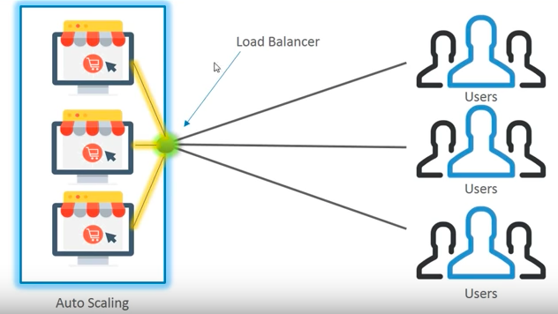

ADVANCED VPC NETWORKING

**VPC Peering**

* A VPC peering connection is a networking connection between two VPCs that enables you to route traffic between them using private IP  addresses

* Instances in either VPC can communicate with each other as if they are within the same network.

* You can create a VPC peering connection between
  + your own VPCs
  + with a VPC in another AWS account
  + VPC's can be in different regions
* You can also use a VPC peering connection to allow other VPCs to access resources you have in one of your VPCs.

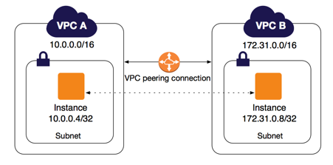

**Peering Basics**

* To establish a VPC peering connection, you do the following:
* The owner of the requester VPC sends a request to the owner of the accepter VPC to create the VPC peering connection. The accepter VPC can be owned by you, or another AWS account, and **cannot have a CIDR block that overlaps with the requester VPC's CIDR block**.
* The owner of the accepter VPC accepts the VPC peering connection request to activate the VPC peering connection.
* To enable the flow of traffic between the VPCs using private IP addresses, the owner of each VPC in the VPC peering connection must manually add a route to one or more of their VPC route tables that points to the IP address range of the other VPC (the peer VPC).

**Rules**

* A VPC peering connection is a one to one relationship between two VPCs.

* You can create multiple VPC peering connections for each VPC that you own, but transitive peering relationships are not supported.

* You do not have any peering relationship with VPCs that your VPC is not directly peered with.

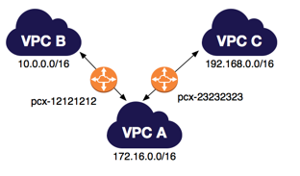

**Peering Limitations**

* You cannot create a VPC peering connection between VPCs that have matching or overlapping CIDR blocks

* You have a limit on VPC peering connections that you can have per VPC
  + Active VPC peering connections per VPC is 50

* VPC peering does not support transitive peering relationships.

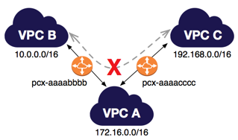

**LAB**

* This Lab provides a hands-on to VPC peering connection to allow other VPCs to access resources you have in one of your VPCs

* This lab includes
* Preparing three vpc's
  + Two VPC's with same CIDR to test the incompatibility
  + Once VPC's with a different CIDR
* Provisioning two instances in two different VPC's and establishing the connection between them

**Security For Instances**

* So when we are talking about the increased security, what we want to focus on is, placing of EC2 instances that are holding our data in private subnets.

* However this causes some issues, we cannot serve traffic from private instances as there is no route to the open internet and also we cannot access or ssh into EC2 instances that are in private subnets or install/update the software on those EC2 instances.

* However with using a Bastion Host and a NAT Gateway we can actually accomplish the above tasks and have our EC2 instances protected as well.

* Setting up a Bastion Host will allow you to SSH and access the EC2 instances, and a NAT Gateway, will allow EC2 instances reach the open internet and install the software packages, but before that let's talk about new concepts like **Bastion Host** and **NAT Gateway**.

**Bastion Host**

* A **Bastion Host** is an EC2 instance that lives in a public subnet, and is used as a "**gateway**" for traffic that is destined for instances that live in private subnets.

* This means that we can use a bastion host as a "portal" to access EC2 instances that are located in a private subnet.

* A bastion host is considered the "**critical strong point**" of the network - as all traffic must pass through it first.

* Taking a look at the diagram, traffic coming from AWS users from open internet, through SSH, coming down through the IGW, and into the Bastion Host

* Coz, Bastion Host will be in our public subnet, that is associated with Route Table with IGW attached,  the Bastion Host then will act as a portal for us to access any other internal resources, since we are inside the VPC N/W, so if you recall, all the instances within a VPC regardless of whether they are in public or private subnets can communicate with each other.

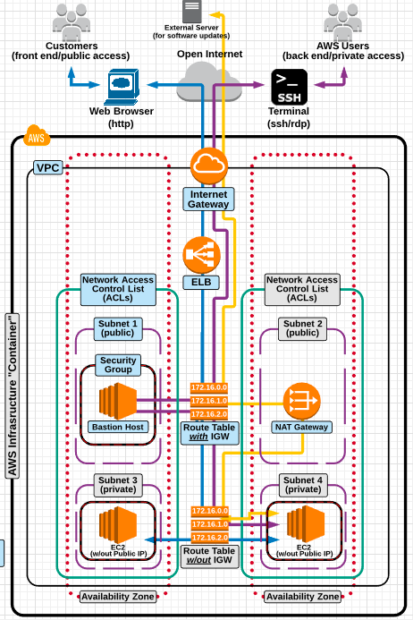

**Bastion**

* So if we were able to access the bastion host, then we can access the instances that are in private subnets.

* A bastion host should have increased and extremely tight security

* A bastion host can be used as an access point to "SSH" into an internal network (to access private resources) without a VPN (virtual private network).

* A bastion host is system identified by the firewall administrator as a **critical strong point** in the **network's security**. Generally, bastion hosts will have some degree of extra attention paid to their security and may undergo regular audits
* So Bastion Host is going to be a access point for us to reach other resources in private parts of AWS VPC network

* Now once we have access to the private instances i.e ssh into private instances. We still won't be able to install any software packages or update the softwares, coz this is just one way connection

* We cannot send traffic from these private instances to open internet, so in order to solve that problem, we will go with **NAT Gateway**.

**NAT Gateway**

* A NAT Gateway is designed to provide EC2 instances that live in a private subnet with a route to the internet (so they can download software packages and updates).

* A NAT Gateway will prevent any hosts located outside of the VPC from initiating a connection with instances that are associated with it.

* A NAT Gateway will only allow incoming traffic through if a request for it originated from an instance in a private subnet.

* A NAT Gateway is needed because instances launched into private subnets can't communicate with the open internet.

* Placing instances in a private subnets creates a higher level of security, but also creates the limitation of the instances not being able to download software and software updates.

* Take a look at diagram, in the bottom part we have private instances and observer the yellow line.

* However any host outside, will not be able to reach the private instances. Nat Gateway will only allow incoming traffic that has been asked by these private instances



**NAT Instance**

* NAT Gateway must be created in a public subnet
* NAT Gateway must be part of the **private subnets route table**

* A **NAT Instance** is identical to a NAT gateway in its purpose.
* However, it is executed differently by configuring an actual EC2 instance to do the same job.
* A NAT instance is a legacy feature in AWS.
* Both **NAT Gateway** and **NAT Instance** does the same thing in diff way, Nat Instance is more of legacy(old) way of doing the things.
* NAT Gateway is updated and more easier way of achieving the same.

**NAT GAteway Vs NAT Instance**

|  |  |  |
| --- | --- | --- |
| **Attribute** | **NAT Gateway** | **NAT Instance** |
| Availability | AWS Managed service, Highly available. | Use a script to manage failover between instances. |
| Bandwidth | Can scale up to 45 Gbps. | Depends on the bandwidth of the instance type. |
| Maintenance | Managed by AWS.You do not need to perform any maintenance. | Managed by you, for example, by installing software updates or operating system patches on the instance. |
| Performance | Software is optimized for handling NAT traffic. | A generic Amazon Linux AMI that's configured to perform NAT. |
| Type & size | Uniform offering, you don’t need to decide on the type or size. | Choose a suitable instance type and size, according to your predicted workload. |

**LAB**

* This Lab provides a hands-on to building a more secure architecture for a web application.

* This lab includes
* Hosting EC2 web servers in private subnets
* Serving traffic to private subnets via an ELB
* Accessing (ssh) instances in a private subnet via a Bastion Host
* Providing instances in a private subnet with the ability to download software packages via a NAT Gateway

**Steps**

* VPC Dashboard → Create **VPC** ( Name - Security-VPC ) with CIDR **10.0.0.0/16** → Leave the rest as default → Create
* Then we need to Create **IGW** for our VPC → VPC Dashboard → Create IGW ( Name - Security-IGW ) → Attach Security-IGW to Security-VPC
* Create 4 Subnets, to match the diagram, and this point is imp to remember for an ELB to be able to serve traffic to private subnets, they must be in the same availability zone, for this example we want to **make sure that at least one public subnet and one private subnet are in the same availability zone** and we are going to do that twice **check the diagram once**
* VPC Dashboard → Create Subnets ( Name - Public1) → Choose Security-VPC → Set AZ to **us-east-1a** → Set IPV4 CIDR to 10.0.1.0/24 → Create
* VPC Dashboard → Create Subnets ( Name - Public2) → Choose Security-VPC → Set AZ to **us-east-1b** → Set IPV4 CIDR to 10.0.2.0/24 → Create
* VPC Dashboard → Create Subnets ( Name - Private3) → Choose Security-VPC → Set AZ to **us-east-1a** → Set IPV4 CIDR to 10.0.3.0/24 → Create
* VPC Dashboard → Create Subnets ( Name - Private4) → Choose Security-VPC → Set AZ to **us-east-1b** → Set IPV4 CIDR to 10.0.4.0/24 → Create

* Now we need to create Two Route Tables, first Route Table is by default created and attached to **Security-VPC**, when we created **Security-VPC**, and is going to be associated with our IGW for our Public Subnet and Second Route table that is not going to be associated with IGW i.e our Private Subnet.
* VPC Dashboard → Route Tables → Rename it ( Name - **Security-PublicRT** ) → Ensure this Route Table is attached to **Security-VPC** → Create
  + Select **Security-PublicRT** → Routes Tab → Add Another Route (this is route to IGW ) → Set **Destination** to 0.0.0.0/0 & Target to **Security-IGW** → Save
  + Select **Security-PublicRT** → Subnet Association Tab → Edit → Select two Public Subnets i.e **Public1 & Public2** → Save
* VPC Dashboard → Route Tables → Create Route Table ( Name - **Security-PrivateRT** ) → Ensure this Route Table is attached to **Security-VPC** → Create
  + For this currently we are going to have only internal routing
  + However we want to associate it to private subnets, Select **Security-PrivateRT** → Subnet Association Tab → Edit → Select two Private Subnets i.e **Private3** & **Private4** → Save

* Now we have our basic architecture setup i.e VPC, we have IGW, 4 Subnets, one public and one private in **us-east-1a** availability zone and one public and one private in **us-east-1b** availability zone.
* Now will create EC2 instances in private subnets
* EC2 Dashboard → Launch Instance → Choose AMI → Choose VPC(**Security-VPC**) → Subnet( Private Subnet i.e **Private3** ) → Auto Assign IP(**Disable**, as public ip is not needed), i'll not give any bootstrapping as well coz we can't install anything from outside → Add Storage (Keep Default) → Add Tags  (Keep Default) →  Configure Security Group ( **Name - Private EC2** ) Allow 22(SSH) and 80(HTTP), source is custom → Review & Launch → Launch → Give Key-pair
* EC2 Dashboard → Launch Instance → Choose AMI → Choose VPC(**Security-VPC**) → Subnet( Private Subnet i.e **Private4** ) → Auto Assign IP(**Disable**, as public ip is not needed), i'll not give any bootstrapping as well coz we can't install anything from outside → Add Storage (Keep Default) → Add Tags  (Keep Default) →  Configure Security Group ( **Name - Private EC2** ) Allow 22(SSH) and 80(HTTP), source is custom → Review & Launch → Launch → Give Key-pair

* Now we have two private instances setup and now we have a major problem, we cannot access these instances as they have private ip addresses, and there is also no route to the internet through the route table they are associated with, now we have to setup our Bastion Host which allows us to SSH into private instances.

* **Launching Bastion Host** → EC2 Dashboard → Launch Instance → Choose AMI → Choose VPC(**Security-VPC**) → Subnet( Public Subnet i.e **Public1** ) → Auto Assign IP(**Enable** ) → Add Storage (Keep Default) → Add Tags  (Key - Name && Value - Bastion) →  Configure Security Group ( Name - **Bastion-SG** ) Allow 22(SSH), source is custom → Review & Launch → Launch → Give Key-pair

* Now we can our Bastion Host is ready, let's ssh into Bastion, then from there will ssh into the private instances
  + ssh -i "ravi.pem" ec2-user@34.229.219.178

* Right now we are logged into Bastion Host, from here we can use private ip addresses of the EC2 instances in private subnet and we can login
  + ssh -i "ravi.pem" ec2-user@10.0.3.131
* Now from private instance if i try to install a web server like apache i'll get error
  + yum -y install httpd
* Now we need to overcome this, by creating a NAT Gateway, VPC Dashboard → NAT Gateways → Create NAT Gateway → Choose Public Subnet ( **Public2** ) as shown in diagram, it should be provisioned in Public Subnet → Create New Elastic IP to be assigned to NAT Gateway → Create NAT Gateway
* Now most important thing is we have to **edit route table**, for our private instances to have a route to the NAT Gateway, → edit route tables → Select **Security-PrivateRT** Route Table →  Routes Tab → Add Another Route → Set Destination to 0.0.0.0/0 & **Target** to **NAT-Gateway** → Save
* Now let's switch back to terminal of private EC2 instances, and do
  + yum -y install httpd

* Let's do same thing on second EC2 private instance
* Now start the httpd service on both the servers
* Now we have everything setup, except for the ELB, we have our 2 EC2 instances with apache web server installed, but we can't access the web pages, coz we have only private ip's, so will setup ELB to access those private instances
* EC2 Dashboard → Load Balancers → Create Load Balancer → Class Load Balancer → **Name - Security-ELB** → Choose **Security-VPC** → Listen Port 80 → Selecting Subnets gets tricky here, an E**LB can only technically serve traffic to a public subnet**, but not private subnet, however if we have both public and private subnets in the same availability zone, then it will actually allow you to select EC2 instances in private subnet to allow traffic.
* Add Both the Public subnets i.e **Public1** and **Public2** but not private → Assign Security Group → Allow port 80 → Configure Health Check → Change Health Threshold to 2 from 10 → Add EC2 Instances → Select Web1 and Web2 Servers → Add Tags → Create
* Copy the DNS name of the ELB, and paste in browser

**EC2 - Troubleshoot**

* **Connectivity issues to an EC2 instance**
  + Correct ports on the security group are may not be open.

* **Cannot attach and EBS volume to an EC2 instance**
  + EBS volumes must live in the same availability zone as the EC2 instance they are to be attached to.
  + You can create a snapshot from the volume and launch the volume in the correct availability zone.

* **Cannot launch additional instance**
  + You have probably reached the EC2 limit and need to contact AWS to increase limit.

* **Unable to download package updates**
  + The EC2 instance may not have a public  address, and/or does not belong to a public subnet.

* **Applications seeming to slow down on T2 micro instances**
* T2 micro instances utilize 1 CPU, so chances are your application is using too much processing power and needs a larger instances or different instance type.

* **AMI unavailable in other regions**
  + AMIs are only available in the regions that they are created.
  + An AMI can be copied to another region but will receive a new AMI id.

**VPC Troubleshoot**

* **New EC2 instances are not automatically being assigned a public IP address**
  + Modify the Auto-Assign Public IP setting on the subnet.

* **NAT Gateway is configured but instances inside a private subnet still cannot download**
* Need to add 0.0.0.0/0 route to the NAT gateway on the route table for private subnets.

* **Traffic is not making it to the instances even though security group rules are correct**
  + Check the Network Access Control Lists to ensure the proper ports from the proper sources are open (also check you IGW and route table settings).

* **Error when attempting to attach multiple internet gateways to a VPC**
* Only one internet gateway can be attached to a VPC at any given time.

**ELB Troubleshoot**

* **Load balancing is not occurring between instances in multiple availability zones**
  + Make sure "Enable Cross-Zone load balancing" has been selected.

* **Instances are healthy but are not registering as healthy with ELB**
  + Check configuration for the "health check" to make sure you have selected the proper ping protocol, ping port and ping path.

* **The ELB is configured to listen on port 80, but traffic is not making it to the instances that belong to the ELB**
  + You may have mistaken the "listeners" for the security groups. Listeners are not the same as the security group rules, port 80 still need to be open on the security group that the ELB is using.

* **Unable to add instances from a specific subnet to the ELB**
  + Most likely the subnet that the instance lives in has not been added to the ELBs configuration.

**AutoScaling Troubleshoot**

* **An Auto Scaled instance continues to start and stop (or create/terminate) in short intervals**
  + The scale-up and scale-down thresholds may be too close to each other. Either raise the scale-up threshold or lower the scale-down threshold.

* **Auto Scaling does not occur even though scaling policies are configured correctly**
  + The "max" number of instance set in the auto scaling group may have been reached.

RDS

* A Database is a store for datasets where :
  + Data access (reads and writes) is needed on a recurring basis
  + It allows multiple user access for reads & writes

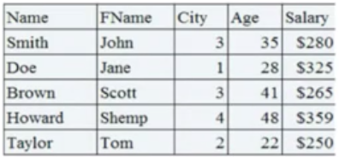

**Relational DB**

* A Relational Database (concept) is a data structure that allows you to link information from **different tables**.
* It normalizes data into structures (rows & columns)
* A schema is used to strictly define tables and relations between tables.
* Structured data, same items in tables are stored in the same table locations and can save data in multiple joined tables.
* All Relational Databases use Structured Query Language (SQL).
* Best Suited for OLTP (On line Transaction Processing) (ATM is example).
* Examples - Oracle, MySQL, DB2 etc

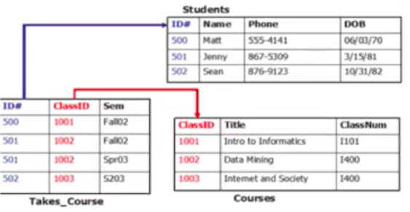

**Non Relational DB**

* A Non-Relational Database store data without a structured mechanism means it's a one big giant table.
* Non-Relational Databases are non-schema based unlike Relational Database.
* Use non-structured data.
* Storage and retrieval of data is modeled without tabular relations as in SQL Databases.
* Non-Relational or No-SQL databases use a variety of data models including documents (JSON/XML), graph based, key-value etc.
* Non-Relational databases meets today's needs in social media, Analytics, big data and IOT.

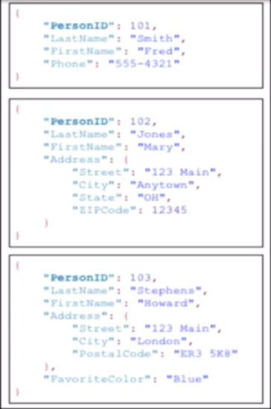

**RDS**

* Amazon Relational Database Service (Amazon RDS) makes it easy to set up, operate and scale a relational database in the cloud.

* It provides cost-efficient and resizable capacity while automating time-consuming administration tasks such as hardware provisioning, database setup, patching and backups.

* It frees you to focus on your applications so you can give them the fast performance, high availability, security and compatibility they need.

* Amazon RDS is available on several database instance types - optimized for memory, performance or I/O

* RDS provides you with six familiar database engines to choose from
  + Amazon Aurora
  + PostgreSQL
  + MySQL
  + MariaDB
  + Oracle
  + Microsoft SQL Server
* One imp thing you need to know about Database section is, we are not going to see, how to use these various DB's, knowing exactly how to use a SQL or NoSQL DB is not the job of Solutions Architect.

* Your job is to understand what are the various offerings, so when a customer or your organization comes with a requirement for DB's you will be able to select the right type of the DB, for your requirement of the application as well as security, cost benefits.

**RDS Essentials**

* RDS is a fully managed Relational Database Service.
* Does not allow access to the underlying operating system (fully-managed).
* You connect to the RDS database server in the same way you would connect to a traditional on-premise database instance (i.e MySQL command line).
* RDS has the ability to provision/resize hardware on demand for scaling.
* Every DB Instance has a weekly maintenance window
* You can enable Multi-AZ deployments for backup and high availability.
* Utilize Read Replicas (MySQL/postgreSQL/Aurora) - to help offload hits on your primary database.
* Relational database are the databases that organize stored data into tables.
* The associated tables have defined relationships between them.

**RDS Benefits**

* Benefits of running RDS instead of a database on your own instance:
* Automatic updates.
* Automatic backups
* Not required to manage operating system
* Multi-AZ
* Automatic recovery in event of a failover.

**RDS Multi AZ Failover**

* From above architecture diagram, we have primary DB instance, when we enable multi AZ failover, which you should do for any kind of production environment, So what will happen is at anytime you write data to primary instance, it is going to synchronously copy that over to a standby instance, in another AZ.

* So as we know with EC2 instances application architecture, we always want to have multiple EC2 instances running our application in multiple AZ's as this provides high availability and fault tolerant, so it's the same concept here, this is how we create high availability and fault tolerance within our DB architecture.

**RDS Backups**

* AWS provides automated point-in-time backups against the RDS database instance.

* Automated backups are deleted once the database instance is deleted and cannot be recovered (but you can take your own snapshots of backups before deleting).

**RDS READ REPLICAS**

* Read replicas are a synchronous copies of the primary database that are used for read only purposes (only allow "read connections").
* When you write new data to the primary database, AWS copies it for you to the read replica.
* You can create, and have multiple read replicas for a primary database.
* Read replicas can be created from other replicas (so no performance hit on the primary database).
* MySQL, MariaDB, PostgreSQL and Aurora currently support read replicas.

* Read Replicas allow for all read traffic to be redirected from the primary database to the read replica. This will greatly improve performance on the primary database.

* Read replicas allow for elasticity in RDS - you can add more read replicas as demand increases.

* You can promote a read replica to a primary instance.

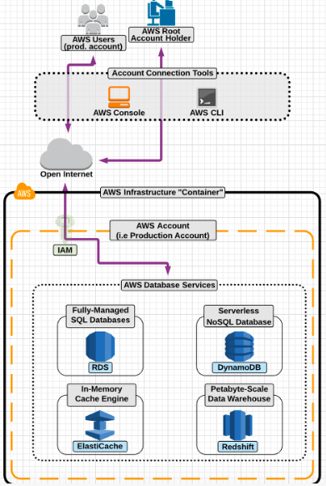

**DynamoDB Essentials**

* Amazon DynamoDB is a nonrelational database that delivers reliable performance at any scale.

* DynamoDB is a fully-managed , NoSQL database service provided by AWS.

* It is similar to MongoDB, but is a home-grown AWS solution.

* Is schemaless, and uses a key-value store.

* Being fully managed means:
* AWS manages all provisioning (and scaling) of underlying hardware.
* Fully distributed, and scales automatically with demand and growth.
* Built as a fault tolerant highly available service.

* On the back end, it fully synchronizes the data across all of the availability zones within the region you created the DynamoDB tables in.

* Popular use cases includes:
* IOT (storing meta-data)
* Gaming (storing session information, leaderboards)
* Mobile (Storing User profiles, personalization).

**Elastic Cache Essentials**

* A ElasticCache is a fully managed, in-memory cache engine.

* ElasticCache is used to improve database performance by caching results of queries that are made to a database.

* ElasticCache is great for large, high-performance or high-taxing queries - and can store them inside of a cache (Elastic Cache Cluster) that can be accessed later (instead of repeat) request continually hitting the primary database.

* So it reduces load on the database, which increases performance.

* ElasticCache allows for managing web sessions, and also caching dynamic generated data.

* Available engines to power ElasticCache include:
* Memcached (Mem-Cache-D)
* Redis

* Generally, the application needs to be built to work with either Redis or Memcached.

**Redshift Essentials**

* Amazon Redshift is a petabyte-scale data warehousing service.

* It is fully managed and scalable.

* Generally used for big-data analytics, and it can integrate with most popular business intelligence tools, including:
* Congos
* Tableau
* Jaspersoft
* Microstrategy
* Business Objects

**RDS LABS**

--> Database Service

--> Java { App is built using Java }

--> App Server { Tomcat 7 }

> Reneders Java Code

--> Maven { Build Tool }

> Converts Source Code to Exe Code

**App Server Setup**

> Pre-requsites for Tomcat

> Install Java

sudo yum -y install java-1.8.0 java-1.8.0-devel

> Download the tomcat 7 binary

wget https://www-eu.apache.org/dist/tomcat/tomcat-7/v7.0.93/bin/apache-tomcat-7.0.93.zip

> Unzip apache-tomcat-7.0.93.zip

> cd apache-tomcat-7.0.93

Start the Server : /home/ec2-user/apache-tomcat-7.0.93/bin/startup.sh { Hit enter }

Stop the Server : /home/ec2-user/apache-tomcat-7.0.93/bin/shutdown.sh { Hit enter }

Config Files :

> credentials : /home/ec2-user/apache-tomcat-7.0.93/conf/tomcat-users.xml

> server : /home/ec2-user/apache-tomcat-7.0.93/conf/server.xml

> DocumentRoot : > credentials : /home/ec2-user/apache-tomcat-7.0.93/webapps

> Default Port : 8080

> Code Management

-----------------

> Install git to fetch the code

sudo yum -y install git

> Fetching code

git clone -b aws https://github.com/ravi2krishna/aws-rds-java.git

> Build Management

-------------------

> Setup Build Tool - Maven

sudo yum -y install maven

**Setup Process**

-> Launch an instance in public subnet with Amazon Linux 2 AMI and tag it as App Server

-> Install Java

> sudo yum -y install java-1.8.0 java-1.8.0-devel

> java -version { confirm }

-> Install Git

> sudo yum -y install git

> git --version { confirm }

-> Install Maven

> sudo yum -y install maven

> mvn --version { confirm }

-> Fetch Code

> git clone -b aws https://github.com/ravi2krishna/aws-rds-java.git

-> Download the tomcat 7 binary

> wget https://www-eu.apache.org/dist/tomcat/tomcat-7/v7.0.93/bin/apache-tomcat-7.0.93.zip

> unzip apache-tomcat-7.0.93.zip

Start the Server : /home/ec2-user/apache-tomcat-7.0.93/bin/startup.sh { Hit enter }

: ls -l /home/ec2-user/apache-tomcat-7.0.93/bin/startup.sh

: cd /home/ec2-user/apache-tomcat-7.0.93/bin

: chmod u+x startup.sh

: chmod u+x catalina.sh

: ./startup.sh

> sudo netstat -ntpl | grep 8080

> curl http://localhost:8080

> Browse : app-server-public-ip:8080

> vi /home/ec2-user/apache-tomcat-7.0.93/conf/tomcat-users.xml

Stop : chmod u+x shutdown.sh

: ./shutdown.sh

: ./startup.sh

**DB Setup**

--> Launch an instance using Amazon Linux 2 in PRIVATE subnet tag as DB Server

--> Instructions to setup DB Server

> Download MYSQL

> wget http://repo.mysql.com/mysql-community-release-el7-5.noarch.rpm

> sudo rpm -ivh mysql-community-release-el7-5.noarch.rpm

> sudo yum -y install mysql-server

> sudo systemctl start mysqld

> DB Port : 3306

> sudo mysql_secure_installation

> Hit Enter and set the root password, hit Y and set password then press Y for every step, which are best practises for Database setup

> mysql -u root -p

> show databases;

> create user ravi identified by 'password';

> create database emp;

> grant all on emp.* to 'ravi'@'pvt-hostname-app-server' identified by 'password';

**Working Setup**

-> In app Server Install Git, Maven, Java

> App Code:

git clone -b aws https://github.com/ravi2krishna/aws-rds-java.git

-> Login to Database

> mysql -u root -p

> create database jwt;

> use jwt;

CREATE TABLE `USER` (

  `id` int(10) unsigned NOT NULL auto_increment,

  `first_name` varchar(45) NOT NULL,

  `last_name` varchar(45) NOT NULL,

  `email` varchar(45) NOT NULL,

  `username` varchar(45) NOT NULL,

  `password` varchar(45) NOT NULL,

  `regdate` date NOT NULL,

  PRIMARY KEY (`id`)

) ENGINE = InnoDB DEFAULT CHARSET = latin1;

> select * from USER;

> create user ravi identified by 'Admin123*';

> Syntax not command : grant all on jwt.* to 'ravi'@'hostname-app-server' identified by 'Admin123*';

> grant all on jwt.* to 'ravi'@'ip-10-0-0-191.us-east-2.compute.internal' identified by 'Admin123*';

> flush privileges;

-> Login to App Server

> cd aws-rds-java

> vim src/main/webapp/login.jsp

Change the line no 6 that says

    Connection con = DriverManager.getConnection("jdbc:mysql://localhost:3306/jwt",

            "ravi", "Admin123*");

             TOO

            Connection con = DriverManager.getConnection("jdbc:mysql://db-server-pvt-dns:3306/jwt",

            "ravi", "Admin123*");

    > vim src/main/webapp/userRegistration.jsp

    Change the line no 9 that says

    Connection con = DriverManager.getConnection("jdbc:mysql://localhost:3306/jwt",

            "ravi", "Admin123*");

             TOO

            Connection con = DriverManager.getConnection("jdbc:mysql://db-server-pvt-dns:3306/jwt",

            "ravi", "Admin123*");

    > mvn package

    > cp /home/ec2-user/aws-rds-java/target/LoginWebApp.war /home/ec2-user/apache-tomcat-7.0.94/webapps

    > Browse : http://App-Server-Public-IP:8080/LoginWebApp

**RDS**

-> Services -> RDS -> List Left side menu -> CLick Subnet Groups -> Create DB Subnet Group -> Choose the VPC -> Select the Subnets -> Create

-> Databases -> Create Database -> Select MySQL -> Scroll down check Only > enable options eligible for RDS Free Usage Tier -> Give some name : DB instance identifier > username : ravi > password : Admin123* > Select VPC -> slect subnet group created > Public accessibility : no > uncheck Enable deletion protection at end -> Create Database

-> endpoint { DNS }

-> Replace the DNS in following files

> vim src/main/webapp/login.jsp

Change the line no 6 that says

    Connection con = DriverManager.getConnection("jdbc:mysql://localhost:3306/jwt",

            "ravi", "Admin123*");

             TOO

            Connection con = DriverManager.getConnection("jdbc:mysql://db-server-pvt-dns:3306/jwt",

            "ravi", "Admin123*");

    > vim src/main/webapp/userRegistration.jsp

    Change the line no 9 that says

    Connection con = DriverManager.getConnection("jdbc:mysql://localhost:3306/jwt",

            "ravi", "Admin123*");

             TOO

            Connection con = DriverManager.getConnection("jdbc:mysql://db-server-pvt-dns:3306/jwt",

            "ravi", "Admin123*");

    -> on App server

     mysql -h endpoint-rds -u ravi -p

     create databaswe jwt;

     use jwt;

CREATE TABLE `USER` (

  `id` int(10) unsigned NOT NULL auto_increment,

  `first_name` varchar(45) NOT NULL,

  `last_name` varchar(45) NOT NULL,

  `email` varchar(45) NOT NULL,

  `username` varchar(45) NOT NULL,

  `password` varchar(45) NOT NULL,

  `regdate` date NOT NULL,

  PRIMARY KEY (`id`)

) ENGINE = InnoDB DEFAULT CHARSET = latin1;

> mvn package

    > cp /home/ec2-user/aws-rds-java/target/LoginWebApp.war /home/ec2-user/apache-tomcat-7.0.94/webapps

    > Browse : http://App-Server-Public-IP:8080/LoginWebApp

S3 - Simple Storage Service

* Cloud storage is a cloud computing model that stores data on the Internet through a cloud computing provider(AWS), who manages and operates
  + **data storage as a service**

* It’s delivered on demand which eliminates buying and managing your own data storage infrastructure. This gives you “**anytime**, **anywhere**” data access.

Types Of Storage

AWS provides three popular services :

* **Simple Storage Service (S3)**
* **Elastic Block Store (EBS)**
* **Elastic File System (EFS)**

* Above services work quite differently and offer different levels of performance, cost, availability and scalability.

* **AWS EBS** provides persistent block storage which offer higher performance than object storage. You need to mount EBS onto an Amazon EC2 instance. Use cases include transactional databases management, business continuity.

* **AWS EFS** is a shared, elastic file storage system that grows and shrinks as you add and remove files. You can mount EFS onto several EC2 instances at the same time.

* **Amazon S3** provides simple object storage, useful for hosting website images and videos. You can access the S3 service from anywhere on the internet.

* **AWS EBS** is scalable up or down. EBS is cheaper than EFS, you can use it for database backups and other low-latency interactive applications that require consistent, predictable performance.

* **AWS EFS** is best used for large quantities of data, such as large analytic workloads. Data at this scale cannot be stored on a single EC2 instance. The EFS service allows concurrent access to thousands of EC2 instances, making it possible to process and analyze large amounts of data seamlessly.

* **Amazon S3** cheapest for data storage and can be accessed from anywhere. EBS and EFS are both faster than Amazon S3, with high IOPS and lower latency.

Object Storage

* **Object Storage** stores the object (file), it's metadata and global unique ID

* In object storage there is no limit on type or amount for objects. Examples of object Storage : S3, Drop Box, Facebook { videos images }

* Object storage cannot be mounted as drive or directory to EC2 instance.

* Object storage is perfect solution for data growth storage problems

* Companies today need the ability to simply and securely collect, store, and analyze their data at a massive scale. Amazon **S3** is object storage built to store and retrieve any amount of data from anywhere.

* With S3,  you manage your storage in one place with an easy-to-use application interface i.e AWS Management Console.

* You can use S3 to optimize storage costs, tiering between different storage classes automatically. AWS makes storage easier to use to perform analysis, gain insights, and make better decisions faster.

S3 Essentials

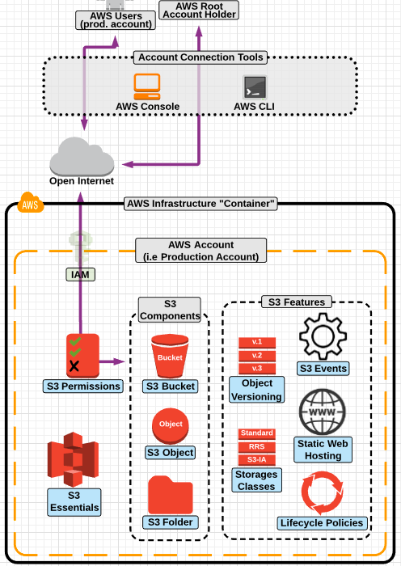

* As AWS main storage service, S3 can serve many purposes when designing highly available, fault tolerant and secure application architecture including:
  + Bulk (basically unlimited) static object storage.
  + Various storage classes to optimize cost vs needed object availability/durability
  + Object versioning
  + Access restrictions via S3 bucket policies
  + Object management via lifecycle policies
  + Hosting static files & websites
  + File shares and backup/archiving for hybrid networks (via AWS Storage gateway)

* Amazon S3 is Global Service.

* Objects stay within an AWS region and are synced across all Az's for extremely high availability and durability.

* You should always create an S3 bucket in a region that makes sense to its purpose:
* For better performance, lower latency and to minimize costs, create an S3 bucket closer to client location.

Buckets

* Data is stored in Buckets, Buckets are the main storage containers of S3.

* You can store unlimited objects in a bucket, but an object cannot exceed 5 TB

* S3 bucket is Region specific. **Each bucket must have a unique name across ALL of AWS.**
  + https://s3-<region>.amazonaws.com/<bucketname>

* Bucket names cannot be changed once created and ownership is not transferable.
* By default Buckets are private.

Objects

* By default, all objects are private.

* Objects stored in S3 bucket in a region will never leave that region unless we specify by enabling Cross Region Replication.

* S3 provides high availability, Objects are redundantly stored on multiple devices across multiple facilities(AZ's) in an region where bucket exists.

Managing Access

* By default, all amazon S3 resources are private.
  + Only a resource owner can access the resources.

* A bucket owner can grant cross-account permissions to another AWS accounts (users in another account) to upload objects.

* Managing access refers to granting (AWS Accounts & Users) permissions to perform the resource operations by writing an access policy.

* You can grant S3 bucket/object permissions to:
  + Individual Users, AWS Accounts & Make resources public (grant permissions to everyone)

* Access policy describes who has access to what. You can associate an access policy with a S3 resource(Bucket & Objects) or a User.

* Amazon S3 access policies are as follows:
  + Resource based policies
    - ACL's (Bucket & Object ACL)
    - Bucket Policy
  + User Access policies  (IAM)

* Bucket Policies and ACL's are resource based because you attach them to Amazon S3 resources.

* ACL's (Bucket & Object ACL's)
  + Each bucket & object can have ACL associated with it, You can use ACL's to grant basic read/write permissions to other accounts and public.

* Bucket Policy
  + For your bucket, you can add bucket policy to grant other aws accounts, to have access on bucket and objects inside it.
  + Bucket policies are preferred over ACL's(Legacy)

Bucket ACL

* S3 access control lists (ACL's) enable you to manage access to buckets and objects. Each bucket and object can have acl attached.

* ACL's define which AWS accounts are granted access and type of access.

* You cannot provide permissions to individual IAM users here.

Storage Classes

* A Storage Class represents the classification assigned to each object in S3. Amazon S3 offers a range of storage classes designed for different use cases.

* Each storage class has varying attributes that dictate things like:
  + Storage cost
  + Object availability
  + Object durability
  + Frequency of access (to the object)

* Current Storage Class Types include:
  + **Amazon S3 Standard**
  + **Amazon S3 Standard-Infrequent Access**
  + **Amazon S3 One Zone-Infrequent Access**
  + **Amazon Glacier**

**Go through the following for Storage Classes**

[**https://aws.amazon.com/s3/storage-classes/**](https://aws.amazon.com/s3/storage-classes/)

S3 Versioning

* S3 versioning is a feature to manage and store versions of an object
* S3 versioning protects your data against accidental deletion.
* By default, versioning is disabled on all buckets.
* Once versioning is enabled, you can only "suspend" versioning. It cannot be fully disabled.
* Suspending versioning only prevents new versions from being created. All objects with existing versions will maintain their older versions.
* Versioning can only be set on the **bucket level** and applies to ALL objects in the bucket.
* Versioning and lifecycle policies can both be enabled on a bucket at the same time.
* Versioning can be used with lifecycle policies to create a great archiving and backup solution in S3.

S3 Lifecycle policies

* An object lifecycle policy is a set of rules that automate the migration of an object's storage class to a different storage class (or deletion) based on specified time intervals.
* By default, lifecycle policies are disabled on a bucket.
* Are customizable to meet your company's data retention policies.
* Great for automating the management of object storage and to be more cost efficient.

* Example:
* I have a work file that I am going to access everyday for the next 30 days.
* After 30 days, I may only need to access that file once a week for the next 60 days.
* After which (90 days total) I will probably never access the file again but want to keep it just in case.

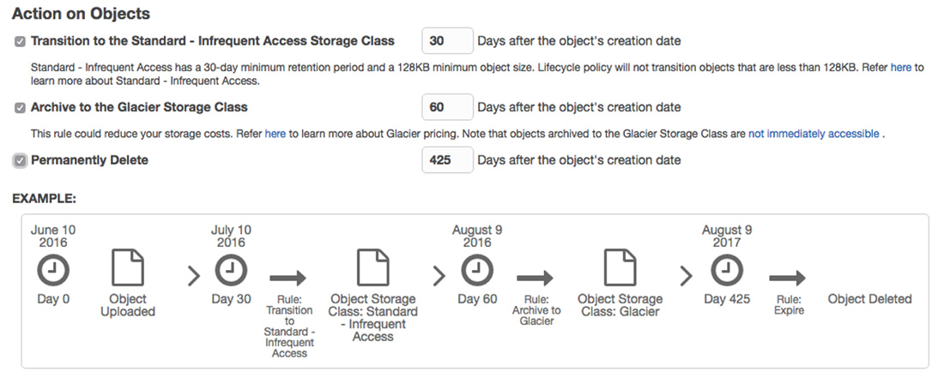

S3 Event Notifications

* The Amazon S3 notification feature enables you to receive notifications when certain events happen in your bucket.
* To enable notifications, you must first add a notification configuration identifying the events you want Amazon S3 to publish, and the destinations where you want Amazon S3 to send the event notifications.
* Currently, Amazon S3 can publish the following events:
  + A new object created event
  + An object removal event
  + A Reduced Redundancy Storage (RRS) object lost event
* Amazon S3 supports the following destinations where it can publish events:
  + Amazon Simple Notification Service (Amazon SNS)
  + Amazon Simple Queue Service (Amazon SQS)
  + AWS Lambda

S3 Cross Region Replication

* Cross-region replication is a bucket-level configuration that enables automatic copying of objects across buckets in different AWS Regions.

* We refer to these buckets as **source bucket** and **destination bucket**.

* To activate this feature, you add a replication configuration to your source bucket. In the replication configuration, you provide information such as the following:
  + The **destination bucket** where you want Amazon S3 to replicate the objects.

* You can replicate objects from a source bucket to only one destination bucket i.e you cannot replicate to multiple buckets.

* The source and destination buckets must have **versioning enabled**.

* The source and destination buckets must be in different AWS Regions.

* FIles in an existing bucket are not replicated automatically, all subsequent updated files will be replicated automatically.

S3 Web Hosting

* Amazon S3 provides an option for low-cost, highly reliable web hosting service for static websites (content that does not change frequently).

* When enabled, static web hosting will provide you with an unique endpoint (url) that you can point to any properly formatted file stored in an S3 bucket. Supported formats include:
* HTML
* CSS
* JavaScript

* Amazon Route S3 can also map human-readable domain names to static web hosting buckets, which are ideal for DNS failover solutions.

AWS Import-Export

* AWS Import/Export gives the ability to take on-premise data and send it to AWS.

* AWS will import the data to either S3, EBS or Glacier within one business day of the physical device arriving at AWS.

* **Benefits**:
  + Off-site backup policy.
  + Quickly migrate LARGE amounts of data to the cloud (up to 16TB per job)
  + Disaster recovery (AWS will even take S3 data and ship it back to you)

**Snow Ball**

* Snowball is a petabyte-scale data transport solution.

* Snowball uses an AWS provided secure transfer appliance.

* Quickly move large amounts of data into and out of the AWS cloud.

Application and Messaging Services [ AWS Developer ]

* Application & Messaging Services provided by AWS offer a great variety of solutions - from receiving important alerts and enable different software systems and end devices–often using different programming languages, and on different platforms–to communicate and exchange information.

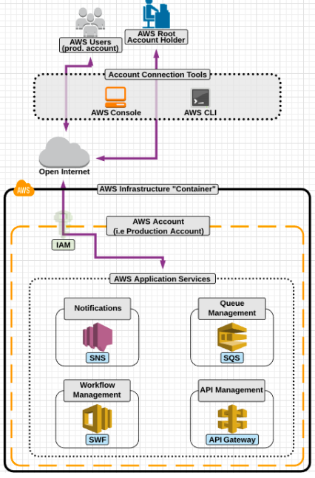

SNS - Simple Notification Service

* Simple Notification Service is an integrated notification service provided by AWS that allows for the sending of messages to various endpoints.

* Generally these messages are used to alert system admins.

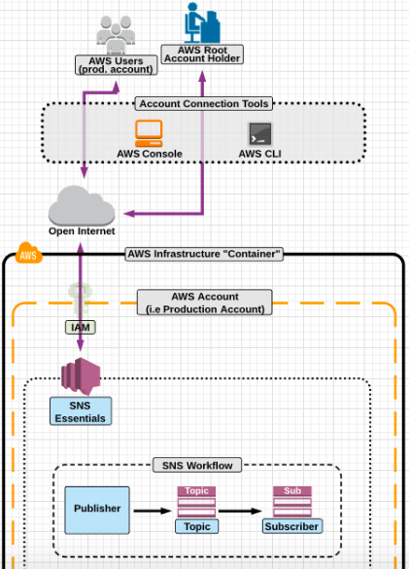

* SNS coordinates and manages the sending and delivery of messages to specific endpoints.

* We are able to use SNS to receive notification when events occur in our AWS Environments.

* SNS is integrated into many AWS services, so it is very easy to setup notifications based on events that occur in those services.

* With CloudWatch and SNS, a full-environment monitoring solution can be created that notifies administrators

SNS - Components

* **Topic**
* The group of subscriptions that you send a message to.

* **Subscriptions**
* An endpoint that a message is sent. Available endpoints include:
* HTTP
* HTTPS
* Email
* Email-JSON
* SQS
* Application, Mobile APP notifications (IOS/Android/Amazon/Microsoft)
* SMS (Cellular text message)

* **Publisher**
* The "entity" that triggers the sending of a message
* Example include:
  + Human
  + S3 Event
  + CloudWatch Alarm.

App Architectures

* **Tightly Coupled Systems**
* A system architecture of components that are not just linked together but are also dependent upon each other.
* If one component fails all components fail.

* **Loosely Coupled/Decoupled Systems**
* Multiple components that can process information without being connected.
* Components are not connected-if one fails the rest of the system can continue processing (fault tolerant).

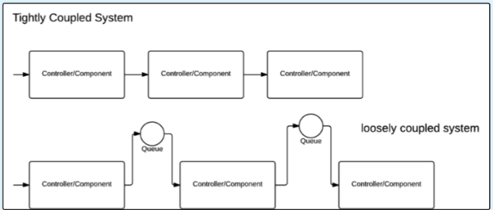

* AWS Services that are used for distributed/decoupled system architecture:
* **SQS** (Simple Queue service)
* **SWF** (Simple WorkFlow Service)

SQS - Simple Queue Service

* Simple Queue Service allows for highly available and decoupled application architecture.

* Generally this is accomplished through utilizing the use of messages and queues.

* SQS provides the ability to host highly available queues that can be used for messages being sent between servers.

* This allows for the creation of distributed/decoupled application components.

* SQS is used to create decoupled applications environments.

**SQS - Facts**

* Each message can contain up to 256KB of text

* Amazon SQS offer two different types of queues:
* **Standard Queue**: Guaranteed delivery of each message at least once BUT DOES NOT guarantee the order (best effort) in which they are delivered to the queue.
* **First-in-first-out (FIFO) Queue**: Designed for applications where the order of operations and events is critical or where duplicates can't be tolerated.

* SQS is also highly available Service.

**SQS - Working**

* Simple Queue Service allows for highly available and decoupled application architecture.

* Generally this is accomplished through utilizing the use of messages and queues.

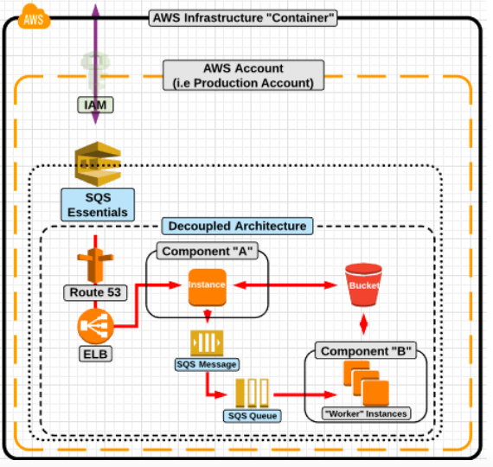

Now taking a look at this diagram, this is an application which will take an uploaded photo and apply a filter, so let say you are a customer, you uploaded a photo to the application then it will come through Route 53, through the ELB, and to a Particular Instance (Component A), now when the initial photo has been uploaded, the photo is sent and saved into S3 bucket,

Let's see how SQS is used to decouple this process, Component A will create a message, and have that message in a queue with the information of the photo name and the filter that should be applied, what will happen next is, the worker instances which are going to do the processing on the photo, will periodically poll the queue and poll a message in, it will then receive the message, the message will say, hey goto the S3 bucket, get this photo and apply this particular filter.

Then the worker instances will perform those operations, then the new updated photo is stored in S3 and the same info is sent  back to the original instance Comp A.

Now why is this decoupled, cuz if the main instance fails, the worker instance could process images, it can still pull the instructions from the queue, get those photos from S3 and continue to process them and save the updated photos to S3, all without the original instance Comp A.

In the same regards, if the worker instance fails, the main instance Comp A, will continue to stack the SQS queue with SQS messages and instructions, once the worker instances are back online they will be able to pull and process the messages.

So again SQS creates a great way for components to work independently, if one component fails the other one would be able to process and continue to do the job.

SWF - Simple Workflow

* SWF is a fully-managed "workflow" service provided by AWS.

* A SWF workflow allows developer to implement distributed, asynchronous applications as a workflow.

* A workflow coordinates and manages the execution of activities that can be run asynchronously across multiple computing devices.

* SWF has consistent execution. Guarantees the order in which tasks are executed.

* The SWF service is primarily an API which an application can integrates it's workflow service into.

* Components of SWF
  + **Workflow/Decider** : A sequence of steps required to perform a specific task.
  + **Activities** : A single step (or unit of work) in the workflow.
  + **Tasks** : A task list is a logical entity used by Amazon SWF to manage events for your workflows and activities.
  + **Worker** : Responsible for receiving a task and taking action on it. Can be any type of component such as an EC2 instance.

**SWF - Working**

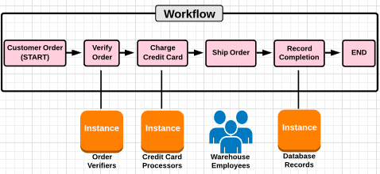

It's imp to understand that workflow is basically a job, that is followed from Start to Finish, and it follows a specific sequence of steps.

So when the order comes in, the workflow or decider will decide what the first activity will be, so in this particular image, the first activity is to verify the order, then it will send an activity task to the worker, here it's an instance that will verify the order and then send the decision task back to the workflow, and it will be moved forward to the next activity i.e to charge the customer then it will repeat the same process, now next it will be ship order, now here we need to know the worker can be not only an EC2 instance, but can also be an employee, something like a warehouse and pull the product and physically package it and once completed, it will then get back to the workflow and repeats till the end of workflow.

We need to know about the components that's it.

Monitoring Services [ AWS SysOps ]

* AWS offers two primary monitoring services:
  + Cloud Watch
  + Cloud Trail

* These services allows you to effectively keep tabs on the status of your environments and who is taking what actions inside of it.

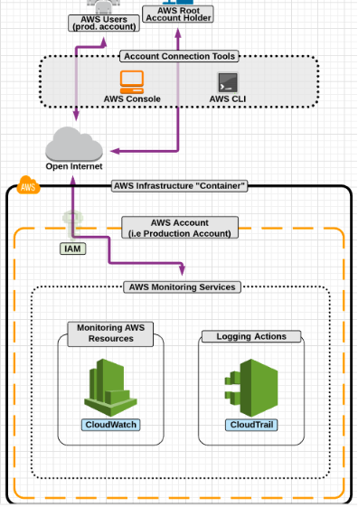

Cloud Watch

* Cloudwatch is an AWS integrated monitoring service.

* Cloudwatch allows for comprehensive monitoring of all AWS provisioned resources with ability to trigger alarms based off metric thresholds.

* Cloudwatch is used to monitor AWS services such as EC2, ELB and S3.

* Metrics are specific to each AWS service or resource, and include such metrics as:
  + CPU Utilization
  + Number Of Objects
  + Unhealthy Host Count

**Monitoring Levels**

* Detailed Vs Basic level monitoring:
* **Basic** : Data is available automatically in 5 minute periods at no charge
* **Detailed** : Data is available in 1 minute period

* Cloud Watch Alarms can be created to trigger alerts ( or other actions in your AWS accounts, such as an SNS topic), based on threshold you set on Cloudwatch metrics.

* Auto Scaling heavily utilizes CloudWatch - relying on threshold and alarms to trigger the addition (or removal) of instances from an auto scaling group.

**Cloudwatch Alarms**

* One nice thing is, we can set up Cloudwatch Alarms, which can trigger events to SNS which in turn will send notifications to users.

* CloudWatch Alarms allow for you (or the system admin) to be notified when certain defined thresholds are met on Cloudwatch Metrics.

* For Example, you can setup an alarm to be triggered whenever the CPU Utilization metric on an EC2 instance goes above 70%

* Alarms can also be used to trigger other events in AWS like publishing to an SNS topic or triggering auto scaling.

* **System Status Checks** : (things that are outside of our control)
* Loss of network connectivity
* Loss of system power
* Software issues on the physical host
* Hardware issues on the physical host.

* **How to Resolve** : Generally stopping and restarting the instances will fix the issue. This causes the instance to launch on a different physical hardware device.

* **Instance Status Checks** : (software issues that we do control)
* Failed system status checks
* Misconfigured networking or startup configuration
* Exhausted memory
* Corrupted file system
* Incompatible kernel

* **How to Resolve** : Generally a reboot or solving the file system configuration issue.

Cloud Trail

* CloudTrail is an API logging service that logs all API calls made to AWS.

* It does not matter if the API calls from the command line, SDK or console.

* All created logs are placed into a designated S3 bucket - so they are highly available by default.

* Cloudtrail logs help when addressing security concerns, by allowing you to view what actions users on your AWS account have performed.

* Since AWS is just one big API - CloudTrail can log ever single action taken in your account.

Deployment Services [ AWS DevOps ]

* AWS offers two great options for quick and efficient deployment of application infrastructure
  + Cloud Formation
  + Elastic Beanstalk
* Cloud Formation to manage infrastructure as code
* Elastic Beanstalk to easily deploy applications

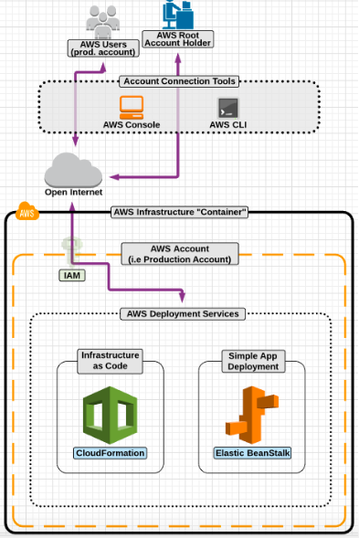

Cloud Formation

* AWS CloudFormation provides a common language for you to describe and provision all the infrastructure resources in your cloud environment.

* Cloudformation allows you to turn **infrastructure into code**.

* Cloudformation provides numerous benefits including quick deployments, infrastructure version control and disaster recovery solutions.

* AWS CloudFormation is available at no additional charge, and you pay only for the AWS resources needed to run your applications.

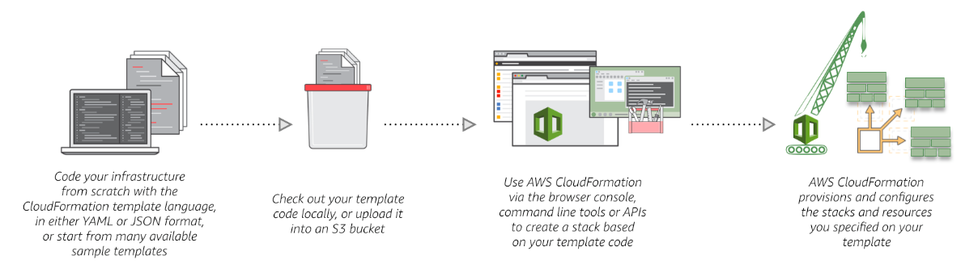

* Saves time - you don't have to manually create infrastructure.

* Since your infrastructure is now code, you can version control your infrastructure. Allowing for rollbacks to previous versions of your infrastructure if a new version has issues.

* Allows backup of your infrastructure.

* Great solution for disaster recovery.

* When you use AWS CloudFormation, you work with **templates** and **stacks**.

* You create templates to describe your AWS resources and their properties.

* Whenever you create a stack, AWS CloudFormation provisions the resources that are described in your template.

**Templates**

* An AWS CloudFormation template is a JSON or YAML formatted text file. You can save these files with any extension, such as .json, .yaml, .template, or .txt.

* AWS CloudFormation uses these templates as blueprints for building your AWS resources.

* For example, in a template, you can describe an Amazon EC2 instance, such as the instance type, the AMI ID and its Amazon EC2 key pair name. Whenever you create a stack, you also specify a template that AWS CloudFormation uses to create whatever you described in the template.

**Stacks**

* When you use AWS CloudFormation, you manage related resources as a single unit called a stack. You create, update, and delete a collection of resources by creating, updating, and deleting stacks.

* All the resources in a stack are defined by the stack's AWS CloudFormation template.

* To create the resources, you create a stack by submitting the template that you created, and AWS CloudFormation provisions all those resources for you.

Elastic BeanStalk

* Why/When to use Elastic Beanstalk:
* In order to quickly provisions an AWS environment that require little to no management.
* The application fits within the parameters of the Beanstalk service.
* Can deploy from repositories or from uploaded code files.
* Easily update applications by uploading new code files or requesting a pull from a repository

* Supported Platforms:
* Java, Node.js & PHP
* .NET
* Python
* Ruby

Analytics Services [ Data Analytics ]

* AWS provides two primary services for data analytics
  + Kinesis
  + Elastic MapReduce

* Kinesis for real time data processing

* Elastic MapReduce for Hadoop framework data processing

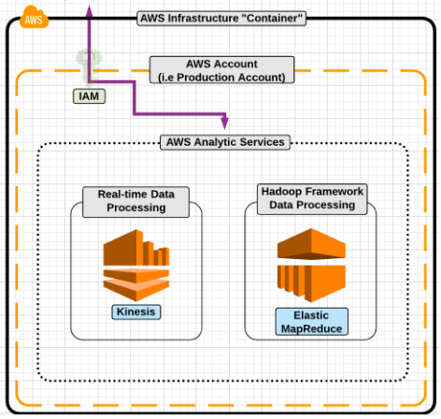

Kinesis

* Kinesis is a real-time data processing service that continuously captures large amounts of data that can power real-time streaming dashboards.

* Using the AWS provided SDKs, you can create real-time dashboards, integrate dynamic pricing strategies, and export data from kinesis to other AWS services.

* Including:
  + EMR (analytics)
  + S3 (storage)
  + Redshift (big data)
  + Lambda (event driven actions)

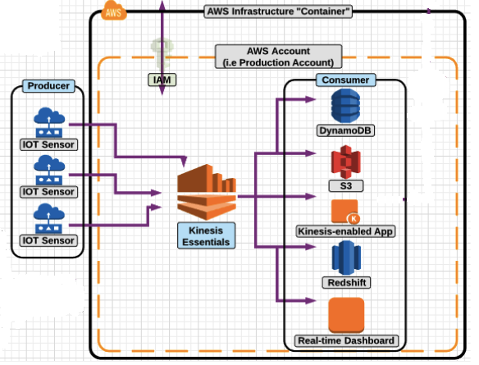

**Kinesis Benefits**

* **Real-time processing** : continuously collect and build applications that analyze the data as it's generated.

* **Parallel processing** : multiple Kinesis applications can be processing the same incoming data streaming concurrently.

* **Durable** : Kinesis synchronously replicates the streaming data across three data centers within a single AWS region and preserves the data  for up to 24 hours.

* **Scales** : Can stream from as little as a few megabytes to several terabytes per hour.

**When to use Kinesis**

* **Gaming** : collect gaming data such as player actions and feed the data into the gaming platform, for example a reactive environment based off of real-time actions of the player.
* **Real-time analytics** : collect IOT (sensors) from many sources and high amounts of frequency and process it using kinesis to gain insights as data arrives in your environment.
* **Application alerts** : Build a kinesis application that monitors incoming application logs in real-time and trigger events based off the data.
* **Log/event Data collection** : Log data from any number of devices and use kinesis application to continuously process the incoming data, power real-time dashboards and store the data in S3 when completed.
* **Mobile data Capture** : mobile applications can push data to kinesis from countless number of devices which makes the data available as soon as it is produced.

**Kinesis Producers**

* Producers are devices that collect data for kinesis processing.

* You build producers to continuously input data into a kinesis stream.

* Producers can include (but not limited to):
* IoT Sensors
* Mobile devices (cell phones)

* You can have literally thousands of different producers and scale based on need.
* The more data you want to process, the more "shards" you add to your kinesis stream.
* Each "shard" can process 2MB of read data per second, and 1MB of write data per second.

**Kinesis Consumers**

* Consumers consume the stream's data.

* This is done concurrently (multiple consumers can consume the same data at the same time).

* Consumers include (but are not limited to ):
* S3
* Redshift (data warehouse)
* EMR

* Kinesis keeps 24 hours of streaming data stored by default, but can be configured to store up to 7 days.

**Kinesis Workflow**

let say we are a shoe manufacturing company and we decided to put IOT sensors into each pair of shoes that we sell, now we have 1000's of IOT sensors i.e shoes worn by our customers, now this sensors will capture simple amount of data like steps, now what are we going to do with that data, is capture all these data(steps) and funnel that into the Kinesis and store that data into S3 and we can see in real time, how many people are walking in our shoes and how many steps they took, and then we can even arrange something like, after certain amount of steps say 1,00,000 steps then the shoe may wear out and we want to send the customers a email alert, saying it may time for you to buy new pair of shoe.

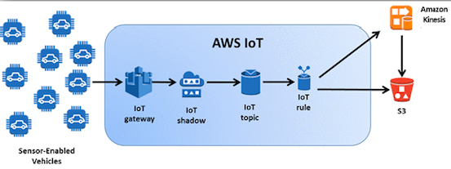

Elastic Mapreduce

* Amazon EMR is a service which deploys out EC2 instances based off of the Hadoop big data framework.

* EMR is used to analyze and process vast amounts of a data.

* EMR also supports other distributed framework such as:
  + Apache Spark
  + HBase
  + Presto
* Data stored in S3, DynamoDB or Redshift is sent to EMR

* The data is mapped to a "cluster" of Hadoop Master/Slave nodes for processing.

* Computations (coded/created by the developer) are used to process the data.

* The processed data is then reduced to a single output set of return information.
* EMR has the ability to access the underlying operating system.

* EMR can add user data to EC2 instances launched into the cluster via bootstrapping.

* EMR takes advantage of parallel processing for faster processing of data.

* EMR can resize a running cluster at any time, and you can deploy multiple clusters.

**EMR Master/Slave**

* A Master node manages the cluster by running software components which coordinate the distribution of a data and tasks among other (slave) nodes for processing.
* The master node tracks the status of tasks and monitors the health of the cluster.
* There are two types of slave nodes:
* **Core Node**:
* A slave node has software components which run tasks AND stores data in the Hadoop Distributed File System (HDFS) on your cluster.
* The core nodes do the "heavy lifting" with the data.
* **Task node**:
* A slave node that has software components which only run tasks.
* Task nodes are optional.

**Map Phase**

* Mapping is a function that defines the processes which splits the large data file for processing.
* During the mapping phase, the data is split into 128MB "chunks"
* The larger the instance size used in our EMR cluster, the more chucks you map and process at the same time.
* If there are more chucks than nodes, the chunks will queue for processing.

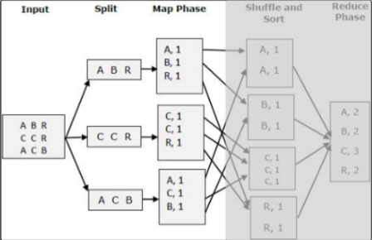

**EMR Reduce Phase**

* Reducing is a function that aggregates the split data back into one data source.
* Reduced data needs to be stored (in a service like S3) as data processed by the EMR cluster is not persistent.

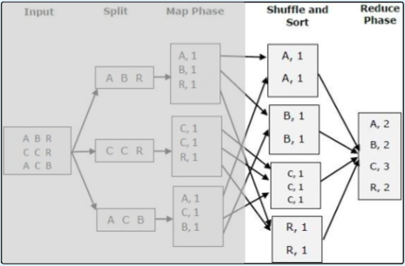

What is AWS CloudFormation?

* AWS CloudFormation is a service that helps you model and set up your AWS resources so that you can spend less time managing those resources and more time focusing on your applications that run in AWS.
* You create a template that describes all the AWS resources that you want (like Amazon EC2 instances or Amazon S3 Buckets), and AWS CloudFormation takes care of provisioning and configuring those resources. You don't need to individually create and configure AWS resources.

**How CloudFormation can help/When to use Cloud Formation ??**

**Simplify Infrastructure Management**

* For a scalable web application that also includes a back-end database, you might use an Auto Scaling group, an Elastic Load Balancing load balancer, and an Amazon Relational Database Service database instance. Normally, you might use each individual service to provision these resources. And after you create the resources, you would have to configure them to work together. All these tasks can add complexity and time before you even get your application up and running.

* Instead, you can create or modify an existing AWS CloudFormation template. A template describes all of your resources and their properties. When you use that template to create an AWS CloudFormation stack, AWS CloudFormation provisions the Auto Scaling group, load balancer, and database for you.

* By using AWS CloudFormation, you easily manage a collection of resources as a single unit.

**Quickly Replicate Your Infrastructure**

* If your application requires additional availability, you might replicate it in multiple regions so that if one region becomes unavailable, your users can still use your application in other regions. The challenge in replicating your application is that it also requires you to replicate your resources. Not only do you need to record all the resources that your application requires, but you must also provision and configure those resources in each region.

* When you use AWS CloudFormation, you can reuse your template to set up your resources consistently and repeatedly.

**Easily Control and Track Changes to Your Infrastructure**

* When you provision your infrastructure with AWS CloudFormation, the AWS CloudFormation template describes exactly what resources are provisioned and their settings. Because these templates are text files, you simply track differences in your templates to track changes to your infrastructure, similar to the way developers control revisions to source code.

* For example, you can use a version control system with your templates so that you know exactly what changes were made, who made them, and when. If at any point you need to reverse changes to your infrastructure, you can use a previous version of your template.

**Tit-Bits**

* Templates can be stored in Version Control System
* Track all changes made to infrastructure stack
* Create and update resources in a controlled and predictable way
* CF is declarative and flexible, meaning just choose the resources and configurations you need

AWS CloudFormation Concepts

* When you use AWS CloudFormation, you work with **templates** and **stacks**.
* You create templates to describe your AWS resources and their properties.
* Whenever you create a stack, AWS CloudFormation provisions the resources that are described in your template.

**Templates**

* An AWS CloudFormation template is a JSON or YAML formatted text file. You can save these files with any extension, such as .json, .yaml, .template, or .txt.
* AWS CloudFormation uses these templates as blueprints for building your AWS resources.
* For example, in a template, you can describe an Amazon EC2 instance, such as the instance type, the AMI ID, block device mappings, and its Amazon EC2 key pair name. Whenever you create a stack, you also specify a template that AWS CloudFormation uses to create whatever you described in the template.

* *For example, if you created a stack with the following template, AWS CloudFormation provisions an instance with user choice to select Key Pair Name, Instance Type etc*

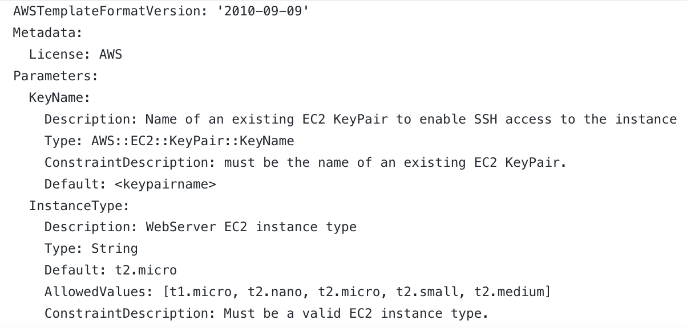

**Stacks**

* When you use AWS CloudFormation, you manage related resources as a single unit called a stack. You create, update, and delete a collection of resources by creating, updating, and deleting stacks.
* All the resources in a stack are defined by the stack's AWS CloudFormation template. Suppose you created a template that includes an Auto Scaling group, ELB, and an Amazon RDS database instance.
* To create those resources, you create a stack by submitting the template that you created, and AWS CloudFormation provisions all those resources for you.

**Templates Anatomy**

A template is a **JSON or YAML-formatted text file** that describes your AWS infrastructure. The following examples show an AWS CloudFormation template structure and its sections.

**JSON**

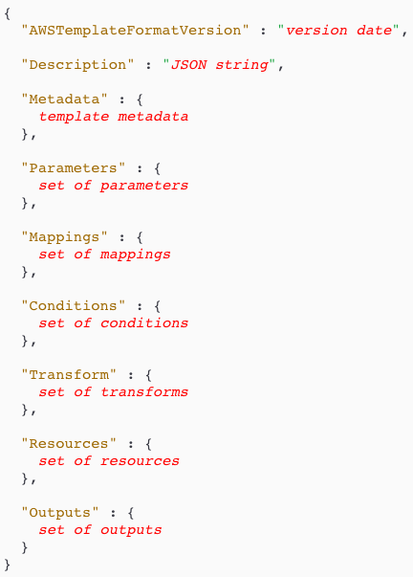

**YAML**

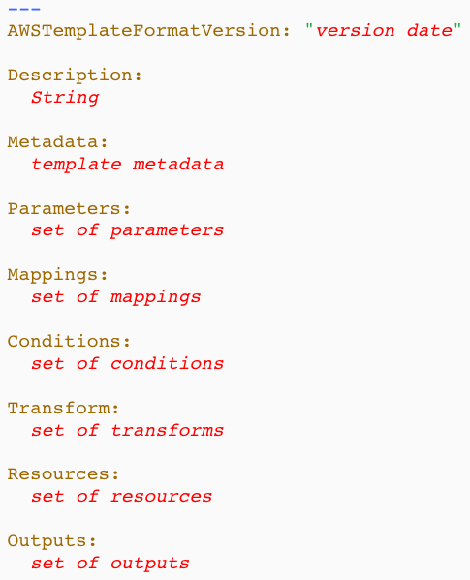

* **AWSTemplateFormatVersion** - 'version date'
  + Required : NO
  + **2010-09-09** is currently the only available option

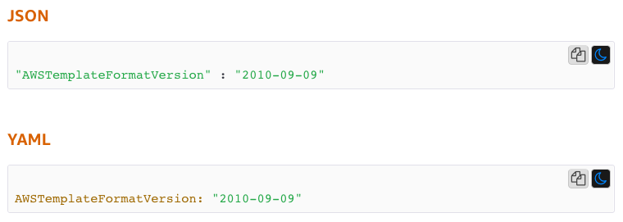

* **Description** - String
  + Required : NO
  + It's basically a user friendly description of template, a string literal that is between **0 and 1024 bytes in length**.

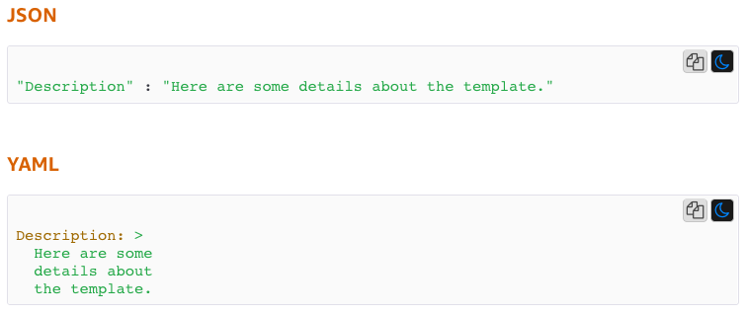

* **Metadata**
  + Required : NO
  + Objects that provide additional information about the template.

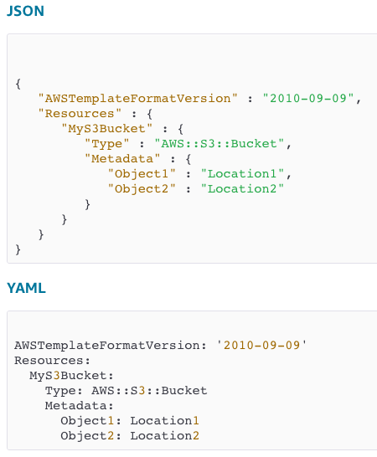

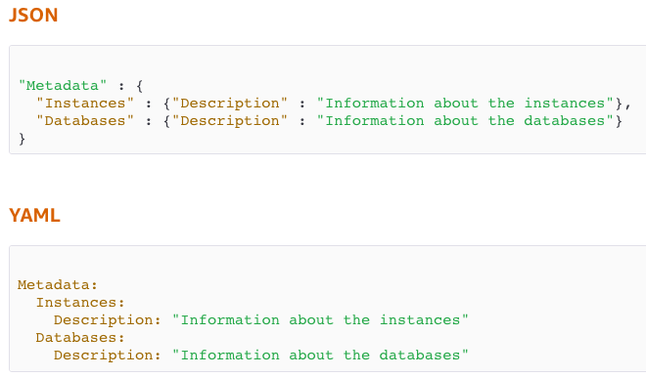

* **Parameters**
  + Required : NO
  + Input Parameters for customizing deployed resources
  + The following example declares a parameter named **InstanceTypeParameter**. This parameter lets you specify the Amazon EC2 instance type for the stack to use when you create or update the stack.

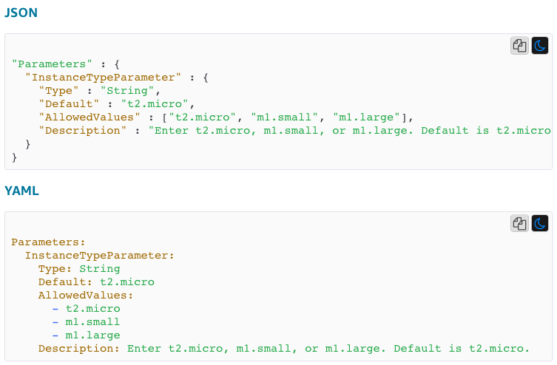

* **Mappings**
  + Required : NO
  + A mapping of keys and associated values that you can use to specify conditional parameter values. For example, if you want to set values based on a region, you can create a mapping

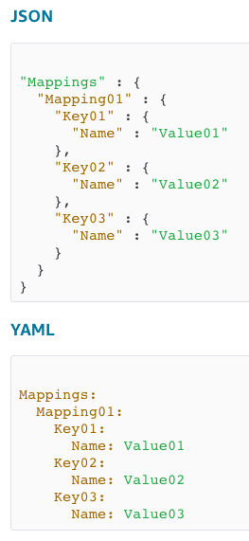

* The following example shows a Mappings section with a map **RegionMap**, which contains five keys that map to name-value pairs containing single string values. The keys are region names. Each name-value pair is the AMI ID for the HVM64 AMI in the region represented by the key.

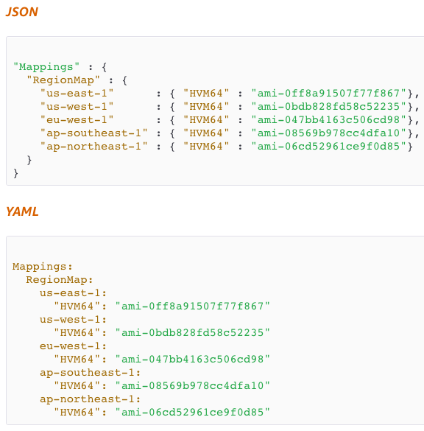

* **Conditions**
  + Required : NO
  + A mapping of keys and associated values that you can use to specify conditional parameter values. For example, if you want to set values based on a region.
  + For example, you can create a condition and then associate it with a resource, so that AWS CloudFormation only creates the resource if the condition is true.
  + You might use conditions when you want to reuse a template that can create resources in different contexts, such as a test environment versus a production environment. In your template, you can add an **EnvironmentType** input parameter, which accepts either prod or test as inputs. For the production environment, you might include Amazon EC2 instances with certain capabilities; however, for the test environment, you want to use reduced capabilities to save money. With conditions, you can define which resources are created and how they're configured for each environment type.

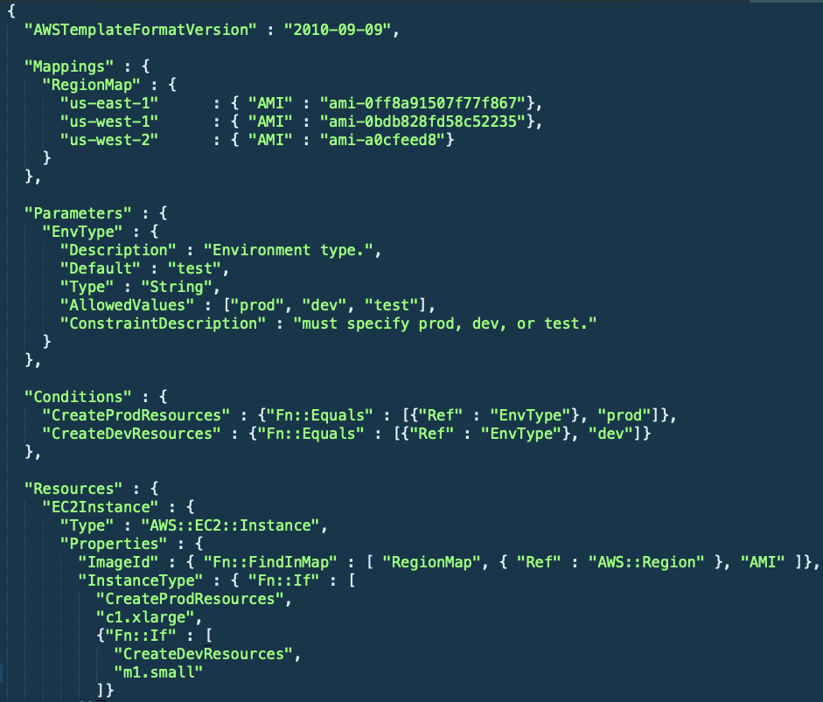

* **Transform**
  + Required : NO
  + For [serverless applications](https://docs.aws.amazon.com/lambda/latest/dg/deploying-lambda-apps.html) (also referred to as Lambda-based applications), specifies the version of the [AWS Serverless Application Model (AWS SAM)](https://github.com/awslabs/serverless-application-specification) to use. When you specify a transform, you can use AWS SAM syntax to declare resources in your template.

* **Resources**
  + **Required : YES**
  + Specifies the stack resources and their properties, such as an Amazon EC2 instance or an Amazon Simple Storage Service bucket.

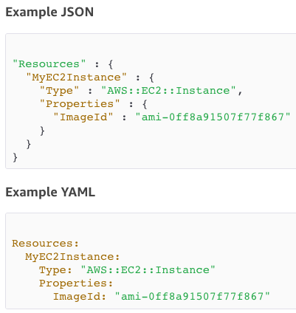

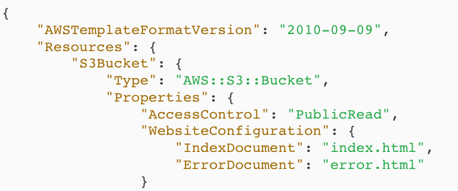

* **Outputs**
  + Required : No
  + The Outputs section declares output values that you can import into other stacks. For example, you can output the S3 bucket name for a stack to make the bucket easier to find.
  + In the following example, the output named BackupLoadBalancerDNSName returns the DNS name for the resource with the logical ID BackupLoadBalancer only when the CreateProdResources condition is true.

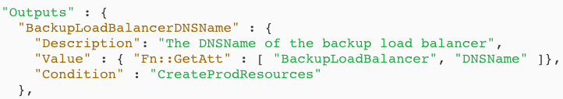

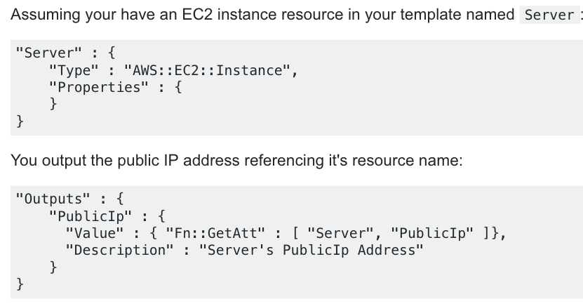

**Cloud Formation Template**

<https://github.com/ravi2krishna/aws-cloud-formation-demo>

Project Setup

**Project #1**

Setting up a highly available and fault tolerant CMS

In WEb Server instance

Make sure to use the Route 53

sudo yum install -y wget unzip httpd php php-mysql elinks

sudo systemctl enable httpd

sudo systemctl start httpd

wget https://wordpress.org/latest.zip

unzip latest.zip

sudo mv wordpress /var/www/html

sudo touch /var/www/html/wordpress/health.html

sudo chown -R apache:apache /var/www/html/wordpress

sudo vi /etc/httpd/conf/httpd.conf

{ Change DocumentRoot from /var/www/html to /var/www/html/wordpress }

sudo setenforce 0

sudo systemctl restart httpd

In order to Setup the application, we need Database, Setup Mysql RDS and enable Multi AZ failover

In the wordpress setup process in Database host, input RDS endpoint

Now take an AMI for future use in Launch Configuration, it’s very important to have the AMI built with Domain name using Route 53

Now setup Load Balancer

Next create an Launch Configuration with wordpress AMI

Next Create an Auto Scaling Group, with above launch configuration

[**Class Running Notes**](https://docs.google.com/document/d/1b6o2j3G4s5FYJaYLgFuZ_n0GpuqLzxTSts2t7BUDmR8/edit?usp=sharing)

[**AWS Official Guide**](https://drive.google.com/open?id=1nBSoEMP4LAZShc-x5w6NPDBz-PpnWCdD)

**AWS Whitepapers**

[**AWS Cloud Computing Whitepapers (aws.amazon.com/whitepapers)**](https://acloud.guru/aws.amazon.com/whitepapers)

[**Overview of Security Processes**](http://d0.awsstatic.com/whitepapers/Security/AWS%20Security%20Whitepaper.pdf)

[**Storage Options in the Cloud**](http://d0.awsstatic.com/whitepapers/aws-storage-options.pdf)

[**Defining Fault Tolerant Applications in the AWS Cloud**](http://d0.awsstatic.com/whitepapers/aws-building-fault-tolerant-applications.pdf)

[**Overview of Amazon Web Services**](http://d0.awsstatic.com/whitepapers/aws-overview.pdf)

[**Compliance Whitepaper**](http://d0.awsstatic.com/whitepapers/compliance/AWS_Risk_and_Compliance_Whitepaper.pdf)

[**Architecting for the AWS Cloud**](http://d0.awsstatic.com/whitepapers/AWS_Cloud_Best_Practices.pdf)

[**Storage Options Use Cases Companion Whitepaper**](http://d0.awsstatic.com/whitepapers/aws-storage-use-cases.pdf)**.**

[**CSA Quiz**](https://drive.google.com/open?id=0B5iz6lCPKKazc2ZzUkZ2VERZRzdIcVF3aF8yMmRPWmU3UU5B)